Contents

Introduction 6

Streaming 6

How Does it Work? 6

Varying Quality Levels 6

Event Streaming 6

What is Kafka? 10

More Explanations 20

Apache Kafka 20

Core Capabilities 21

Ecosystem 24

Design Goals of Apache Kafka 24

Simplify The Backend Architecture 26

Universal Pipeline Of Data 26

Connects To Existing Systems 27

Process Data In Real-Time 27

Understanding Kafka 27

Architecture 27

Kafka Architecture 28

*Stream Partitions and Tasks* 29

*Threading Model* 30

*Local State Stores* 31

*Fault Tolerance* 32

Kafka Messaging 32

What is a Messaging System? 32

*Point to Point System* 32

*Publish-Subscribe (Pub/Sub) System* 33

Kafka Framework – Core APIs 33

Topic 34

Describe Kafka Topic 34

Kafka Message Size 35

Kafka Cluster 36

Kafka Broker 36

Role of ZooKeeper in Kafka 36

Producers – Apache Kafka Producer API 37

Consumers – Apache Kafka Consumer API 37

Stream Processors – Apache Kafka Streams API 37

Connectors – Apache Kafka Connect API 37

Kafka Command-Line Tools 37

Installation 39

Install Java 39

Setup Apache Kafka 39

Start Zookeeper 39

Start Apache Kafka Server 40

Stop Kafka and Zookeeper 41

Create a Topic 42

Start Zookeeper and Kafka Cluster 42

Run kafka-topics.sh with required arguments 42

Error : Topic already exists. 43

List All Topics 43

Describe a Topic 43

Kafka Console Producer and Consumer 44

1. Start Zookeeper and Kafka Cluster 44

2. Create a Kafka Topic 44

3. Create a Kafka Console Producer. 44

On the Hortonworks HDP Sandbox: 44

4. Create a Kafka Console Consumer. 44

On the Hortonworks HDP Sandbox: 44

5. Send Messages 44

6. More Consumer(s) – Pub/Sub 45

7. Delete a Topic 45

Using Connectors 46

Kafka with Scala 47

Input Sources — Kafka 47

Output Sinks 50

Setup 50

Output sink — Console 50

Output sink — File 50

Output sink — Kafka 51

Output sink — foreachBatch 53

Output sink — foreach 55

Demo: Multiple Brokers (Fault Tolerance) 58

Start Multiple Brokers on a Single Machine 58

Checkpoints and Triggers 60

Setup 60

Checkpoints 61

Output to console 61

Triggers 63

Default 63

Fixed interval micro-batches 63

One-time micro-batch 64

Kafka Producer and Consumer - Python and Scala (Kafka APIs) 66

Simple Example - PySpark 66

Kafka Consumer 66

Kafka Producer 66

Kafka-Python Producer and Consumer 66

Producer 66

Consumer 67

Kafka-Scala Producer and Consumer 68

Producer 68

Consumer 70

Spark Streaming 73

A Quick Example - Python 74

Process 75

Points to remember: 76

Full code: NetworkWordCount.py: 76

A Quick Example – Scala 77

Process 78

Points to remember 78

Spark Streaming with Kafka (Python) 81

Structured Streaming: 83

Output modes 84

How does it work? 85

Demo – Orders Data 88

Demo – Transaction Data 89

Demo – Orders Data – AVRO 89

Demo – Orders Data - CSV 90

Spark Streaming with Kafka (Scala) 90

Topic commands 90

Run Kafka Producer Shell 91

Streaming With Kafka 91

Spark Streaming Scala example 91

Source code stream.scala: (SparkSamples\Scala) 92

Spark Streaming Write to Console 92

Spark Streaming Write to Kafka Topic 93

Run Kafka Consumer Shell 94

Full code stream.scala: (SparkSamples\Scala) 94

Other Articles – withWaterMark, window, multiple o/p sinks etc. 97

Complete Producer-Consumer Example (Scala) 97

The Domain 98

The Producer Generator (Helper) 98

The Shops Records Producer 100

The Shops Records Consumer 102

Run the Application 104

Try these 105

Need for Spark Streaming 105

Spark Streaming Sources 106

Spark Streaming Operations 106

Spark DStream (Discretized Streams) 108

Apache Spark DStream Operations 108

i. Transformation 108

ii. Output Operation 109

4. Input DStreams and Receivers 109

Differences between DStreams and Spark Structured Streaming 110

RDDs vs Dataframes/Datasets 110

Real Streaming 110

Windowing Event time 110

Sinks 110

Troubleshooting 111

Terminate the Kafka Environment 111

References 113

# Introduction

## Streaming

Streaming means listening to music or watching video in ‘real time’, instead of downloading a file to your computer and watching it later.

### How Does it Work?

Streaming is a relatively recent development, because your broadband connection has to run fast enough to show the data in real time. Files encoded for streaming are often highly compressed to use as little bandwidth as possible.

If there is an interruption due to congestion on the internet, the audio will drop out or the screen will go blank.

To minimize the problem, the PC stores a ’buffer’ of data that has already been received. If there’s a drop-out, the buffer goes down for a while but the video is not interrupted. If there is no more data in the buffer, it will usually stop and display a message - ’buffering’ - while it catches up.

Streaming has become very common thanks to the popularity of internet radio stations and various audio and video on-demand services, including Spotify, Last.fm, YouTube, NetFlix etc.

### Varying Quality Levels

Some services offer different levels of quality for different internet connections.

YouTube, for example, can stream low, medium and high-quality videos to both mobile phone users and broadband users. However, YouTube’s high-quality videos for phones (320 x 240 pixels) have less resolution than low-quality videos for PCs (400 x 226 pixels) because phones have smaller screens.

Most people know that downloading files uses up their bandwidth allowance, which may be capped at a fixed number of gigabytes per month. But what they don’t know is how much bandwidth they use while streaming.

Listening to music can consume about 0.5-1.0 megabytes per minute and watching ordinary YouTube videos can consume about 4-5 megabytes per minute. It can be more or less, depending on the quality.

One drawback with streaming is that there’s one stream per computer - ‘unicasting’. Broadcasters, including the BBC, would prefer to use ‘multicasting’, where everyone listens to the same stream. This would save a lot of expensive internet bandwidth and allow better quality streams. Multicasting is still in development.

### Event Streaming

Technically speaking, event streaming is the practice of capturing data in real-time from event sources like databases, sensors, mobile devices, cloud services, and software applications in the form of streams of events; storing these event streams durably for later retrieval; manipulating, processing, and reacting to the event streams in real-time as well as retrospectively; and routing the event streams to different destination technologies as needed. Event streaming thus ensures a continuous flow and interpretation of data so that the right information is at the right place, at the right time.

#### Uses of Event Streaming

Event streaming is applied to a wide variety of use cases across a plethora of industries and organizations. Its many examples include:

* To process payments and financial transactions in real-time, such as in stock exchanges, banks, and insurances.
* To track and monitor cars, trucks, fleets, and shipments in real-time, such as in logistics and the automotive industry.
* To continuously capture and analyze sensor data from IoT devices or other equipment, such as in factories and wind parks.
* To collect and immediately react to customer interactions and orders, such as in retail, the hotel and travel industry, and mobile applications.
* To monitor patients in hospital care and predict changes in condition to ensure timely treatment in emergencies.
* To connect, store, and make available data produced by different divisions of a company.
* To serve as the foundation for data platforms, event-driven architectures, and microservices.

#### Apache Kafka is an event streaming platform. What does that mean?

Kafka combines three key capabilities so you can implement [your use cases](https://kafka.apache.org/powered-by) for event streaming end-to-end with a single battle-tested solution:

1. To publish (write) and subscribe to (read) streams of events, including continuous import/export of your data from other systems.
2. To store streams of events durably and reliably for as long as you want.
3. To process streams of events as they occur or retrospectively.

And all this functionality is provided in a distributed, highly scalable, elastic, fault-tolerant, and secure manner. Kafka can be deployed on bare-metal hardware, virtual machines, and containers, and on-premises as well as in the cloud. You can choose between self-managing your Kafka environments and using fully managed services offered by a variety of vendors.

#### How does Kafka work in a nutshell?

Kafka is a distributed system consisting of servers and clients that communicate via a high-performance [TCP network protocol](https://kafka.apache.org/protocol.html). It can be deployed on bare-metal hardware, virtual machines, and containers in on-premise as well as cloud environments.

Servers: Kafka is run as a cluster of one or more servers that can span multiple datacenters or cloud regions. Some of these servers form the storage layer, called the brokers. Other servers run [Kafka Connect](https://kafka.apache.org/documentation/#connect) to continuously import and export data as event streams to integrate Kafka with your existing systems such as relational databases as well as other Kafka clusters. To let you implement mission-critical use cases, a Kafka cluster is highly scalable and fault-tolerant: if any of its servers fails, the other servers will take over their work to ensure continuous operations without any data loss.

Clients: They allow you to write distributed applications and microservices that read, write, and process streams of events in parallel, at scale, and in a fault-tolerant manner even in the case of network problems or machine failures. Kafka ships with some such clients included, which are augmented by dozens of clients provided by the Kafka community: clients are available for Java and Scala including the higher-level [Kafka Streams](https://kafka.apache.org/documentation/streams/) library, for Go, Python, C/C++, and many other programming languages as well as REST APIs.

#### Main Concepts and Terminology

An event records the fact that "something happened" in the world or in your business. It is also called record or message in the documentation. When you read or write data to Kafka, you do this in the form of events. Conceptually, an event has a key, value, timestamp, and optional metadata headers. Here's an example event:

* Event key: "Alice"
* Event value: "Made a payment of $200 to Bob"
* Event timestamp: "Jun. 25, 2020 at 2:06 p.m."

Producers are those client applications that publish (write) events to Kafka, and consumers are those that subscribe to (read and process) these events. In Kafka, producers and consumers are fully decoupled and agnostic of each other, which is a key design element to achieve the high scalability that Kafka is known for. For example, producers never need to wait for consumers. Kafka provides various [guarantees](https://kafka.apache.org/documentation/#intro_guarantees) such as the ability to process events exactly-once.

Events are organized and durably stored in topics. Very simplified, a topic is similar to a folder in a filesystem, and the events are the files in that folder. An example topic name could be "payments". Topics in Kafka are always multi-producer and multi-subscriber: a topic can have zero, one, or many producers that write events to it, as well as zero, one, or many consumers that subscribe to these events. Events in a topic can be read as often as needed—unlike traditional messaging systems, events are not deleted after consumption. Instead, you define for how long Kafka should retain your events through a per-topic configuration setting, after which old events will be discarded. Kafka's performance is effectively constant with respect to data size, so storing data for a long time is perfectly fine.

Topics are partitioned, meaning a topic is spread over a number of "buckets" located on different Kafka brokers. This distributed placement of your data is very important for scalability because it allows client applications to both read and write the data from/to many brokers at the same time. When a new event is published to a topic, it is actually appended to one of the topic's partitions. Events with the same event key (e.g., a customer or vehicle ID) are written to the same partition, and Kafka [guarantees](https://kafka.apache.org/documentation/#intro_guarantees) that any consumer of a given topic-partition will always read that partition's events in exactly the same order as they were written.

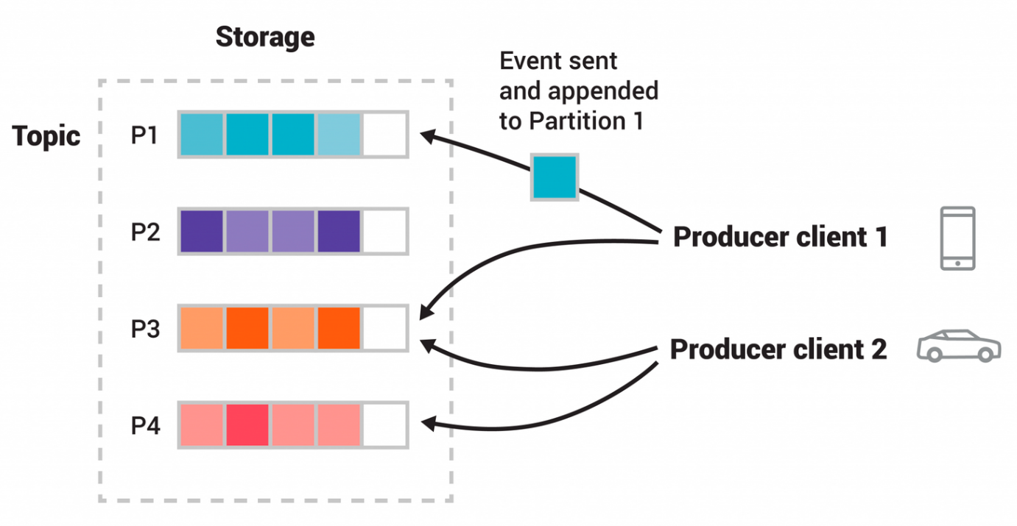**Figure**: This example topic has four partitions P1–P4. Two different producer clients are publishing, independently from each other, new events to the topic by writing events over the network to the topic's partitions. Events with the same key (denoted by their color in the figure) are written to the same partition. Note that both producers can write to the same partition if appropriate.

To make your data fault-tolerant and highly-available, every topic can be replicated, even across geo-regions or datacenters, so that there are always multiple brokers that have a copy of the data just in case things go wrong, you want to do maintenance on the brokers, and so on. A common production setting is a replication factor of 3, i.e., there will always be three copies of your data. This replication is performed at the level of topic-partitions.

#### [Kafka APIs](https://kafka.apache.org/intro#intro_apis)

In addition to command line tooling for management and administration tasks, Kafka has five core APIs for Java and Scala:

* The [Admin API](https://kafka.apache.org/documentation.html#adminapi) to manage and inspect topics, brokers, and other Kafka objects.
* The [Producer API](https://kafka.apache.org/documentation.html#producerapi) to publish (write) a stream of events to one or more Kafka topics.
* The [Consumer API](https://kafka.apache.org/documentation.html#consumerapi) to subscribe to (read) one or more topics and to process the stream of events produced to them.
* The [Kafka Streams API](https://kafka.apache.org/documentation/streams) to implement stream processing applications and microservices. It provides higher-level functions to process event streams, including transformations, stateful operations like aggregations and joins, windowing, processing based on event-time, and more. Input is read from one or more topics in order to generate output to one or more topics, effectively transforming the input streams to output streams.
* The [Kafka Connect API](https://kafka.apache.org/documentation.html#connect) to build and run reusable data import/export connectors that consume (read) or produce (write) streams of events from and to external systems and applications so they can integrate with Kafka. For example, a connector to a relational database like PostgreSQL might capture every change to a set of tables. However, in practice, you typically don't need to implement your own connectors because the Kafka community already provides hundreds of ready-to-use connectors.

## What is Kafka?

Kafka is the answer to the problems faced by the distribution and scaling of messaging systems.

Let’s say we are designing a system that listens to various basketball game updates from various sources. Such updates might include game scoring, participants, and timing information. It then displays game(s) status on various channels such as mobile devices and browsers.



In our architecture, we have a process that reads these updates and writes them in a **Queue**. We call this process a **Producer**.

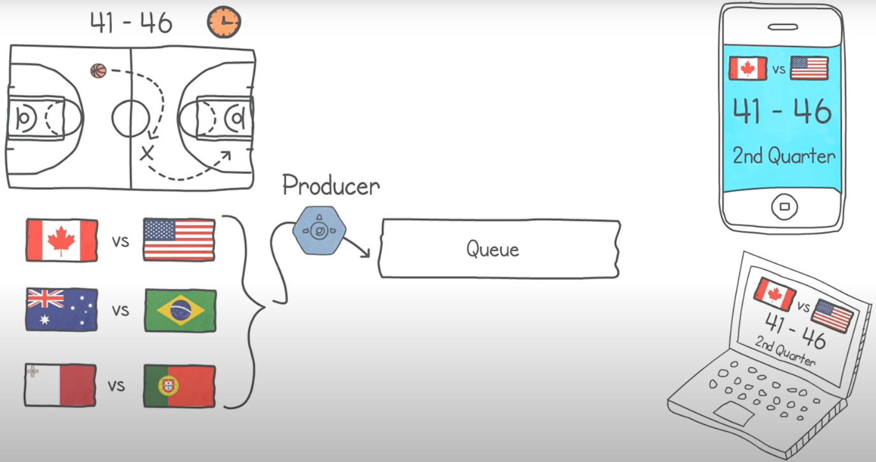

At the head of the queue, a number of processes consume these updates to display them on the various channels. We call these processes, **Consumers**.

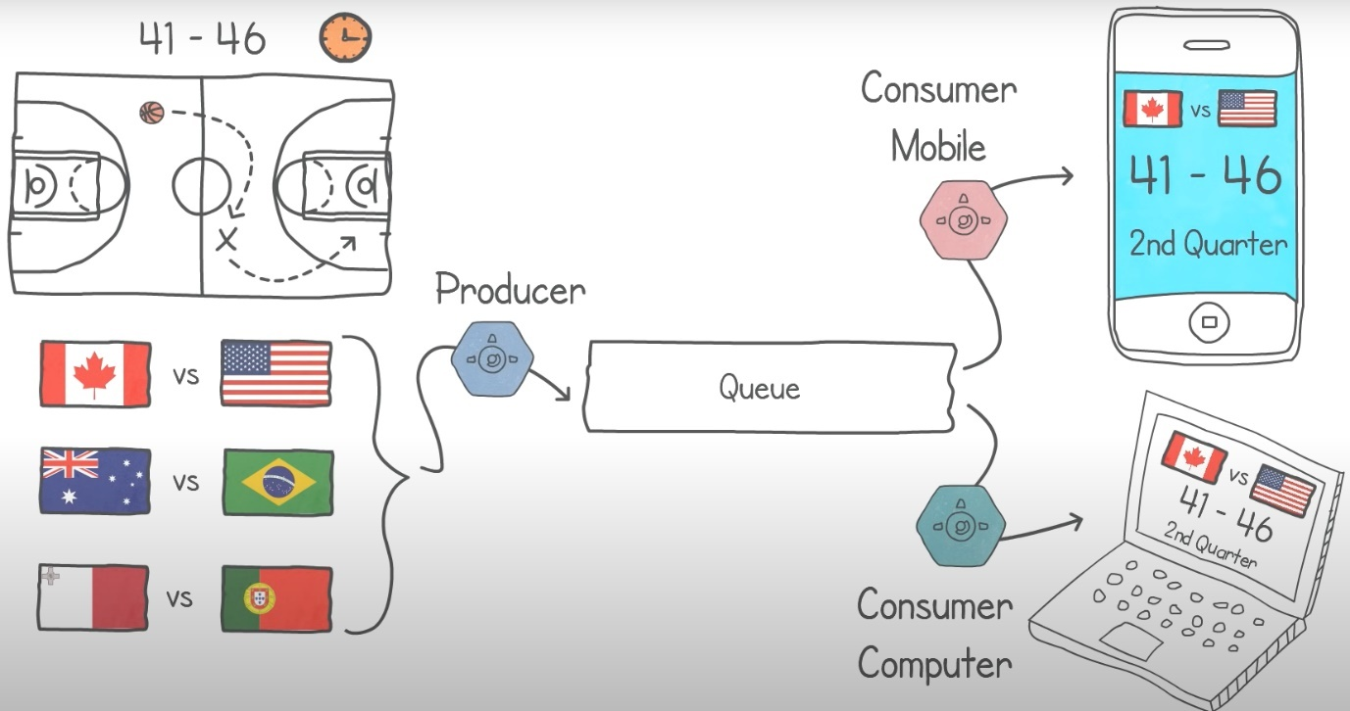

Over time, we decide to expand and follow more and more games. The problem is that our servers are now struggling to handle the load. This is because the queue is hosted on one server, which is running out of memory and processing capacity. Our consumers are also struggling in a similar fashion.

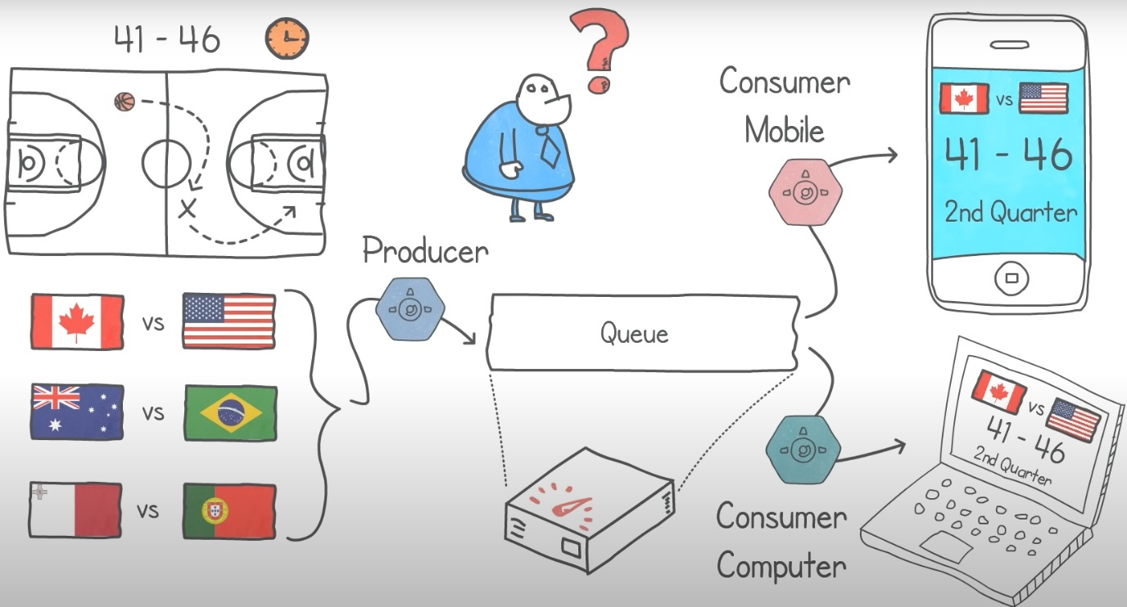

So, now we start thinking “*How we can add more computing power by distributing our architecture?*”. But how do we go about distributing a queue data structure?

By its nature, the items in a queue follow a specific ordering.

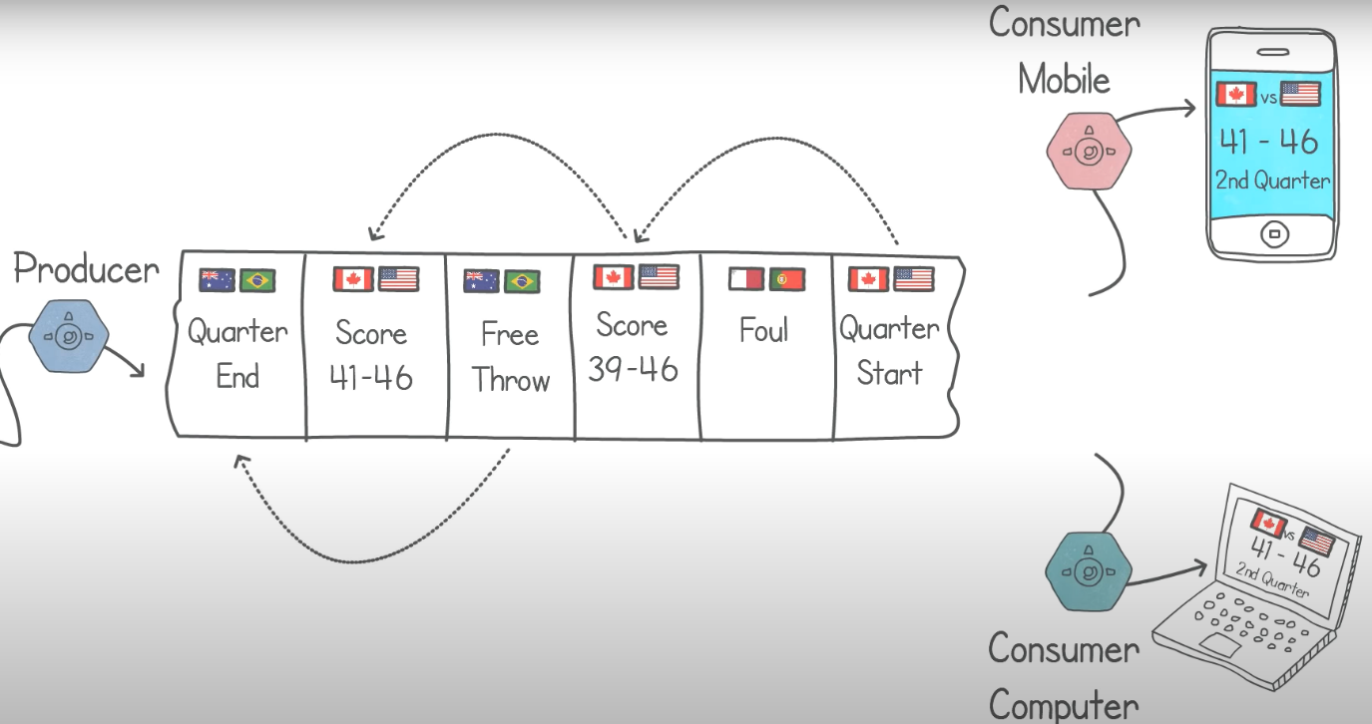

We could try to randomly distribute the contents of the queue onto multiple ones.

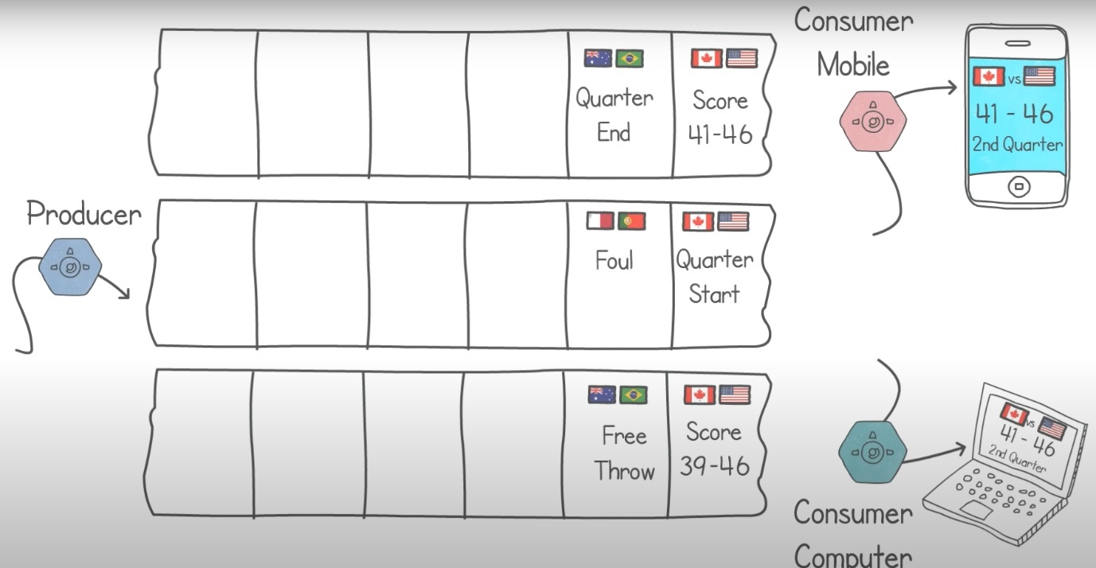

If we do this, our consumers might consume the updates in the wrong order. This would result in inconsistency. For e.g., the wrong scoring being displayed across the channels.

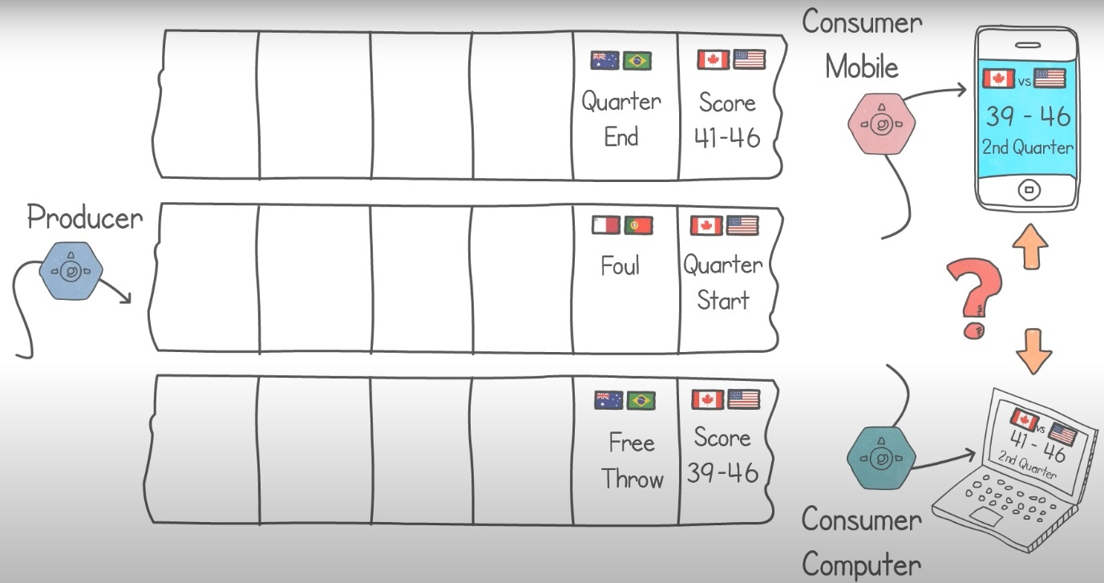

One solution is to let the application specify the way to distribute the items in the queue. In our example, we could distribute the items using the match names. Meaning that the updates coming from the same match would be on the same queue. This strategy would maintain an ordering per basketball match.

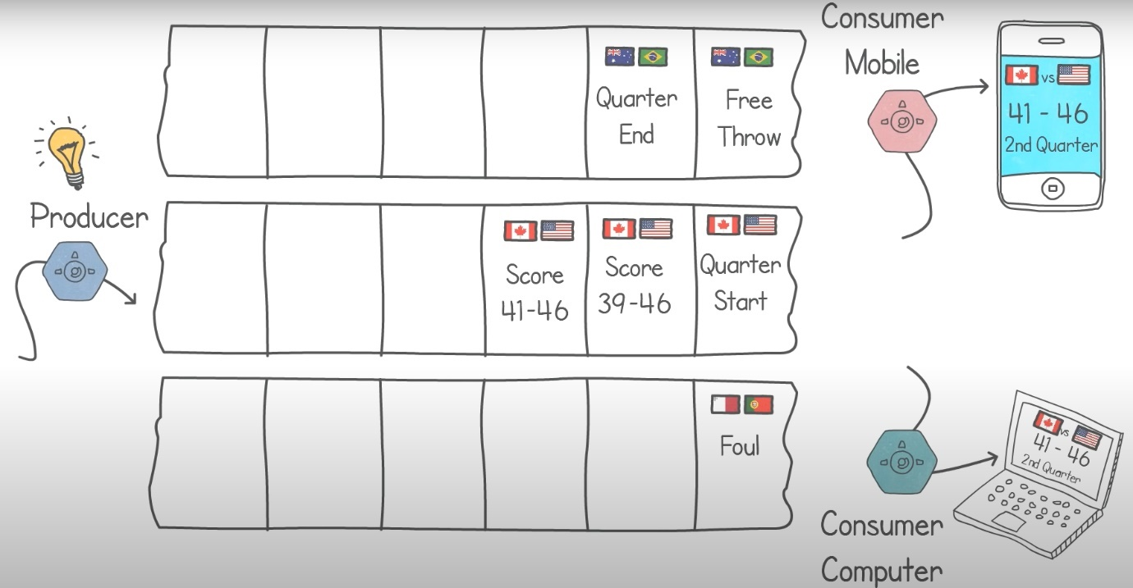

This is the basic fundamental difference of Kafka from other messaging systems, i.e., items sent and received through Kafka require a distribution strategy.

Let’s have a look at some more details and terminologies used.

In Kafka, each one of the queues is known as a **Partition**, and the total number of partitions is called the **Partition Count**.

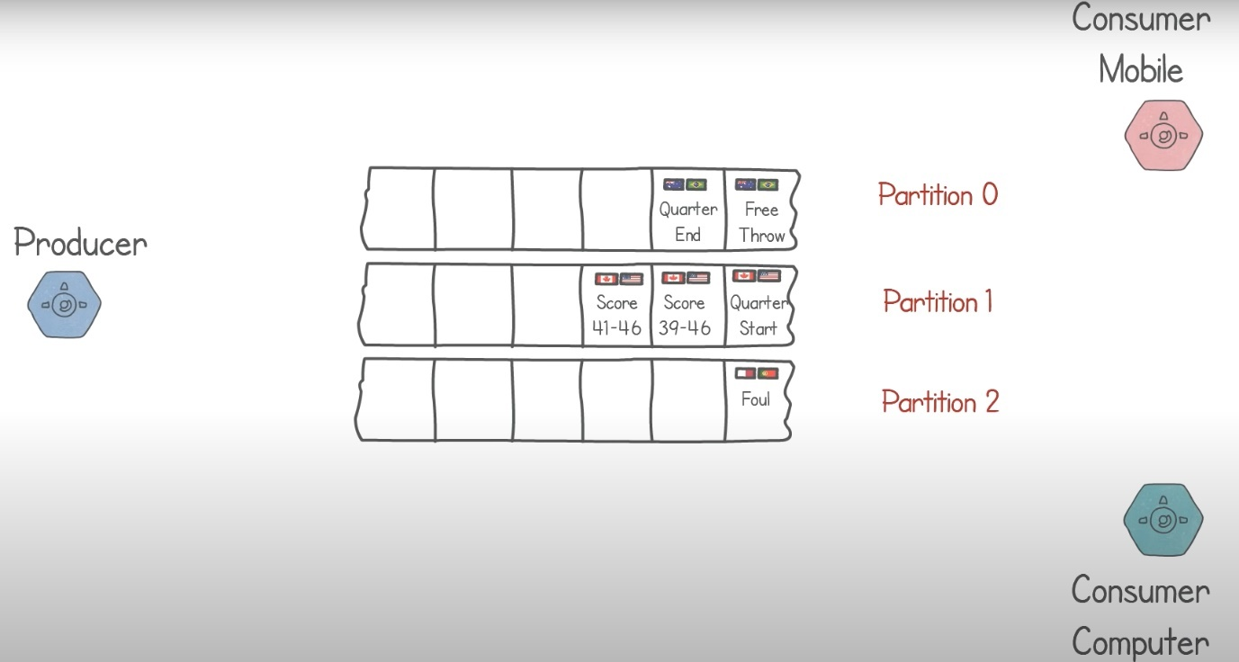

Each server holding one or more of these partitions is called a **Broker**. And each item in a partition is called a **Record**. The field used to decide which partition the record should be stored in is called the **Partition Key**. It is up to the application to decide which field to use as the Partition Key. If no key is specified, Kafka simply assigns a random partition.

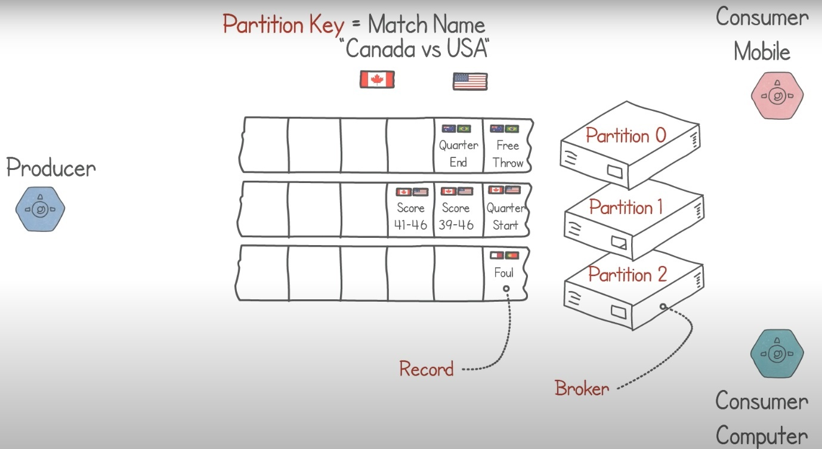

A grouping of partitions handling the same type of data is called a **Topic**. In order to identify each record uniquely, Kafka provides a sequential number to each record. This is called an **Offset**. This is essentially a record in a topic is identified by a partition number and an offset.

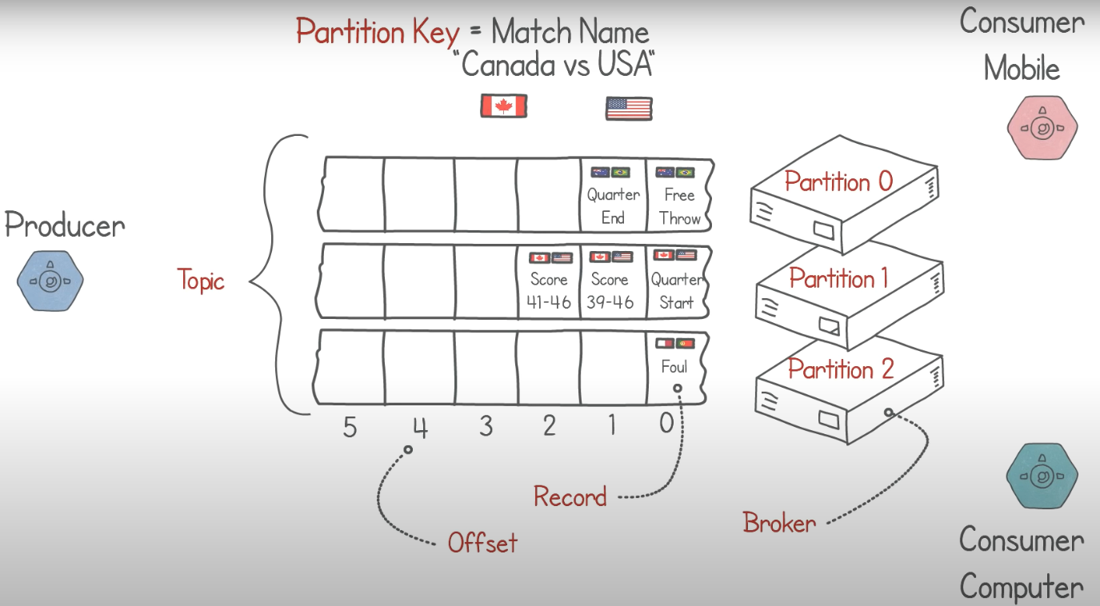

In our application, since we have now distributed our data in the topic, using the name as the partition key, we can now also parallelize our consumer applications having one consumer per partition guarantees ordering per game. Consumers can live on one machine or distributed amongst multiple ones.

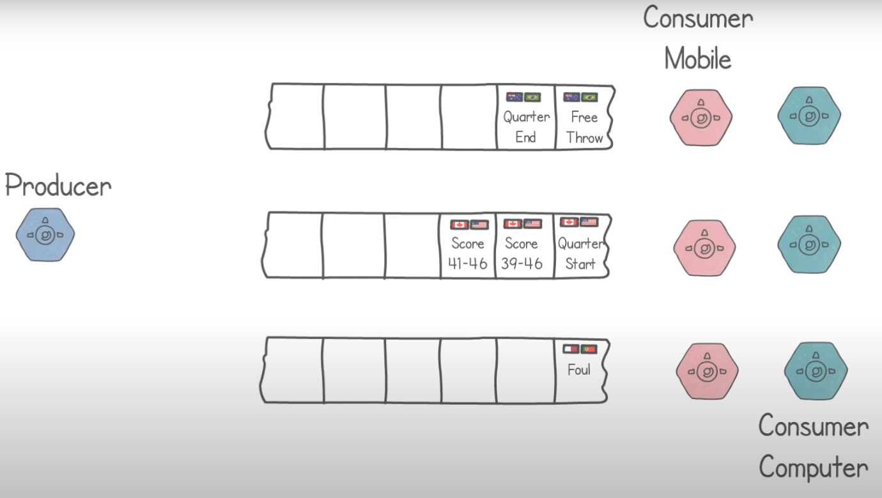

One important concept in Kafka is that consumers are very light-weight, and we can create many of them without affecting performance. This is mainly because Kafka only needs to maintain the latest offset read by each consumer.

Typically, consumers read one record after the other and resume from where they left after a restart.

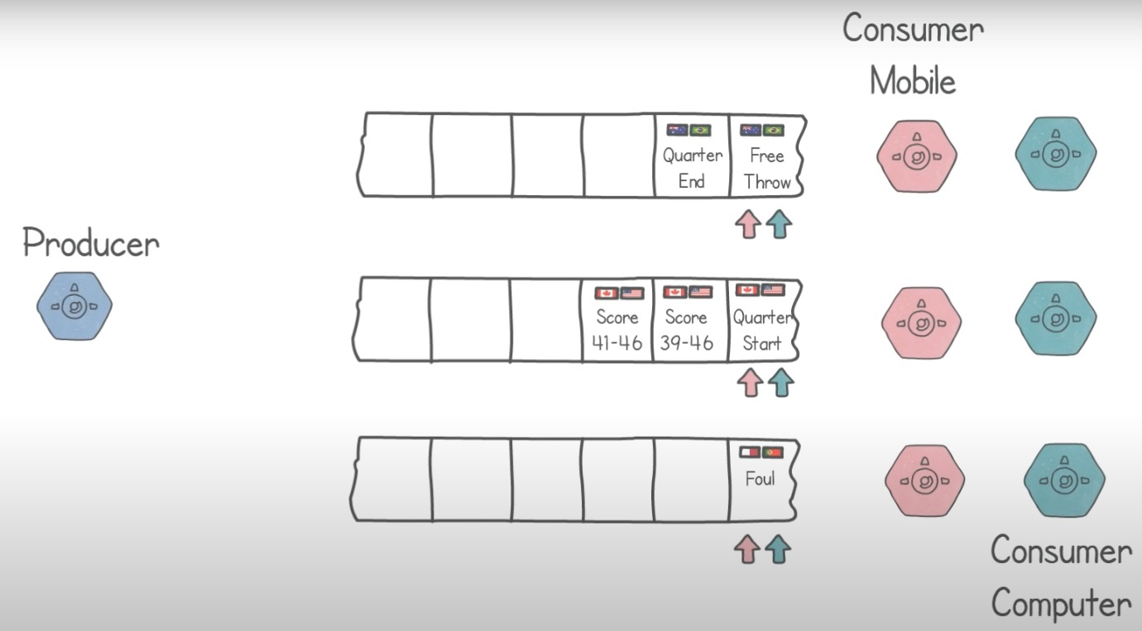

However, in Kafka, it is up to the consumer implementation to decide how to consume records. It is quite common to have consumer read all the records from the beginning on start up or to read the records in different order, such as reading back to front, for e.g.

In Kafka, each consumer belonging to the same **Consumer Group** do not share partitions. This means that each consumer would read different records from the other consumers. Multiple consumer groups are useful when you have different applications reading the same content. In our example, we can have a consumer group called “Mobile” and another consumer group called “Computer”. These groups will read the same records but update different channels.

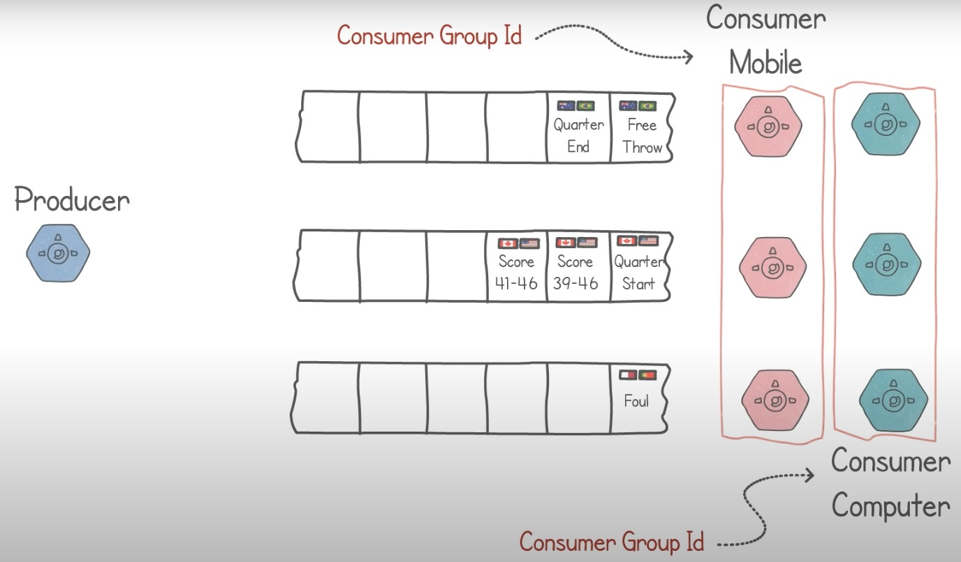

Each consumer in these groups will have separate offset pointers to keep track of which latest record was read.

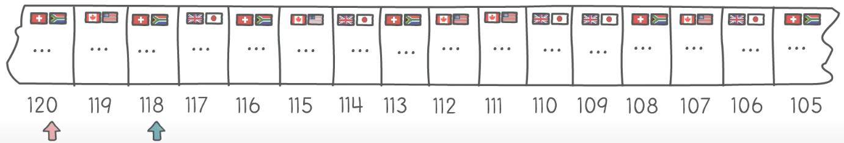

If consumers can read records using custom ordering, how can Kafka determine that the record has been consumed and safely delete that record so that it can free up space.

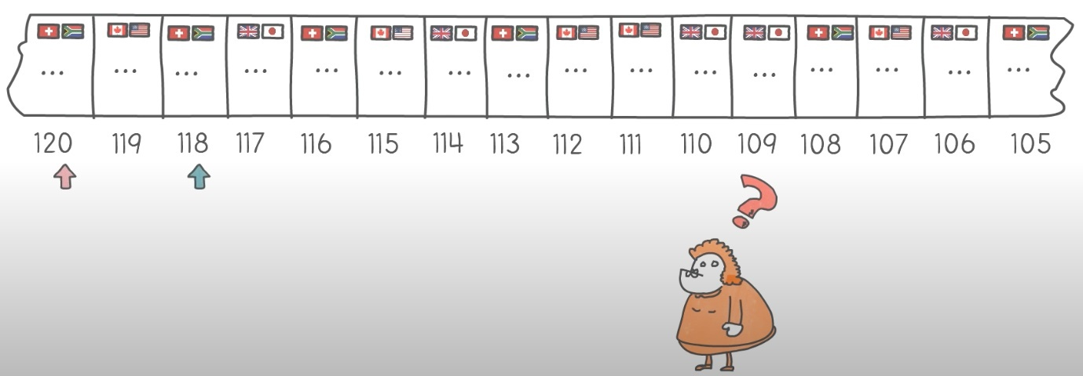

The answer is that Kafka provides various policies that allow it to do a record clean-up.

For e.g., using a retention policy, you can provide a record age limit, say 24 hours, after which the records are automatically deleted.

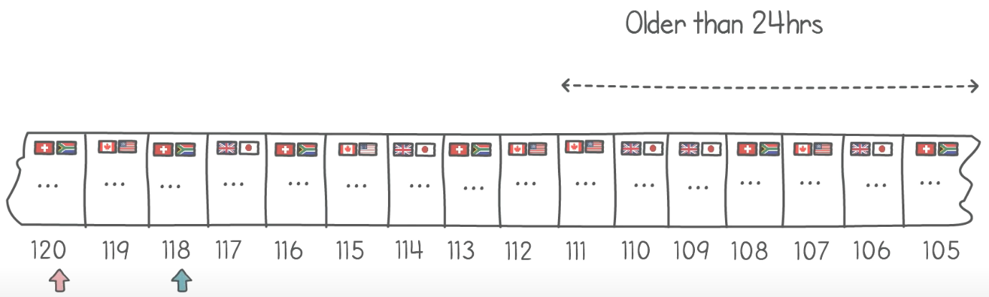

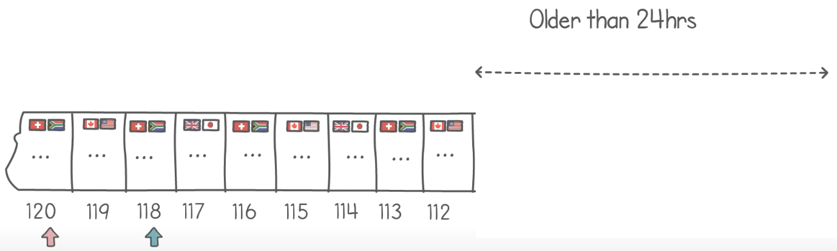

Using this policy, if your consumer application is never down for more than this age limit, no messages are lost.

Another capability of Kafka is to store records in a fault tolerant and durable way.

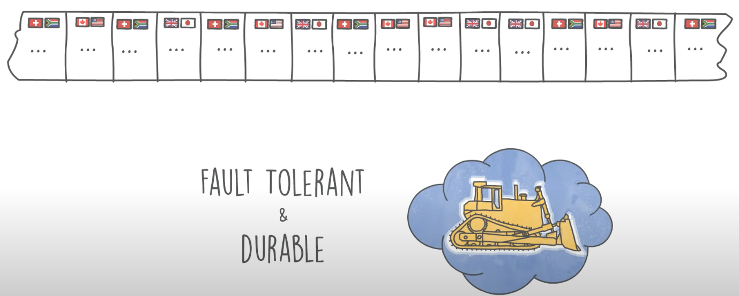

Each record is stored on persistent storage so that if a broker goes down, it can recover when it comes back up.

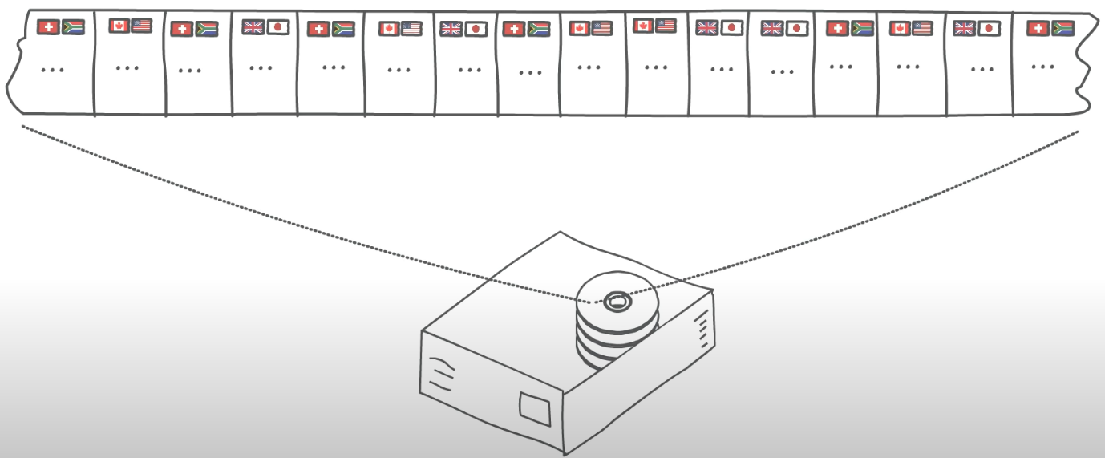

Additionally, Kafka **replicates** partitions so that when a broker goes down, a backup partition takes over and processing can resume. This replication is configured using a **Replication Factor**. For e.g., a replication factor of 3 leads to 3 copies of a partition, 1 leader and 2 backups.

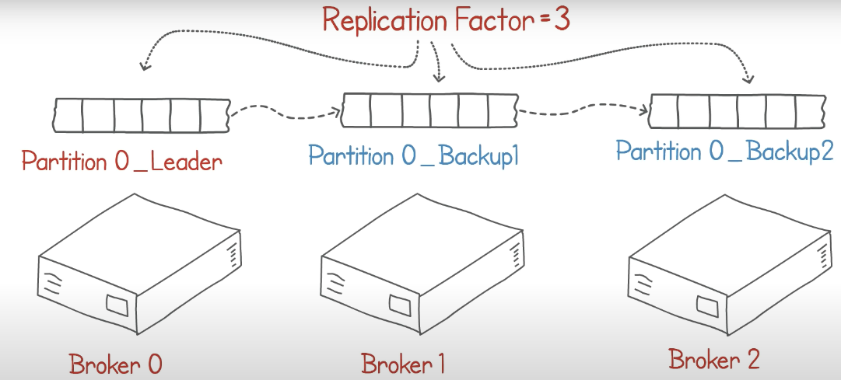

This means that we can tolerate up to 2 brokers going down at the same time.

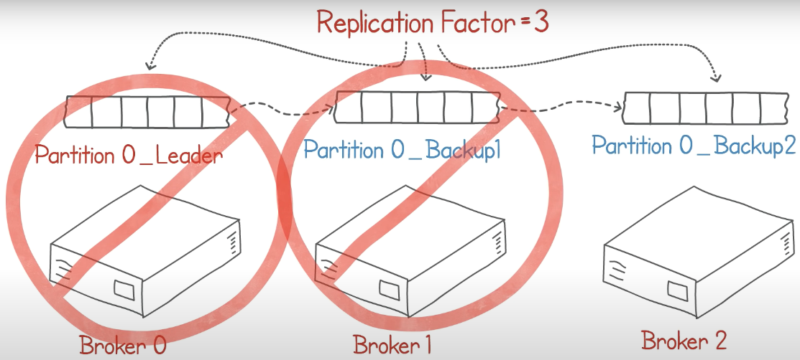

Kafka can be a solution to scalability and redundancy problems if the problem is well-stated and the technologies are well understood.

### More Explanations

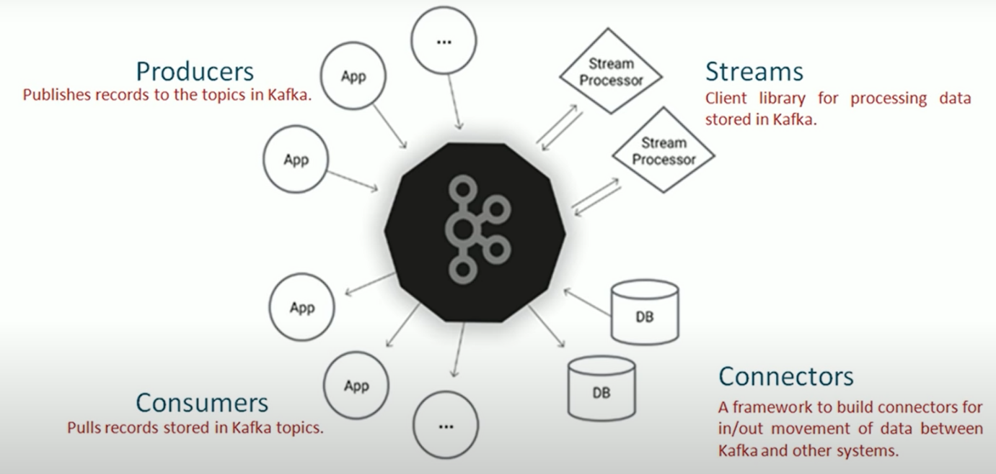

## Apache Kafka

Apache Kafka is a platform for real-time distributed streaming. [Apache Kafka Architecture](https://www.tutorialkart.com/apache-kafka/apache-kafka-architecture/) is a good choice for scalable real-time distributed streaming.

Apache Kafka is an open-source distributed event streaming platform used by thousands of companies for high-performance data pipelines, streaming analytics, data integration, and mission-critical applications.

Kafka has been originally developed at LinkedIn and has become a top level Apache project during 2011. The main goal of Apache Kafka is to be a unified platform that is scalable for handling real-time data streams.

### Core Capabilities

* HIGH THROUGHPUT
  + Deliver messages at network limited throughput using a cluster of machines with latencies as low as 2ms.
* SCALABLE
  + Scale production clusters up to a thousand brokers, trillions of messages per day, petabytes of data, hundreds of thousands of partitions. Elastically expand and contract storage and processing.
* PERMANENT STORAGE
  + Store streams of data safely in a distributed, durable, fault-tolerant cluster.
* HIGH AVAILABILITY
  + Stretch clusters efficiently over availability zones or connect separate clusters across geographic regions.

#### What is Fault Tolerance?

We have seen that Kafka is a distributed system and it works on cluster of computers. Most of the time, Kafka will spread your data in partitions over various systems on the cluster.

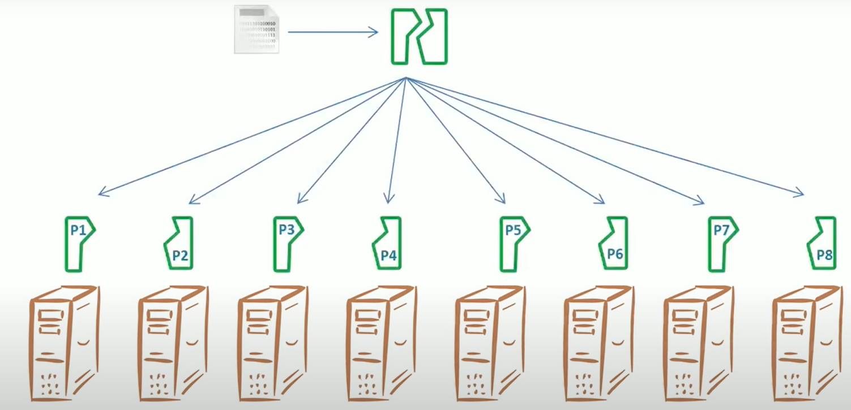

So, if 1 or 2 systems in the cluster fail, what will happen to your data? Will you be able to read it? Probably not. That’s a **Fault**. Can we **Tolerate** it?

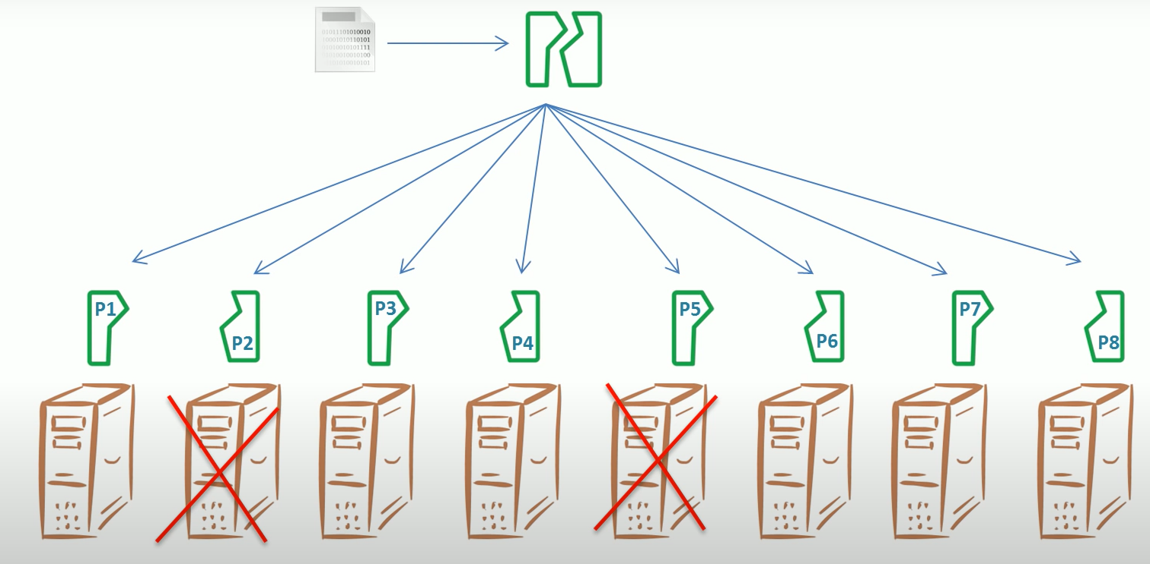

The term Fault Tolerance is very common in distributed systems. It is defined as “*Enabling a system to continue operating properly in the event of the failure of some of its components”*.

But how to achieve it? One simple solution is to make multiple copies of data and keep them on separate systems. So, if you have 3 copies of a partition, Kafka stores them on 3 different machines, you should be able to avoid 2 failures. Since you have 3 copies on 3 different systems, even if 2 of them fail, you can still read your data from the 3rd system.

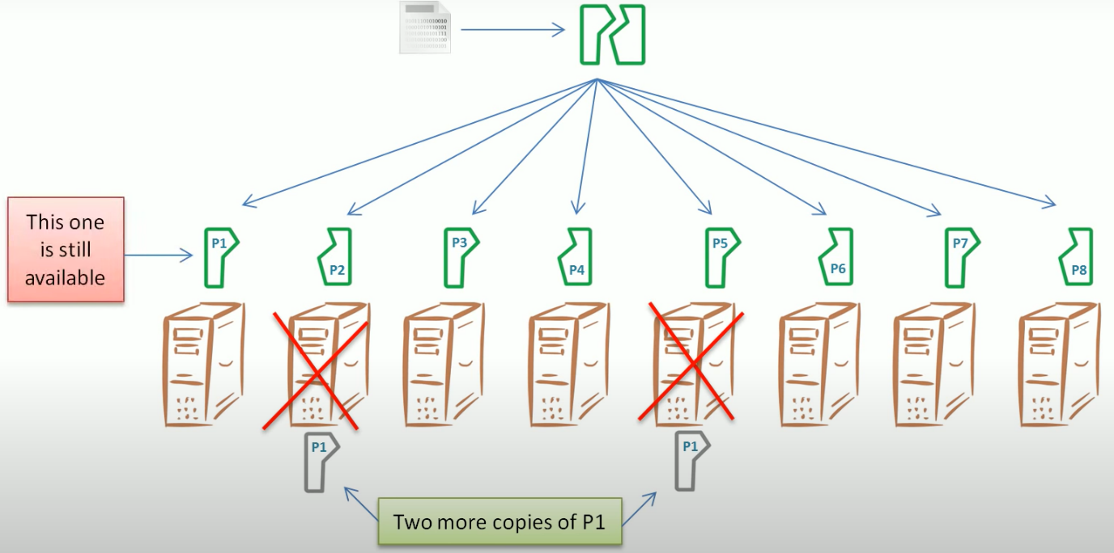

There is a particular term to making multiple copies, **Replication Factor (RF)**. We can define RF at the topic level. W don’t set it for a partition, we set it for a topic. It applies to all partitions within the topic.

But how does Kafka do this?

Kafka has the concept of **Leader** and **Followers**. For every partition, 1 broker is selected as the leader and the leader takes care if all client interactions. This means that when a producer is willing to send some data, it connects to the leader and starts sending the data. It is the leader’s responsibility to receive the message, store it in the local disk and send an acknowledgement back to the producer.

Similarly, when a consumer is willing to read data, it sends a request to the leader. It is the leader’s responsibility to read the data and send it back to the consumer.

For every partition we have a leader and the leader takes care of all requests and responses.

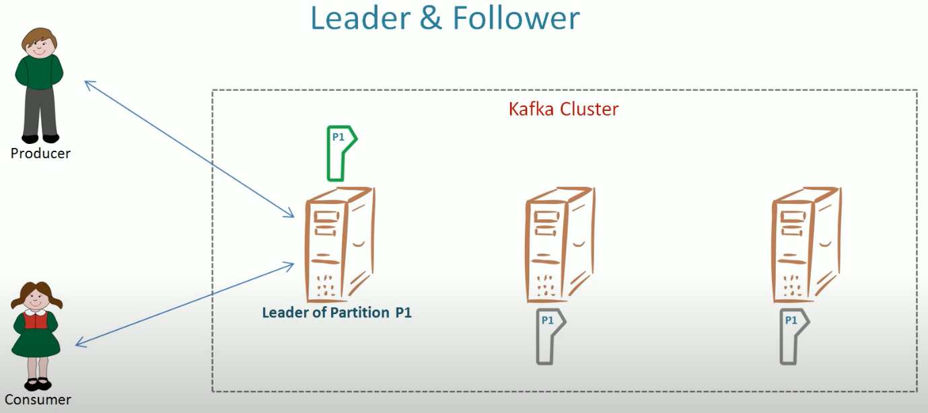

But, what about the copies? Leader maintains the 1st copy. We need 2 more copies (*assuming RF = 3*). So, Kafka will identify 2 more brokers as followers to maintain those 2 copies. These followers will copy the data from the leader. They don’t talk to the producer or consumer. They just copy data from the leader.

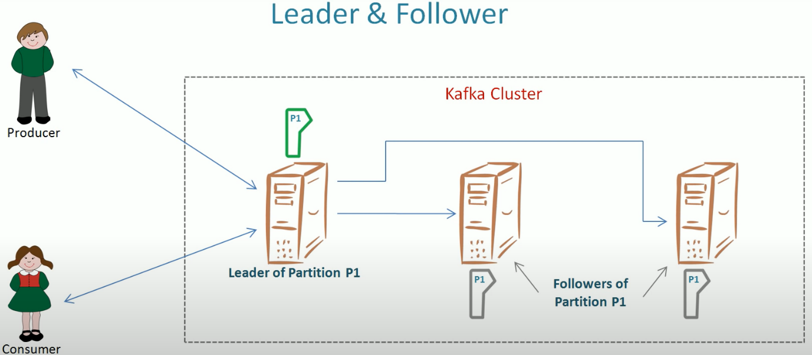

### Ecosystem

* BUILT-IN STREAM PROCESSING
  + Process streams of events with joins, aggregations, filters, transformations, and more, using event-time and exactly-once processing.
* CONNECT TO ALMOST ANYTHING
  + Kafka’s out-of-the-box Connect interface integrates with hundreds of event sources and event sinks including Postgres, JMS, Elasticsearch, AWS S3, and more.
* CLIENT LIBRARIES
  + Read, write, and process streams of events in a vast array of programming languages.
* LARGE ECOSYSTEM OPEN SOURCE TOOLS
  + Large ecosystem of open source tools: Leverage a vast array of community-driven tooling.

## Design Goals of Apache Kafka

Following are some of the design goals for its framework:

* Scalability – The framework should handle scalability in all the four dimensions (event producers, event processors, event consumers and event connectors).
  + Messaging system scales easily without down time.
* High-Volume – It should be capable of working with huge volume of data streams.
* Data Transformations – Kafka should provide provision for deriving new data streams using the data streams from producers.
* Low latency – To address traditional use cases of messaging, which require low latency.
* Fault Tolerance – The Kafka cluster should handle failures with the masters and data bases.
* Reliability – Distributed, partitioned, replicated and fault tolerant.
* Scalability –
* Durability - "Distributed commit log" which allows messages to continue to exist on disk even after the processes that created that data have ended.
* Performance – High throughput for publishing and subscribing messages.
  + Maintains stable performance for many terabytes stored.

Kafka is a distributed streaming platform.

Imagine that you have a simple web application which consists of an interactive UI, a web server, and a database.

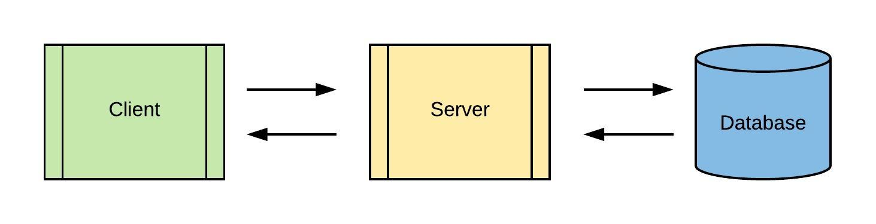

You need to record all the events such as clicks, requests, impressions and searches that take place on your web application and store them for computation, reporting, and analysis, each of which is done by separate applications or services. A simple solution would be to store the data in your database and connect all other applications and services to your database.

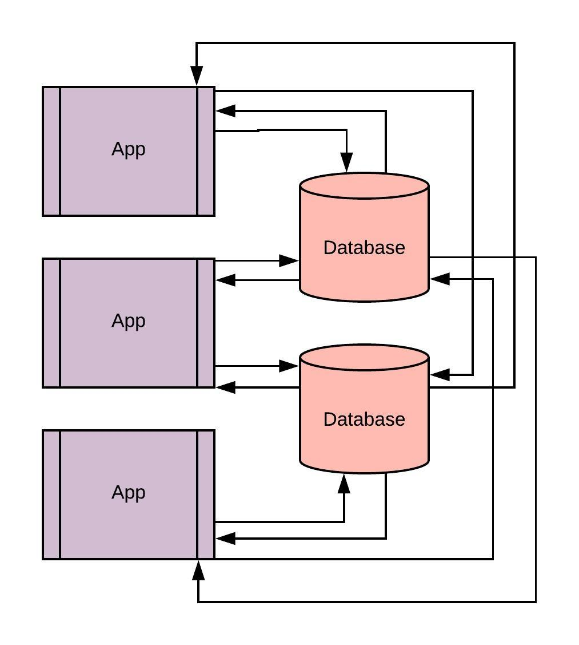

This might look simple, but you're not finished. There are multiple challenges that can arise:

1. Events like clicks, requests, impressions and searches results in high-frequency interaction/requests or data flow to your web server and your primary database may not be equipped to scale seamlessly. This could introduce a high latency as more and more events pour into the server.
2. If you choose to store high-frequency data in database systems like SQL or MongoDB, it would be hard to introduce and reconstruct a new system or a database on all of the historical data. You lose the flexibility to extend the capabilities of your system by introducing new technologies.
3. What if you have data processing systems in place to process these events to gain deeper insights? Since these systems wouldn't be capable of handling high-frequency reads and you wouldn't have access to the true source of data, it is practically impossible to experiment with various data processing or machine learning algorithms on all of the data.
4. Each application can follow its own data format, which means that you will need systems for data transformations when there is the exchange of data across these applications.

All these problems can be better addressed by bringing a streaming platform like Kafka into the picture. A streaming platform is a system that can perform the following:

1. Store a huge amount of data that can be persistent, checksummed and replicated for fault tolerance.
2. Process continuous flow of data (data streams) in real time across systems
3. Allow applications to publish data or data streams independently and agnostic to the application/service consuming it

Although Kafka can store persistent data, it is NOT a database.

Kafka not only allows applications to push or pull a continuous flow of data, but it also deals with processing them to build and support real-time applications. This is different than performing CRUD operations on passive data or running queries on traditional databases.

*That sounds convincing! But how does Kafka solve the above-mentioned challenges and why would one need a system like this?*

Kafka is a distributed platform and built for scale, which means it can handle sky-high frequency reads and writes & store huge volumes of data. It ensures that the data is always reliable. It also supports strong mechanisms for recovery from failures. Here are some of the key aspects of why one should be using Kafka:

### Simplify The Backend Architecture

Look at how a complex architecture can be simplified and streamlined with the help of Kafka

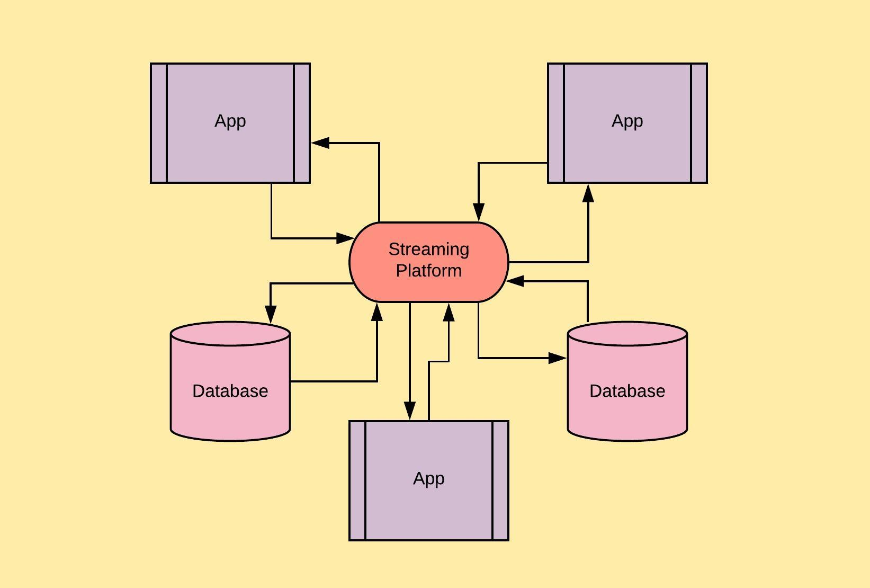

### Universal Pipeline Of Data

As you can see above, Kafka acts as a universal data pipeline across multiple applications and services. This gives us two advantages. The first one is data integration. We have all the data from different systems residing at a single place, making Kafka a true source of data. Any application can push data to this platform which can later be pulled by another application. Secondly, Kafka makes it easy to exchange data between applications. Since we have all the data in one place, we can standardize the data format that we will be using for the platform which can reduce our data transformations.

### Connects To Existing Systems

Although Kafka allows you to have a standard data format, that does not mean the applications do not require data transformations. This allows us to reduce the overall number of data transformations in our architecture, but there may be cases when we still require transformations.

Consider connecting a legacy system to your architecture which does not know about Kafka: In such cases, Kafka offers a framework called Kafka Connect for us to connect to existing systems maintaining the universal data pipeline.

### Process Data In Real-Time

A real-time application usually requires a continuous flow of data which can be processed immediately or within the current span of time with reduced latency. Kafka Streams make it possible to build, package and deploy applications without any need for separate stream processors or heavy and expensive infrastructure.

These features allow Kafka to become the true source of data for your architecture. This enables you to add new services and applications to your existing infrastructure and allows you to rebuild existing databases or migrate from legacy systems with less effort.

## Understanding Kafka

Here is a quick introduction to some of the core concepts of Kafka architecture:

1. Kafka is run as a cluster on one or more servers
2. Kafka stores a stream of records in categories called topics. Each record consists of a key, value and a timestamp
3. Kafka works on the publish-subscribe pattern. It allows some of the applications to act as producers and publish the records to Kafka topics. Similarly, it allows some of the applications to act as consumers and subscribe to Kafka topics and process the records produced by it
4. Alongside, Producer API and Consumer API, Kafka also offers Streams API for an application to work as a stream processor and Connector API through which we can connect Kafka to other existing applications and data systems.

### Architecture

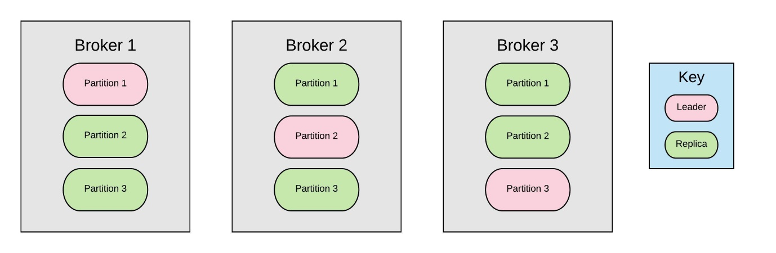

As you can see, Kafka topics are divided into partitions. These topics can be replicated across separate machines using brokers, which allows consumers to read from a topic in parallel.

Each of these brokers has partitions which are leaders and those that are replicas. This allows for an incredible level of fault tolerance through your system. When the system is functioning normally, all reads and writes to a topic go through the leader and the leader makes sure that all the other brokers are updated.

If a broker fails, the system can automatically reconfigure itself so a replica can take over as the new leader for that topic.

### Kafka Architecture

Kafka Streams simplifies application development by building on the Kafka producer and consumer libraries and leveraging the native capabilities of Kafka to offer data parallelism, distributed coordination, fault tolerance, and operational simplicity. In this section, we describe how Kafka Streams works underneath the covers.

The picture below shows the anatomy of an application that uses the Kafka Streams library.

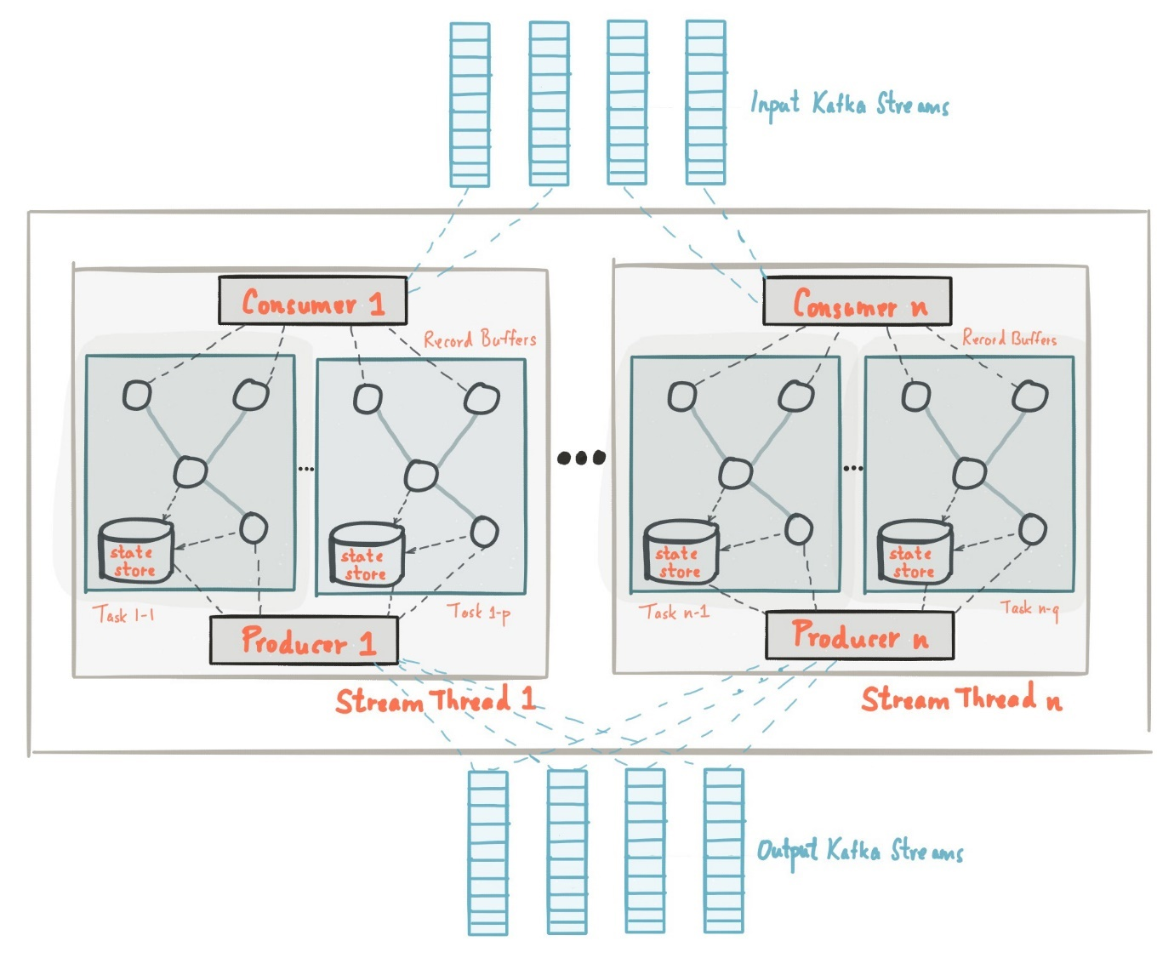

#### [Stream Partitions and Tasks](https://kafka.apache.org/28/documentation/streams/architecture#streams_architecture_tasks)

The messaging layer of Kafka partitions data for storing and transporting it. Kafka Streams partitions data for processing it. In both cases, this partitioning is what enables data locality, elasticity, scalability, high performance, and fault tolerance. Kafka Streams uses the concepts of **partitions** and **tasks** as logical units of its parallelism model based on Kafka topic partitions. There are close links between Kafka Streams and Kafka in the context of parallelism:

* Each **stream partition** is a totally ordered sequence of data records and maps to a Kafka **topic partition**.
* A **data record** in the stream maps to a Kafka **message** from that topic.
* The **keys** of data records determine the partitioning of data in both Kafka and Kafka Streams, i.e., how data is routed to specific partitions within topics.

An application's processor topology is scaled by breaking it into multiple tasks. More specifically, Kafka Streams creates a fixed number of tasks based on the input stream partitions for the application, with each task assigned a list of partitions from the input streams (i.e., Kafka topics). The assignment of partitions to tasks never changes so that each task is a fixed unit of parallelism of the application. Tasks can then instantiate their own processor topology based on the assigned partitions; they also maintain a buffer for each of its assigned partitions and process messages one-at-a-time from these record buffers. As a result stream tasks can be processed independently and in parallel without manual intervention.

Slightly simplified, the maximum parallelism at which your application may run is bounded by the maximum number of stream tasks, which itself is determined by maximum number of partitions of the input topic(s) the application is reading from. For example, if your input topic has 5 partitions, then you can run up to 5 applications instances. These instances will collaboratively process the topic’s data. If you run a larger number of app instances than partitions of the input topic, the “excess” app instances will launch but remain idle; however, if one of the busy instances goes down, one of the idle instances will resume the former’s work.

It is important to understand that Kafka Streams is not a resource manager, but a library that "runs" anywhere its stream processing application runs. Multiple instances of the application are executed either on the same machine, or spread across multiple machines and tasks can be distributed automatically by the library to those running application instances. The assignment of partitions to tasks never changes; if an application instance fails, all its assigned tasks will be automatically restarted on other instances and continue to consume from the same stream partitions.

**NOTE:** Topic partitions are assigned to tasks, and tasks are assigned to all threads over all instances, in a best-effort attempt to trade off load-balancing and stickiness of stateful tasks. For this assignment, Kafka Streams uses the [StreamsPartitionAssignor](https://github.com/apache/kafka/blob/trunk/streams/src/main/java/org/apache/kafka/streams/processor/internals/StreamsPartitionAssignor.java) class and doesn't let you change to a different assignor. If you try to use a different assignor, Kafka Streams ignores it.

The following diagram shows two tasks each assigned with one partition of the input streams.

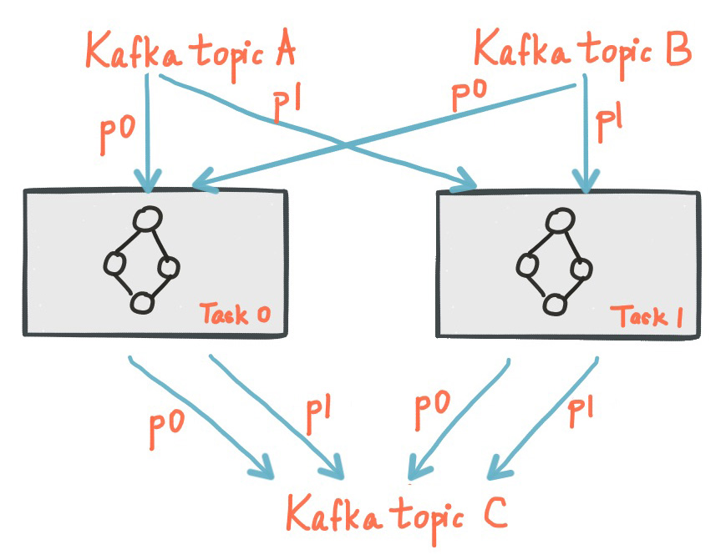

#### [Threading Model](https://kafka.apache.org/28/documentation/streams/architecture#streams_architecture_threads)

Kafka Streams allows the user to configure the number of **threads** that the library can use to parallelize processing within an application instance. Each thread can execute one or more tasks with their processor topologies independently. For example, the following diagram shows one stream thread running two stream tasks.

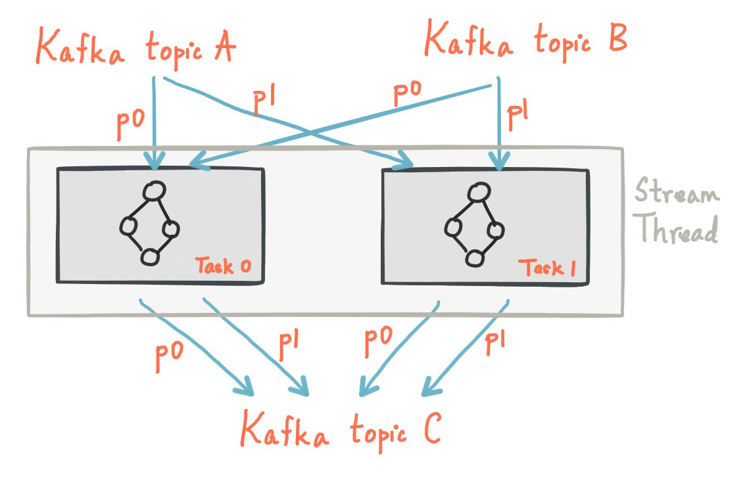

Starting more stream threads or more instances of the application merely amounts to replicating the topology and having it process a different subset of Kafka partitions, effectively parallelizing processing. It is worth noting that there is no shared state amongst the threads, so no inter-thread coordination is necessary. This makes it very simple to run topologies in parallel across the application instances and threads. The assignment of Kafka topic partitions amongst the various stream threads is transparently handled by Kafka Streams leveraging [Kafka's coordination](https://cwiki.apache.org/confluence/display/KAFKA/Kafka+Client-side+Assignment+Proposal) functionality.

As we described above, scaling your stream processing application with Kafka Streams is easy: you merely need to start additional instances of your application, and Kafka Streams takes care of distributing partitions amongst tasks that run in the application instances. You can start as many threads of the application as there are input Kafka topic partitions so that, across all running instances of an application, every thread (or rather, the tasks it runs) has at least one input partition to process.

As of Kafka 2.8 you can scale stream threads much in the same way you can scale your Kafka Stream clients. Simply add or remove stream threads and Kafka Streams will take care of redistributing the partitions. You may also add threads to replace stream threads that have died removing the need to restart clients to recover the number of thread running.

#### [Local State Stores](https://kafka.apache.org/28/documentation/streams/architecture#streams_architecture_state)

Kafka Streams provides so-called **state stores**, which can be used by stream processing applications to store and query data, which is an important capability when implementing stateful operations. The [Kafka Streams DSL](https://kafka.apache.org/28/documentation/streams/developer-guide/dsl-api.html), for example, automatically creates and manages such state stores when you are calling stateful operators such as join() or aggregate(), or when you are windowing a stream.

Every stream task in a Kafka Streams application may embed one or more local state stores that can be accessed via APIs to store and query data required for processing. Kafka Streams offers fault-tolerance and automatic recovery for such local state stores.

The following diagram shows two stream tasks with their dedicated local state stores.

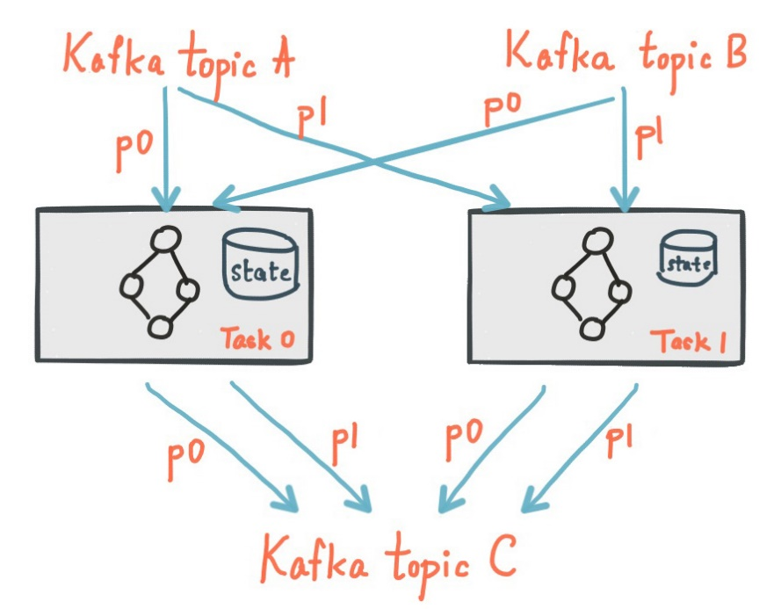

#### [Fault Tolerance](https://kafka.apache.org/28/documentation/streams/architecture#streams_architecture_recovery)

Kafka Streams builds on fault-tolerance capabilities integrated natively within Kafka. Kafka partitions are highly available and replicated; so when stream data is persisted to Kafka it is available even if the application fails and needs to re-process it. Tasks in Kafka Streams leverage the fault-tolerance capability offered by the Kafka consumer client to handle failures. If a task runs on a machine that fails, Kafka Streams automatically restarts the task in one of the remaining running instances of the application.

In addition, Kafka Streams makes sure that the local state stores are robust to failures, too. For each state store, it maintains a replicated changelog Kafka topic in which it tracks any state updates. These changelog topics are partitioned as well so that each local state store instance, and hence the task accessing the store, has its own dedicated changelog topic partition. [Log compaction](https://kafka.apache.org/28/documentation/#compaction) is enabled on the changelog topics so that old data can be purged safely to prevent the topics from growing indefinitely. If tasks run on a machine that fails and are restarted on another machine, Kafka Streams guarantees to restore their associated state stores to the content before the failure by replaying the corresponding changelog topics prior to resuming the processing on the newly started tasks. As a result, failure handling is completely transparent to the end user.

Note that the cost of task (re)initialization typically depends primarily on the time for restoring the state by replaying the state stores' associated changelog topics. To minimize this restoration time, users can configure their applications to have **standby replicas** of local states (i.e. fully replicated copies of the state). When a task migration happens, Kafka Streams will assign a task to an application instance where such a standby replica already exists in order to minimize the task (re)initialization cost. See num.standby.replicas in the [**Kafka Streams Configs**](https://kafka.apache.org/28/documentation/#streamsconfigs) section. Starting in 2.6, Kafka Streams will guarantee that a task is only ever assigned to an instance with a fully caught-up local copy of the state, if such an instance exists. Standby tasks will increase the likelihood that a caught-up instance exists in the case of a failure.

## Kafka Messaging

If you are familiar with working of a messaging system, you may find that Kafka reads and writes data streams just like a messaging system.

### [What is a Messaging System?](https://www.cloudera.com/tutorials/kafka-in-trucking-iot/1.html#what-is-a-messaging-system)

Messaging systems transfer data between client applications. One application produces the data, such as reading from sensors embedded on vehicles and the other application receives the data, processes it to be ready to be visualized to show the characteristics about the drivers driving behavior who drive those vehicles. As you can see each application developer can focus on writing code to analyze the data and not worry about how to share the data. There are two messaging systems used in this scenario, point-to-point and publish-subscribe. The system most often used is *publish subscribe*, but we will look at both.

#### [Point to Point System](https://www.cloudera.com/tutorials/kafka-in-trucking-iot/1.html#point-to-point-system)

Point to Point are messages transmitted into a queue.

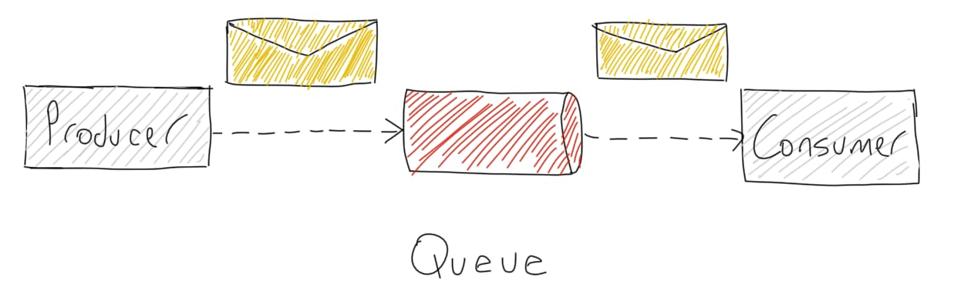

Key Characteristics of generic figure above:

* producer sends messages into the queue; each message is read by only one consumer
* once the message is consumed, it vanishes.
* multiple consumers can read messages from the queue.

#### [Publish-Subscribe (Pub/Sub) System](https://www.cloudera.com/tutorials/kafka-in-trucking-iot/1.html#publish-subscribe-system)

Publish-Subscribe are messages transmitted into a topic:

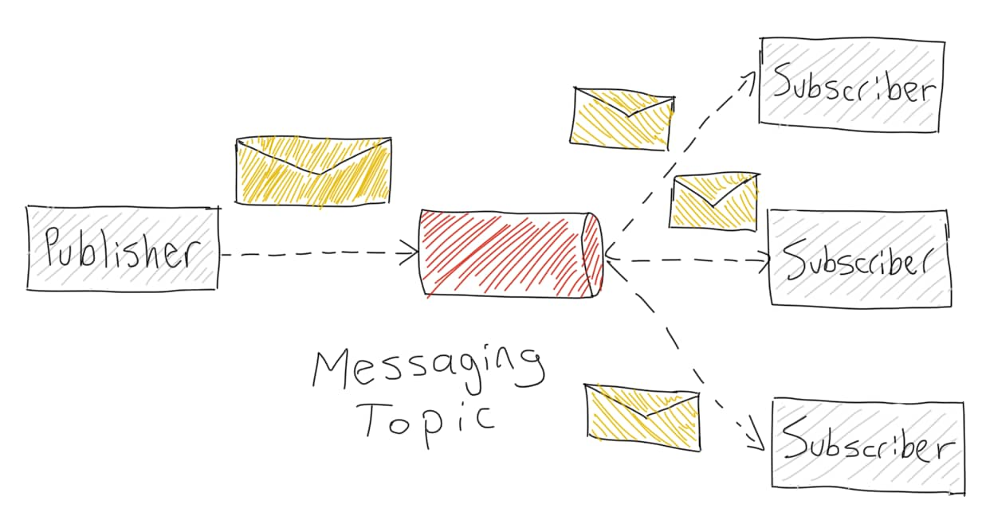

* message producers are known as publishers.
* message consumers are known as subscribers.

How does the Pub-Sub messaging system work?

* publisher sends messages into 1 or more topics.
* subscribers can arrange to receive 1 or more topics, then consume all the messages.

## Kafka Framework – Core APIs

Kafka Framework (Kafka Cluster) contains following five actors:

* Topic [not mentioned in the below picture, but is soul of Kafka]
* Producers
* Consumers
* Stream Processors
* Connectors

[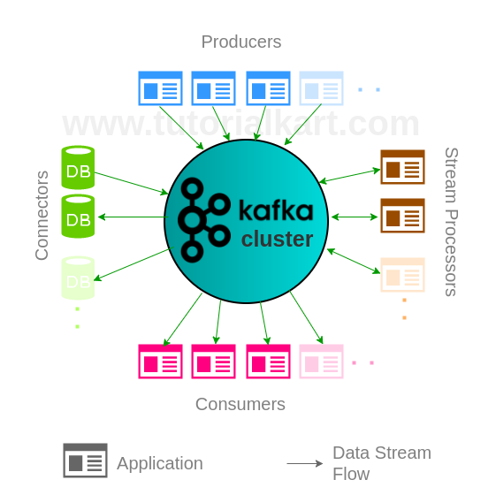](https://www.tutorialkart.com/apache-kafka-tutorial/attachment/apache-kafka-apis/)

## Topic

Topic is a category in which streams of events/records are stored in Kafka cluster. A Kafka cluster can have multiple topics.

**Note**: On the Hortonworkds HDP Sandbox, Kafka is available in the folder: /usr/hdp/current/kafka-broker. So open the .bashrc file and define the environment variable as:

export KAFKA_HOME=”/usr/hdp/current/kafka-broker”

And then from the prompt, source .bashrc

* Tutorial – [Create a Topic in Kafka Cluster](https://www.tutorialkart.com/apache-kafka/create-a-topic-in-apache-kafka/)
* Tutorial – [Describe Kafka Topic](https://www.tutorialkart.com/apache-kafka/describe-kafka-topic/) and get complete meta information about the cluster.

Example:

./kafka-topics.sh --create --zookeeper localhost:2181 --replication-factor 1 --partitions 1 --topic sampleTopic

A Kafka Topic could be divided into multiple partitions. Partitions are the ones that realize parallelism and redundancy in Kafka.

## Describe Kafka Topic

Consider there are three broker instances running on a local machine and to know which kafka broker is doing what with a kafka topic(say my-topic), run the following command

|  |
| --- |
| $ bin/kafka-topics.sh --describe --zookeeper localhost:2181 --topic my-topic  Topic:my-topic    PartitionCount:1 ReplicationFactor:3 Configs:      Topic: my-topic    Partition: 0 Leader: 1 Replicas: 1,2,0 Isr: 1,2,0 |

**The result explains that:**

* Leader: 1 meaning broker instance 1 is responsible for all reads and writes for the given partition. Reads and Writes are done by Kafka Consumers and Kafka Producers respectively.
* Replicas: 1,2,0 meaning broker instances 0, 1 and 2 are acting as nodes that replicate the log irrespective of one being a leader.
* Isr: 1,2,0 meaning broker instances 1, 2 and 0 are in-sync replicas.
* PartitionCount:1 and ReplicationFactor:3 are the details used while creating the topic.

Now Kafka Producers may send messages to the Kafka topic, my-topic and Kafka Consumers may subscribe to the Kafka Topic.

## Kafka Message Size

<https://www.baeldung.com/java-kafka-send-large-message#:~:text=Kafka%20configuration%20limits%20the%20size,configurations%20as%20per%20our%20requirements>.

**Kafka configuration limits the size of messages that it's allowed to send.** By default, this limit is 1MB. However, if there's a requirement to send large messages, we need to tweak these configurations as per our requirements.

Let's configure this property manually at the time of topic creation using the CLI command:

./kafka-topics.sh --bootstrap-server localhost:9092 \

--create --topic longMessage --partitions 1 \

--replication-factor 1 \

--config max.message.bytes=20971520

OR, in code when configuring a topic, set the following property:

("max.message.bytes", "20971520")

An optional configuration property, “message.max.bytes“, can be used to allow all topics on a Broker to accept messages of greater than 1MB in size.

And this holds the value of the largest record batch size allowed by Kafka after compression (if compression is enabled).

Let's add this property in Kafka Broker's “server.properties” config file:

message.max.bytes=20971520

Moreover, the maximum value among “message.max.bytes” and “max.message.bytes” will be the effective value used.

## Kafka Cluster

Kafka Cluster consists of multiple brokers and a Zookeeper.

Each Kafka server is called a ***broker***, you can run it in a standalone mode or form a cluster. Besides Kafka, we need **Zookeeper** to store metadata about Kafka. Zookeeper acts like an orchestrator that manages the status of each broker within the distributed system.

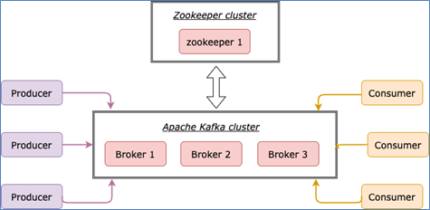

## Kafka Broker

Broker is an instance of Kafka that communicate with ZooKeeper. Each broker holds partition(s) of topic(s). Some of those partitions are leaders and others are replicas of leader partitions from other brokers.

## Role of ZooKeeper in Kafka

ZooKeeper is used to automatically select a leader for a partition. In case of any broker shutdown, an election is held, by ZooKeeper, for leader position of partitions (that went down with the broker). Also metadata like, in which broker a leader partition is living, etc., are held by ZooKeeper. Producers that stream data to topics, or Consumers that read stream data from topics, contact ZooKeeper for the nearest or less occupied broker.

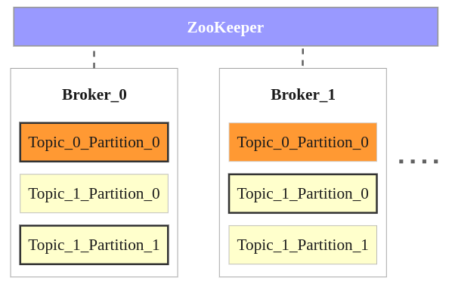

Following points could be made from the above image :

* There are two brokers, and many more can be added to the Kafka cluster.
* There are two topics Topic_0 and Topic_1.
* Topic_0 has only one partition with replication factor of 2. The partition in Broker_0 is the leader and the partition in Broker_1 is the replica.
* Topic_1 has two partitions with replication factor of 2. Partition_0 in Broker_1 and Partion_1 in Broker_0 are the leaders. Others are replicas.
* When a producer or consumers tries to connect to a topic, they connect to leaders with help from ZooKeeper.

## Producers – Apache Kafka Producer API

Producers are applications that send data streams to topics in Kafka Cluster. A producer can send the stream of records to multiple topics. Apache Kafka Producer API enables an application to become a producer.

* Tutorial – [~~Kafka Producer with Java Example~~](https://www.tutorialkart.com/apache-kafka/producer-example-in-apache-kafka/)

## Consumers – Apache Kafka Consumer API

Consumers are applications that feed on data streams from topics in Kafka Cluster. A consumer can receive stream of records from multiple topics through subscription. Apache Kafka Consumer API enables an application to become a consumer.

* Tutorial – [~~Kafka Consumer with Java Example~~](https://www.tutorialkart.com/apache-kafka/kafka-consumer-with-example-java-application/)

## Stream Processors – Apache Kafka Streams API

Stream Processors are applications that transform data streams of topics to other data streams of topics in Kafka Cluster. Apache Kafka Streams API enables an application to become a stream processor.

## Connectors – Apache Kafka Connect API

Connectors are responsible for pulling stream data from Producers or transformed data from Stream Processors and delivering stream data to Consumers or Stream Processors.

Apache Kafka Connect API helps to realize connectors.

* Tutorial – [Kafka Connector Example](https://www.tutorialkart.com/apache-kafka/apache-kafka-connector/) to import data from text file to Kafka Cluster.

## Kafka Command-Line Tools

Kafka provides Command-Line tools to start a Console Producer, Console Consumer, Console Connector etc.

Kafka Tutorial for demonstrating to start a Producer and Consumer through console.

* Tutorial – [Kafka Console Producer and Consumer Example](https://www.tutorialkart.com/apache-kafka/kafka-console-producer-and-consumer-example/)

# Installation

<https://www.tutorialkart.com/apache-kafka/install-apache-kafka-on-ubuntu/>

## Install Java

Open a terminal and run the following command :

|  |
| --- |
| $ sudo apt-get install default-jdk |

To verify the installation of java, run the following command in the terminal :

|  |
| --- |
| $ java -version |

The output should show the version of java installed, similar to below verbose:

|  |
| --- |
| kafkauser@tutorialkart:~$ java -version  openjdk version "1.8.0_131"  OpenJDK Runtime Environment (build 1.8.0_131-8u131-b11-0ubuntu1.16.04.2-b11)  OpenJDK 64-Bit Server VM (build 25.131-b11, mixed mode) |

## Setup Apache Kafka

Download the latest Apache Kafka from [<https://kafka.apache.org/downloads>] under Binary downloads.

Extract the .tgz file using tar -xzf.

Navigate to root of Apache Kafka folder and open a Terminal. Or Open a Terminal and navigate to the root directory of Apache Kafka.

|  |
| --- |
| kafka_2.11-0.11.0.0$ ls  bin config libs LICENSE logs NOTICE site-docs |

## Start Zookeeper

Apache Kafka depends on Zookeeper for cluster management. Hence, prior to starting Kafka, Zookeeper has to be started. There is no need to explicitly install Zookeeper, as it comes included with Apache Kafka.

From the root of Apache Kafka, run the following command to start Zookeeper:

|  |
| --- |
| ~$ bin/zookeeper-server-start.sh config/zookeeper.properties |

The zookeeper should be started with a similar following trace in the output.

~$ bin/zookeeper-server-start.sh config/zookeeper.properties

[2017-08-14 10:34:02,974] INFO Reading configuration from: config/zookeeper.properties (org.apache.zookeeper.server.quorum.QuorumPeerConfig)

[2017-08-14 10:34:03,035] INFO autopurge.snapRetainCount set to 3 (org.apache.zookeeper.server.DatadirCleanupManager)

[2017-08-14 10:34:03,036] INFO autopurge.purgeInterval set to 0 (org.apache.zookeeper.server.DatadirCleanupManager)

[2017-08-14 10:34:03,036] INFO Purge task is not scheduled. (org.apache.zookeeper.server.DatadirCleanupManager)

[2017-08-14 10:34:03,036] WARN Either no config or no quorum defined in config, running in standalone mode (org.apache.zookeeper.server.quorum.QuorumPeerMain)

[2017-08-14 10:34:03,061] INFO Reading configuration from: config/zookeeper.properties (org.apache.zookeeper.server.quorum.QuorumPeerConfig)

[2017-08-14 10:34:03,083] INFO Starting server (org.apache.zookeeper.server.ZooKeeperServerMain)

[2017-08-14 10:34:03,131] INFO Server environment:zookeeper.version=3.4.10-39d3a4f269333c922ed3db283be479f9deacaa0f, built on 03/23.6.07 10:13 GMT (org.apache.zookeeper.server.ZooKeeperServer)

## Start Apache Kafka Server

Open another Terminal and run the following command from the root of Apache Kafka to start Apache Kafka.

|  |
| --- |
| ~$ bin/kafka-server-start.sh config/server.properties --override delete.topic.enable=true |

Following should be the end of trace stating that Kafka server is started.

|  |
| --- |
| [2017-08-14 10:38:11,070] INFO Cluster ID = xp4xG4pbSEGnLXXW5hB8qA (kafka.server.KafkaServer)  [2017-08-14 10:38:11,076] WARN No meta.properties file under dir /tmp/kafka-logs/meta.properties (kafka.server.BrokerMetadataCheckpoint)  [2017-08-14 10:38:11,198] INFO [ThrottledRequestReaper-Fetch]: Starting (kafka.server.ClientQuotaManager$ThrottledRequestReaper)  [2017-08-14 10:38:11,199] INFO [ThrottledRequestReaper-Produce]: Starting (kafka.server.ClientQuotaManager$ThrottledRequestReaper)  [2017-08-14 10:38:11,201] INFO [ThrottledRequestReaper-Request]: Starting (kafka.server.ClientQuotaManager$ThrottledRequestReaper)  [2017-08-14 10:38:11,353] INFO Log directory '/tmp/kafka-logs' not found, creating it. (kafka.log.LogManager)  [2017-08-14 10:38:11,381] INFO Loading logs. (kafka.log.LogManager)  [2017-08-14 10:38:11,391] INFO Logs loading complete in 10 ms. (kafka.log.LogManager)  [2017-08-14 10:38:11,460] INFO Starting log cleanup with a period of 300000 ms. (kafka.log.LogManager)  [2017-08-14 10:38:11,463] INFO Starting log flusher with a default period of 9223372036854775807 ms. (kafka.log.LogManager)  [2017-08-14 10:38:11,552] INFO Awaiting socket connections on 0.0.0.0:9092. (kafka.network.Acceptor)  [2017-08-14 10:38:11,555] INFO [Socket Server on Broker 0], Started 1 acceptor threads (kafka.network.SocketServer)  [2017-08-14 10:38:11,588] INFO [ExpirationReaper-0-Produce]: Starting (kafka.server.DelayedOperationPurgatory$ExpiredOperationReaper)  [2017-08-14 10:38:11,590] INFO [ExpirationReaper-0-Fetch]: Starting (kafka.server.DelayedOperationPurgatory$ExpiredOperationReaper)  [2017-08-14 10:38:11,592] INFO [ExpirationReaper-0-DeleteRecords]: Starting (kafka.server.DelayedOperationPurgatory$ExpiredOperationReaper)  [2017-08-14 10:38:11,691] INFO [ExpirationReaper-0-topic]: Starting (kafka.server.DelayedOperationPurgatory$ExpiredOperationReaper)  [2017-08-14 10:38:11,696] INFO [ExpirationReaper-0-Heartbeat]: Starting (kafka.server.DelayedOperationPurgatory$ExpiredOperationReaper)  [2017-08-14 10:38:11,698] INFO [ExpirationReaper-0-Rebalance]: Starting (kafka.server.DelayedOperationPurgatory$ExpiredOperationReaper)  [2017-08-14 10:38:11,700] INFO Creating /controller (is it secure? false) (kafka.utils.ZKCheckedEphemeral)  [2017-08-14 10:38:11,732] INFO Result of znode creation is: OK (kafka.utils.ZKCheckedEphemeral)  [2017-08-14 10:38:11,762] INFO [GroupCoordinator 0]: Starting up. (kafka.coordinator.group.GroupCoordinator)  [2017-08-14 10:38:11,764] INFO [GroupCoordinator 0]: Startup complete. (kafka.coordinator.group.GroupCoordinator)  [2017-08-14 10:38:11,767] INFO [Group Metadata Manager on Broker 0]: Removed 0 expired offsets in 4 milliseconds. (kafka.coordinator.group.GroupMetadataManager)  [2017-08-14 10:38:11,894] INFO [ProducerId Manager 0]: Acquired new producerId block (brokerId:0,blockStartProducerId:0,blockEndProducerId:999) by writing to Zk with path version 1 (kafka.coordinator.transaction.ProducerIdManager)  [2017-08-14 10:38:11,990] INFO [Transaction Coordinator 0]: Starting up. (kafka.coordinator.transaction.TransactionCoordinator)  [2017-08-14 10:38:11,995] INFO [Transaction Marker Channel Manager 0]: Starting (kafka.coordinator.transaction.TransactionMarkerChannelManager)  [2017-08-14 10:38:11,995] INFO [Transaction Coordinator 0]: Startup complete. (kafka.coordinator.transaction.TransactionCoordinator)  [2017-08-14 10:38:12,081] INFO Will not load MX4J, mx4j-tools.jar is not in the classpath (kafka.utils.Mx4jLoader$)  [2017-08-14 10:38:12,179] INFO Creating /brokers/ids/0 (is it secure? false) (kafka.utils.ZKCheckedEphemeral)  [2017-08-14 10:38:12,192] INFO Result of znode creation is: OK (kafka.utils.ZKCheckedEphemeral)  [2017-08-14 10:38:12,194] INFO Registered broker 0 at path /brokers/ids/0 with addresses: EndPoint(arjun-VPCEH26EN,9092,ListenerName(PLAINTEXT),PLAINTEXT) (kafka.utils.ZkUtils)  [2017-08-14 10:38:12,195] WARN No meta.properties file under dir /tmp/kafka-logs/meta.properties (kafka.server.BrokerMetadataCheckpoint)  [2017-08-14 10:38:12,259] INFO Kafka version : 0.11.0.0 (org.apache.kafka.common.utils.AppInfoParser)  [2017-08-14 10:38:12,259] INFO Kafka commitId : cb8625948210849f (org.apache.kafka.common.utils.AppInfoParser)  [2017-08-14 10:38:12,261] INFO [Kafka Server 0], started (kafka.server.KafkaServer) |

## Stop Kafka and Zookeeper

* Stop the producer and consumer clients with Ctrl-C, if you haven't done so already.
* Stop the Kafka broker with Ctrl-C.
* Lastly, stop the ZooKeeper server with Ctrl-C.

If you also want to delete any data of your local Kafka environment including any events you have created along the way, run the command:

$ rm -rf /tmp/kafka-logs /tmp/zookeeper

# Create a Topic

<https://www.tutorialkart.com/apache-kafka/create-a-topic-in-apache-kafka/>

**Note**: On the Hortonworks HDP Sandbox, the broker is referenced on sandbox-hdp.hortonworks.com:6667 and not localhost:9092.

All the information about Kafka Topics is stored in Zookeeper (Cluster Manager). For each Topic, you may specify the replication factor and the number of partitions. A topic is identified by its name. All these information must be provided as arguments to the shell script, /kafka-topics.sh, while creating a new Kafka Topic.

Following is the syntax to create a topic:

./kafka-topics.sh --create --zookeeper <ZOOKEEPER_URL:PORT> --replication-factor <NO_OF_REPLICATIONS> --partitions <NO_OF_PARTITIONS> --topic <TOPIC_NAME>

where the arguments are :

| **Argument** | **Description** |
| --- | --- |
| <ZOOKEEPER_URL:PORT> | IP and port at which zookeeper is running. |
| <NO_OF_REPLICATIONS> | Number of replications that the topic has to maintain in the Kafka Cluster. |
| <NO_OF_PARTITIONS> | Number of partitions into which the Topic has to be partitioned. |
| <TOPIC_NAME> | Name of the Kafka Topic to be created. |

To create a topic in Apache Kafka, Zookeeper and Kafka have to be up and running.

### Start Zookeeper and Kafka Cluster

Navigate to the root of Kafka directory and run each of the following commands in separate terminals to start Zookeeper and Kafka Cluster.

|  |
| --- |
| $ bin/zookeeper-server-start.sh config/zookeeper.properties |
| $ bin/kafka-server-start.sh config/server.properties --override delete.topic.enable=true |

### Run kafka-topics.sh with required arguments

Kafka provides a script, kafka-topics.sh, in the <KAFKA_HOME>/bin/ directory, to create a topic in the Kafka cluster.

An example is given below :

./kafka-topics.sh --create --zookeeper localhost:2181 --replication-factor 1 --partitions 1 --topic sampleTopic

Running the script creates a Topic named sampleTopic  with 1  replication and  1  partition maintaining metadata in the Zookeeper live at localhost:2181.

Open a terminal from bin directory and run the shell script kafka-topics.sh  as shown below :

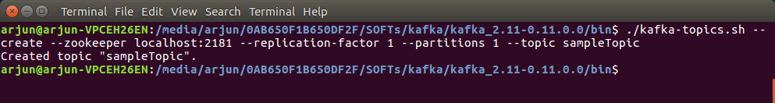

Created topic “sampleTopic”. : sampleTopic has been created.

### Error : Topic already exists.

When you try to create a duplicate topic, you could get an error saying the topic already exists. An example is given below :

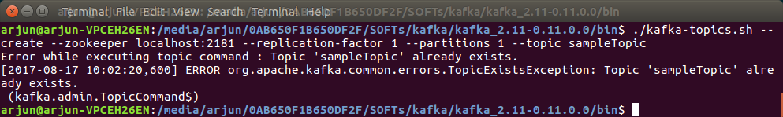

### List All Topics

To list all Kafka topics in a cluster, we can use the *bin/kafka-topics.sh*shell script bundled in the downloaded Kafka distribution. **All we have to do is to pass the *–list*option along with the information about the cluster**. For instance, we can pass the Zookeeper service address:

$ bin/kafka-topics.sh --list --zookeeper localhost:2181

Also, in order to talk to the Kafka cluster, we need to pass the Zookeeper service URL using the –zookeeper option.

$ ./bin/kafka-topics.sh --zookeeper sandbox-hdp.hortonworks.com:2181 --list

Our single-instance Kafka cluster listens to the 9092 port, so we specified “localhost:9092” as the bootstrap server. Put simply, bootstrap servers are Kafka brokers.

### Describe a Topic

$ bin/kafka-topics.sh --describe --zookeeper localhost:2181 --topic my-topic

$bin/kafka-topics.sh --describe --zookeeper localhost:2181 --topic my-topic

Topic:my-topic    PartitionCount:1 ReplicationFactor:3 Configs:

    Topic: my-topic    Partition: 0 Leader: 1 Replicas: 1,2,0 Isr: 1,2,0

* Leader: 1 meaning broker instance 1 is responsible for all reads and writes for the given partition. Reads and Writes are done by Kafka Consumers and Kafka Producers respectively.
* Replicas: 1,2,0 meaning broker instances 0, 1 and 2 are acting as nodes that replicate the log irrespective of one being a leader.
* Isr: 1,2,0 meaning broker instances 1, 2 and 0 are in-sync replicas.
* PartitionCount:1 and ReplicationFactor:3 are the details used while creating the topic.

# Kafka Console Producer and Consumer

<https://www.tutorialkart.com/apache-kafka/kafka-console-producer-and-consumer-example/>

bin/kafka-console-producer.sh and bin/kafka-console-consumer.sh in the Kafka directory are the tools that help to create a Kafka Producer and Kafka Consumer respectively.

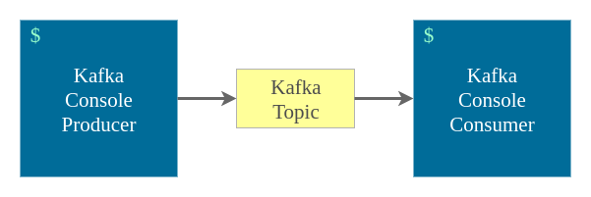

## 1. Start Zookeeper and Kafka Cluster

Navigate to the root of Kafka directory and run each of the following commands in separate terminals to start Zookeeper and Kafka Cluster respectively.

|  |
| --- |
| $ bin/zookeeper-server-start.sh config/zookeeper.properties |
| $ bin/kafka-server-start.sh config/server.properties \  --override delete.topic.enable=true |

## 2. Create a Kafka Topic

Create a topic named sampleTopic by running the following command.

$ bin/kafka-topics.sh --create --zookeeper localhost:2181 --replication-factor 1 --partitions 1 --topic sampleTopic

## 3. Create a Kafka Console Producer.

Run the following command to start a Kafka Producer, using console interface, writing to sampleTopic.

$ bin/kafka-console-producer.sh --broker-list localhost:9092 --topic sampleTopic

### On the Hortonworks HDP Sandbox:

$ bin/kafka-console-producer.sh --broker-list sandbox-hdp.hortonworks.com:6667 --topic sampleTopic

## 4. Create a Kafka Console Consumer.

Run the following command to start a Kafka Consumer, using console interface, subscribed to sampleTopic.

$ bin/kafka-console-consumer.sh --bootstrap-server localhost:9092 --topic sampleTopic --from-beginning

### On the Hortonworks HDP Sandbox:

$ bin/kafka-console-consumer.sh --bootstrap-server sandbox-hdp.hortonworks.com:6667 --topic sampleTopic --from-beginning

## 5. Send Messages

Start sending messages from the producer. Consumer would get the messages via Kafka Topic.

In the Producer terminal, type any message and press <ENTER>. The message will appear in the Consumer terminal.

## 6. More Consumer(s) – Pub/Sub

Open a new terminal window and create one more consumer:

$ bin/kafka-console-consumer.sh --bootstrap-server localhost:9092 --topic sampleTopic --from-beginning

Now, send some more messages from the Producer terminal. Bot Consumers would get the messages via Kafka Topic.

## 7. Delete a Topic

bin/kafka-topics.sh –zookeeper localhost:2181 –delete --topic sampleTopic

*(****Note****: refer to* *Troubleshooting* *section to delete topic related log and other files)*

# Using Connectors

**Terminal #1:**

$ cd $KAFKA_HOME/config

$ cp connect-standalone.properties ~

$ cp connect-file-sink.properties ~

$ cp connect-file-source.properties ~

$ cd ~

$ ~~wget http://media.sundog-soft.com/hadoop/access_log_small.txt~~

$ cat > logfile.txt

Hello there!

Welcome to Kafka.

Testing this file for File Sink and Source Connector

^C

$ cat logfile.txt

* In ~/connect-standalone.properties, change the bootstrap-server property value to sandbox-hdp.hortonworks.com:6667
* In ~/connect-file-sink.properties, change the file property value to /home/maria_dev/testlog.out.txt
* In ~/connect-file-source.properties, change the file property value to /home/maria_dev/ttt.txt
* In ~/connect-file-sink.properties and ~/connect-file-source.properties, change the topics property value to the name of a topic you created and want to use for this demo.

**Terminal #2:**

$ $KAFKA_HOME/bin/kafka-console-consumer.sh --bootstrap-server sandbox-hdp.hortonworks.com:6667 --topic connectTest1

**Terminal #1:**

$ $KAFKA_HOME/bin/connect-standalone.sh ~/connect-standalone.properties ~/connect-file-source.properties ~/connect-file-sink.properties

**Terminal #3:**

* Check the contents of the output file ttt.txt. Exit vi.
* Then, add a line to the input file and see if it appears on the consumer console and also in the output file.

$ echo “This is a lined added manually…” >> logfile.txt

# Kafka with Scala

<https://dzone.com/articles/hands-on-apache-kafka-with-scala>

<https://sparkbyexamples.com/kafka/apache-kafka-consumer-producer-in-scala/>

<https://medium.com/expedia-group-tech/apache-spark-structured-streaming-input-sources-2-of-6-6a72f798838c>

### Input Sources — Kafka

We will read data from Kafka and display it on the console. In order to read data from Kafka, first we need to set up Kafka and publish messages to a Kafka topic which we will then read into Spark Streaming.

#### Kafka Setup

You can follow below steps to setup Kafka.

* Install Kafka: We can refer to this article to install Kafka.
* Create a Kafka Topic

kafka-topics --create \  
--zookeeper localhost:2181 \  
 --replication-factor 1 \  
 --partitions 1 \  
 --topic testscala

// On Hortonworks:

kafka-topics --create \  
--zookeeper sandbox-hdp.hortonworks.com:2181 \  
 --replication-factor 1 \  
 --partitions 1 \  
 --topic testscala

* List Kafka Topic

kafka-console-producer --broker-list localhost:9092 --topic testscala

// On Hortonworks:

kafka-console-producer --broker-list sandbox-hdp.hortonworks.com:2181 --topic testscala

* Publish data to a Kafka topic, so that we can read it back into Spark Streaming

// On Hortonworks:

kafka-console-producer --broker-list sandbox-hdp.hortonworks.com:2181 --topic testscala

* Consume data from Kafka topic to verify the published data.

kafka-console-consumer --bootstrap-server localhost:9092 --topic testscala

// On Hortonworks:

kafka-console-consumer --bootstrap-server sandbox-hdp.hortonworks.com:6667 --topic testscala

#### Spark Streaming Setup

Import required libraries and create a Spark session.

// SparkStreamKafkaSource.scala

// Import Libraries

import org.apache.spark.sql.SparkSession

import org.apache.spark.sql.SparkSession

import org.apache.spark.sql.Row

import org.apache.spark.sql.functions._

// Create Spark Session

//val spark = SparkSession

// .builder()

// .master("local")

// .appName("Kafka Source")

// .getOrCreate()

val sparkSession = SparkSession.builder.appName("Kafka Source").config("spark.master", "local[*]").getOrCreate()

// Set Spark logging level to ERROR.

spark.sparkContext.setLogLevel("ERROR")

#### Create Streaming DataFrame

Read data from Kafka into Spark Streaming.

// Use this for the Custom VM

// .option("kafka.bootstrap.servers", "localhost:9092")

val initDf = spark

.readStream

.format("kafka")

.option("kafka.bootstrap.servers", "localhost:9092")

.option("subscribe", "testscala")

.load()

.select(col("value").cast("string"))

We use the kafka format to read data from Kafka. We specify the details of our locally installed Kafka bootstrap server and subscribe to Kafka topic test created above. At last, we select only data ingested into Kafka topic which is present in the value column.

#### Transformation

Perform simple word count similar to socket source example.

val wordCount = initDF

.select(explode(split(col("value"), " ")).alias("words"))

.groupBy("words")

.count()

#### Output to Console

Print the contents of streaming DataFrame to console.

wordCount

.writeStream

.outputMode("update")

.format("console")

.start()

.awaitTermination()

**Run the program:**

***On Hortonworks:***

$ spark-submit --packages org.apache.spark:spark-sql-kafka-0-10_2.11:2.3.0 ~/kafkaspark_2.11-0.1.0-SNAPSHOT.jar --class example.SparkStreamKafkaSource

**OR**

spark-shell --packages org.apache.spark:spark-sql-kafka-0-10_2.11:2.3.0

scala> :load SparkStreamKafkaSource.scala

Output looks very similar to our socket source example but this time our streaming application reads data from Kafka.

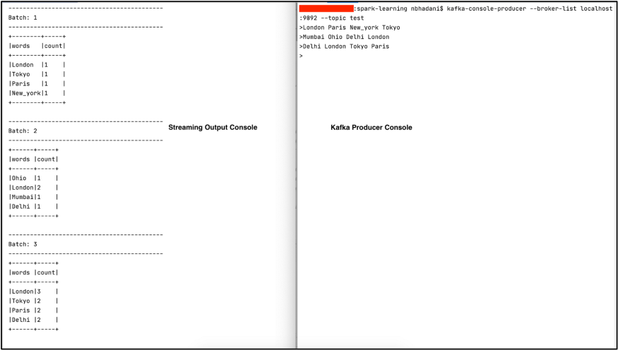

For easy reference, you can find the complete code on [**GitHub**](https://github.com/NeerajBhadani/spark-streaming/blob/master/src/main/scala/streamKafkaSource.scala).

## Output Sinks

In Spark Streaming, output sinks store results into external storage.

* Console sink: Displays the content of the DataFrame to console. In this series, we have only used console sink, refer to [previous](https://medium.com/expedia-group-tech/apache-spark-structured-streaming-first-streaming-example-1-of-6-e8f3219748ef) [posts](https://medium.com/expedia-group-tech/apache-spark-structured-streaming-input-sources-2-of-6-6a72f798838c) for details.
* File sink: Stores the contents of a DataFrame in a file within a directory. Supported file formats are csv, json, orc, and parquet.
* Kafka sink: Publishes data to a Kafka® topic.
* Foreach sink: Applies to each row of a DataFrame and can be used when writing custom logic to store data.
* ForeachBatch sink: Applies to each micro-batch of a DataFrame and also can be used when writing custom logic to store data.

It’s time to get our hands dirty; let’s discuss each output sink in detail.

### Setup

We use the same csv data files as in the input sources post of this series to create a streaming DataFrame from a file source. Please refer to [this](https://medium.com/expedia-group-tech/apache-spark-structured-streaming-input-sources-2-of-6-6a72f798838c) blog for more details on the code below.

**Source**: SparkSamples/KafkaSpark/src/main/scala/example/SparkStreamFileSource.scala

### Output sink — Console

We covered the console output sink multiple times in [a previous post](https://medium.com/expedia-group-tech/apache-spark-structured-streaming-input-sources-2-of-6-6a72f798838c).

### Output sink — File

The file sink stores the contents of a streaming DataFrame to a specified directory and format. We use initDf (created above) and apply a simple transformation before storing it to the file system.

#### Transformation

Perform a very simple transformation by selecting a few columns from initDF

val resultDf = initDF.select("Name", "Date", "Open", "Close")

#### Output to file sink

***Note****: File sink only supports append output mode.*

Store the content of DataFrame resultDf using file sink.

|  |
| --- |
| resultDf  .writeStream |
| .outputMode("append") // Filesink only support Append mode. |
| .format("csv") // supports these formats : csv, json, orc, parquet |
| .option("path", "output/filesink_output") |
| .option("header", true) |
| .option("checkpointLocation", "checkpoint/filesink_checkpoint") |
| .start() |
| .awaitTermination() |

We store the results into csv files. We also use checkpoint, which we discuss in a separate blog post. Execute the code above and check the output folder output/filesink_output .

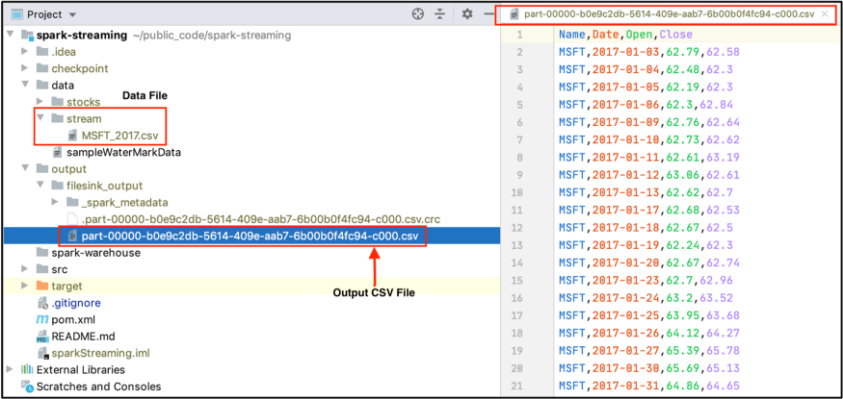

The output of our resultDf DataFrame is stored in directory output/filesink_output . Check out the selected columns (Name, Date, Open, Close) in the csv on the right side of the snapshot.

Now change the file format to json and review the output. The content of our resultDf DataFrame is stored in a json file.

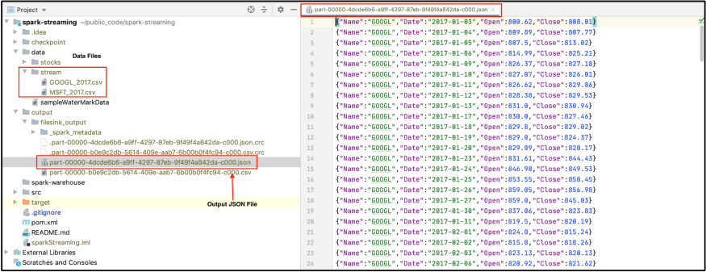

You can try orc and parquet formats as well. For easy reference, you can find the complete code on [**GitHub**](https://github.com/NeerajBhadani/spark-streaming/blob/master/src/main/scala/streamFileSink.scala).

### Output sink — Kafka

With the kafka sink, we publish the content of our streaming DataFrame to a Kafka topic using the initDf DataFrame defined in the Setup section above. You can refer to [this](https://github.com/NeerajBhadani/spark-streaming/blob/master/src/main/scala/setupKafka) to install Kafka and create a Kafka topic.

**Note**: Delete the checkpoint folders before running the code because it will not read files that have already been read. It keeps a check I the checkpoint folder and hence, you will not see results coming into the Kafka topic.

#### Transformation

Kafka expects data in a column name value, so let's concatenate all the column values and store them in one value column.

val resultDf =

initDf.withColumn("value", concat_ws("|",$"Name",$"Date",$"High",$"Low",$"Open",$"Close"))

#### Output to Kafka sink

|  |
| --- |
| resultDf  .writeStream |
| .format("kafka") |
| .option("kafka.bootstrap.servers", "localhost:9092") |
| .option("topic", "testConsumer") |
| .option("checkpointLocation", "file:///home/maria_dev/output/checkpoint/filesink_checkpoint") |
| .start() |
| .awaitTermination() |

We pass the value "kafka” to format() and specify other necessary Kafka information like "kafka.bootstrap.servers” and the "topic” to which we publish.

#### Execute our streaming application

We use the command below to consume the data which our streaming application published to Kafka.

kafka-console-consumer --bootstrap-server localhost:9092 --topic testConsumer

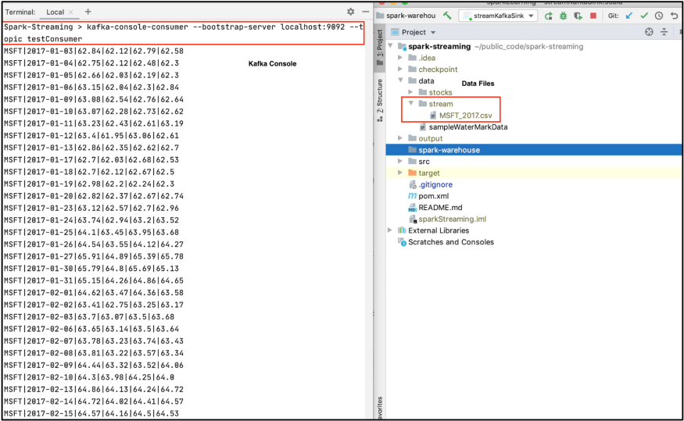

In the screenshot above, as soon as we drop a file into data/stream (a folder in the right window), we see our transformed output on Kafka’s console on the left window (which is pipe | separated). For easy reference, you can find the complete code on [**GitHub**](https://github.com/NeerajBhadani/spark-streaming/blob/master/src/main/scala/streamKafkaSink.scala).

### Output sink — foreachBatch

So far we discussed sinks where the output system was already defined like file, kafka, or console. What if we would like to store data in any arbitrary storage like a NoSQL DB (for example MongoDB) or a Relational DB (like MySQL). By using foreach and foreachBatch we can write custom logic to store data. foreach performs custom write logic on each row and foreachBatch performs custom write logic on each micro-batch.

Using foreachBatch, we write each micro-batch to storage defined in our custom logic. In this case, we store the output of our streaming application to MySQL DB.

#### Transformation

Select a few columns from initDF

val resultDf = initDF.select("Name", "Date", "open")

#### Output to foreachBatch sink

foreachBatch takes a function that expects 2 parameters, first: micro-batch as DataFrame or Dataset and second: unique id for each batch. First, create a function with custom write logic to save a micro-batch to MySQL.

|  |
| --- |
| def saveToMySql = (df: Dataset[Row], batchId: Long) => {  val url = """jdbc:mysql://localhost:3306/training""" |
|  |
| df |
| .withColumn("batchId", lit(batchId)) |
| .write.format("jdbc") |
| .option("url", url) |
| .option("dbtable", "test") |
| .option("user", "root") |
| .option("password", <mySQL_PASSWORD>) |
| .mode("append") |
| .save() |
| } |

We specified all the necessary details of MySQL DB like URL, DB name (training), Table name (test), User name (root), and Password.

Use the savetoMySQL() function to save our streaming DataFrame to MySQL.

|  |
| --- |
| resultDf  .writeStream |
| .outputMode("append") |
| .foreachBatch(saveToMySql) |
| .start() |
| .awaitTermination() |

We use the foreachBatch output sink and pass the saveToMySql() function to store data in MySQL. Start the application, ingest the data, and check the result on MySQL.

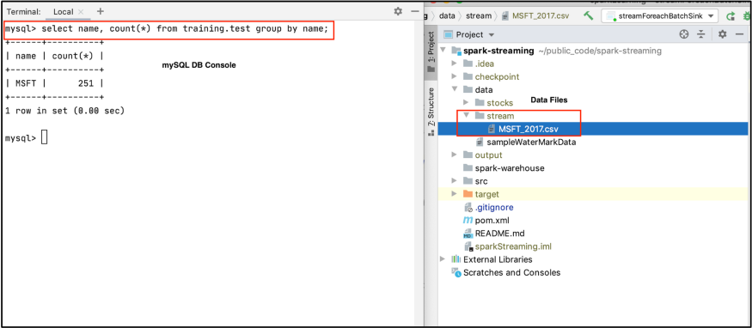

In the screenshot above, we dropped the MSFT_2017.csv file into data/stream on the right window and see the number of records for Microsoft™️ in training.test MySQL table on the left window.

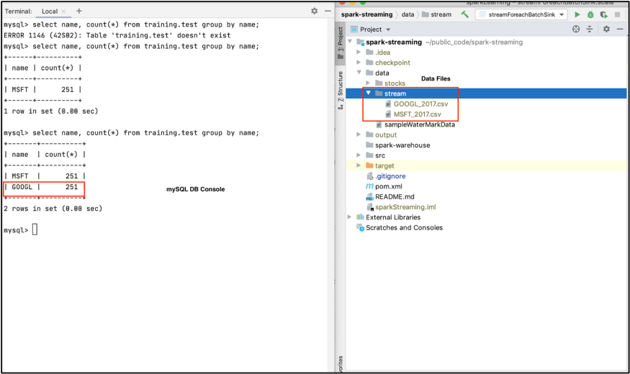

Here we drop the GOOGL_2017.csv file into data/stream on the right window and see the number of records for Google in training.test MySQL table on the left window. For easy reference, you can find the complete code on [**GitHub**](https://github.com/NeerajBhadani/spark-streaming/blob/master/src/main/scala/streamForeachBatchSink.scala).

### Output sink — foreach

If you have made it this far, great! Now we discuss our last sink for this blog post. The foreach output sink performs custom write logic to each record in a streaming DataFrame. If foreachBatch is not an option, e.g. in [continuous processing](https://spark.apache.org/docs/latest/structured-streaming-programming-guide.html#continuous-processing) mode or if a batch data writer does not exist, then we can use the foreach sink for custom write logic.

To use foreach we need to implement 3 methods (open, process, and close).

* open: function to open connection
* process: write data to the specified connection
* close: function to close connection

#### Output to foreach sink

We use initDF to read data from a File source. Then we create an instance of the ForeachWriter class and implement the open(), process(), and close() methods. We simply print records to console, so we use println() statements in the process() function.

|  |
| --- |
| val customWriter = new ForeachWriter[Row] {  override def open(partitionId: Long, version: Long) = true |
|  |
| override def process(value: Row) = { |
| println("Name : " + value.getAs("Name")) |
| println("Open : " + value.getAs("Open")) |
| println("Size : " + value.size) |
| println("Values as Seq : " + value.toSeq) |
| } |
|  |
| override def close(errorOrNull: Throwable) = {} |
| } |

Use the ForeachWriter instance defined above to write data using the foreach sink.

|  |
| --- |
| initDF  .writeStream |
| .outputMode("append") |
| .foreach(customWriter) |
| .start() |
| .awaitTermination() |

We used the foreach output sink and provide an instance of customWriter defined above. Execute the streaming application and check the result.

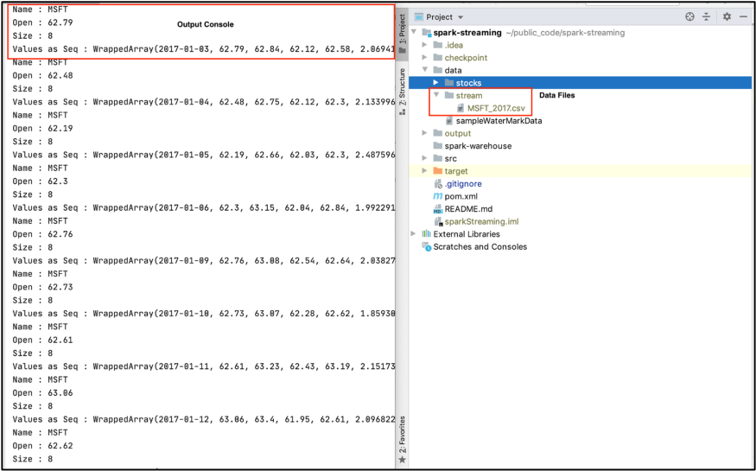

As soon as we drop the file MSFT_2017.csv into folder data/stream on the right-hand window, we see output on the left window defined by process method in the foreach output sink. For easy reference, you can find the complete code on [**GitHub**](https://github.com/NeerajBhadani/spark-streaming/blob/master/src/main/scala/streamForeachSink.scala).

# Demo: Multiple Brokers (Fault Tolerance)

## Start Multiple Brokers on a Single Machine

* Copy config/server.properties to server-1.properties and server-2.properties.

cp config/server.properties config/server-1.properties

cp config/server.properties config/server-2.properties

* Make the following changes in server-1.properties:

# Unique identifier for the broker.

broker.id=1

# Broker uses this port no. to communicate with producer and consumer.

# Increment it to the next number from the default provided.

# Don’t have to do this for brokers on separate machines.

listeners=PLAINTEXT://9093

# The broker log directory.

log.dirs=/tmp/kafka-logs-1

* Make the following changes in server-2.properties:

# Unique identifier for the broker.

broker.id=2

# Broker uses this port no. to communicate with producer and consumer.

# Increment it to the next number from the default provided.

# Don’t have to do this for brokers on separate machines.

listeners=PLAINTEXT://9094

# The broker log directory.

log.dirs=/tmp/kafka-logs-2

* Start the 2 new brokers.

bin/kafka-server-start.sh config/server-1.properties

bin/kafka-server-start.sh config/server-2.properties

* Create topic (*using the Topic Management Tool*).

bin/kafka-topics.sh --zookeeper localhost:2181 --create TestTopicXYZ --partitions 2 --replication-factor 3

* Describe the topic.

bin/kafka-topics.sh --zookeeper localhost:2181 --describe TestTopicXYZ

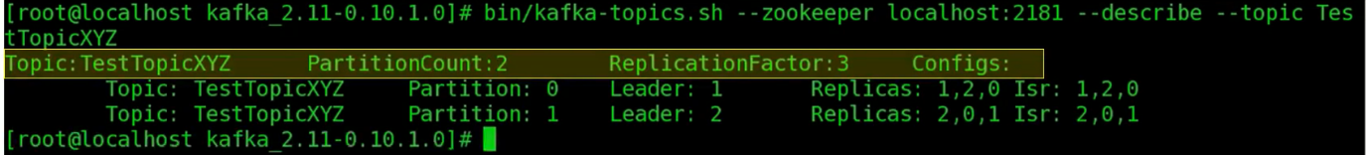

* + Displays 2 rows, 1 for each partition.
  + Partition Ids => Partition: 0 and Partition: 1
  + Leaders => For the 1st partition, Broker 1 is the leader. For the 2nd partition, broker 2 is the leader.
  + Replicas =>
    - For P1, 1 = broker, 2 = first copy, 0 = second copy.
    - For P2, 2 = broker, 0 = first copy, 1 = second copy.
  + ISR => In-sync Replicas
    - You might have 3 copies, but one or more of them may not be in-sync with the leader.
    - ISR shows the list of replicas that are in-sync with the leader.
    - Here, all 3 are in-sync.

# Checkpoints and Triggers

## Setup

Let’s start creating a streaming DataFrame (resultDF) from a file source by reading a file in each micro-batch and performing aggregations. We use this resultDF for all examples in this blog post.

|  |
| --- |
| // Import Libraries  import org.apache.spark.sql.SparkSession |
| import org.apache.spark.sql.functions._ |
| import org.apache.spark.sql.Column |
| import org.apache.spark.sql.streaming.Trigger |
| import org.apache.spark.sql.types._ |
|  |
| // Create Spark Session |
| val spark = SparkSession |
| .builder() |
| .master("local") |
| .appName("Check Point") |
| .getOrCreate() |
|  |
| // Set Spark logging level to ERROR. |
| spark.sparkContext.setLogLevel("ERROR") |
|  |
| // Define Schema |
| val schema = StructType(List( |
| StructField("Date", StringType, true), |
| StructField("Open", DoubleType, true), |
| StructField("High", DoubleType, true), |
| StructField("Low", DoubleType, true), |
| StructField("Close", DoubleType, true), |
| StructField("Adjusted Close", DoubleType, true), |
| StructField("Volume", DoubleType, true) |
| )) |
|  |
| // Extract the Name of the stock from the file name. |
| def getFileName : Column = { |
| val file_name = reverse(split(input_file_name(), "/")).getItem(0) |
| split(file_name, "_").getItem(0) |
| } |
|  |
| // Create Streaming DataFrame by reading data from socket. |
| val initDF = (spark |
| .readStream |
| .option("maxFilesPerTrigger", 1) |
| .option("header", true) |
| .schema(schema) |
| .csv("data/stream") |
| .withColumn("Name", getFileName) |
| ) |
|  |
| // Some aggregations transformation. |
| val resultDF = initDF.select("Name","Date", "Open", "High", "Low") |
| .groupBy(col("Name"), year(col("Date")).as("Year")) |
| .agg(avg("High").as("Avg")) |
| .withColumn("timestamp", current_timestamp()) |

## Checkpoints

A checkpoint helps build fault-tolerant and resilient Spark applications. In Spark Structured Streaming, it maintains intermediate state on HDFS compatible file systems to recover from failures. To specify the checkpoint in a streaming query, we use the checkpointLocation parameter.

Let’s understand this with an example. We use the resultDF streaming DataFrame defined in the Setup section above.

## Output to console

|  |
| --- |
| resultDF  .writeStream |
| .outputMode("complete") // Try with "update" mode as well. |
| .option("checkpointLocation", "checkpoint") |
| .format("console") |
| .start() |
| .awaitTermination() |

The parameter "checkpointLocation” enables the checkpoint and specifies the location where we keep checkpoint information.

Let’s execute the application and inspect the checkpoint directory.

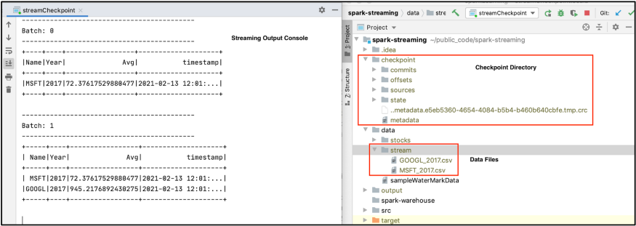

We see a directory named checkpoint with a bunch of sub-directories and files. This folder contains the state of our streaming application. E.g. the sources folder contains batches of data processed so far.

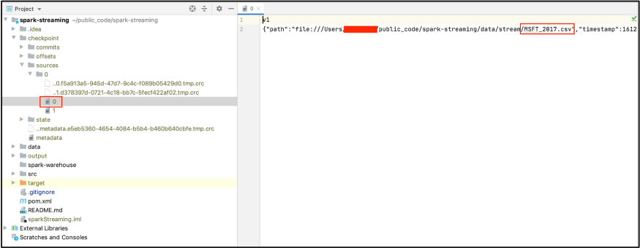

This screen shot shows the contents of the sources folder. In this example, we executed 2 batches with 1 file in each micro-batch. You can see the file MSFT_2017.csv was the first to be processed.

Now let’s interrupt our streaming application to simulate a failure and start the application again.

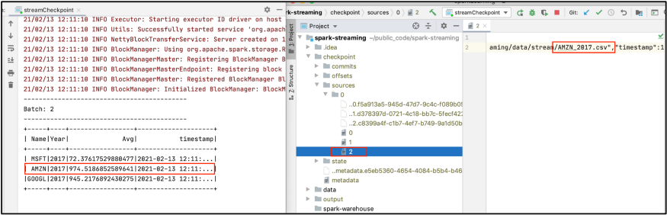

Here we see an application started withBatch: 2 since it already processed Batch: 0 and Batch: 1. We also see another file, named 2, under the sources folder corresponding to AMZN_2017.csv . This is how our application recovered from a failure. You can find the complete code on [**GitHub**](https://github.com/NeerajBhadani/spark-streaming/blob/master/src/main/scala/streamCheckpoint.scala).

**Note**: We are getting all records for MSFT, GOOGL and AMZN because we are running in complete output mode.

## Triggers

By definition, data continuously flows into a streaming system. The arrival of data is not novel enough to kick off processing. In streaming systems, we need a special event to kick off processing and that event is called a trigger. Let’s discuss a few triggers in Spark Streaming.

* **Default**: Executes a micro-batch as soon as the previous finishes.
* **Fixed interval micro-batches**: Specifies the interval when the micro-batches will execute. For example, 1 minute , 30 seconds or 1 hour etc.
* **One-time micro-batch**: Executes only one micro-batch to process all available data and then stops.

### Default

If we don’t specify any trigger, then our query will execute in micro-batch mode. The default trigger executes the next batch as soon as the previous one finishes. In our checkpoint example, we used the default trigger since we hadn't specified another.

### Fixed interval micro-batches

Micro-batches are processed after a user-specified time interval. If the processing time of the previous batch is more than the specified interval, the next batch will be executed immediately. If we set 1 minute as the interval and a micro-batch takes 35 seconds, then the next batch will trigger after waiting for 25 seconds. If a micro-batch takes 70 seconds, then the next micro-batch execute immediately after the first ends.

Time for an example. Let’s read data from a file source, 1 file in each micro-batch, and print the result to console in complete mode. This way we can compare all the processed records. We process micro-batches every 1 minute. Again, we start with the resultDF streaming DataFrame defined above.

Here is a snippet for a fixed interval trigger set at 1 minute.

|  |
| --- |
| resultDF  .writeStream |
| .outputMode("complete") |
| .trigger(Trigger.ProcessingTime("1 minute")) |
| .format("console") |
| .option("truncate", false) |
| .start() |
| .awaitTermination() |

Let’s execute our streaming application!

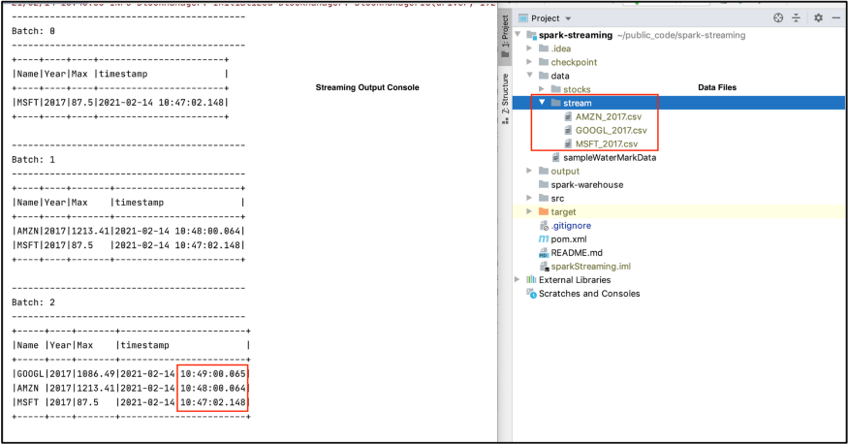

We have 3 files in the data/stream folder and specified to process 1 file in each micro-batch. Thus, we see 3 micro-batches in our output. Upon carefully inspecting the timestamp column in our output, we can see Batch: 0 was executed when we started our application and each subsequent micro-batch was executed at the start of every minute because we specified a 1 minute interval.

### One-time micro-batch

With a once trigger, our query will execute a single micro-batch. It will process all available data and then stop the application. This trigger is useful when you would like to spin-up a cluster periodically, to process all available data, and then shutdown the cluster. This may lead to considerable cost savings.

We reuse the set-up from the fixed interval trigger example, except we set the trigger strategy to once. We also reuse the familiar resultDF streaming DataFrame defined above in the Setup section. Here is the snippet for a trigger once.

|  |
| --- |
| resultDF  .writeStream |
| .outputMode("complete") |
| .trigger(Trigger.Once()) |
| .format("console") |
| .option("truncate", false) |
| .start() |
| .awaitTermination() |

Let’s execute our streaming application with the once trigger.

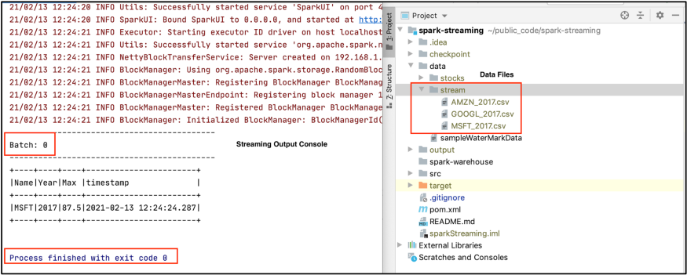

Our streaming application has only executed 1 micro-batch and completed/stopped successfully. Although we have 3 csv files in the data/stream folder, it has only processed 1 file because we specified only 1 file should be processed in each micro-batch. You can find the complete code on [**GitHub**](https://github.com/NeerajBhadani/spark-streaming/blob/master/src/main/scala/streamTriggers.scala).

# Kafka Producer and Consumer - Python and Scala (Kafka APIs)

## Simple Example - PySpark

Before you get started with the following examples, ensure that you have kafka-python installed in your system:

pip install kafka-python

OR

python3 pip install kafka-python

### Kafka Consumer

Enter the following code snippet in a python shell:

from kafka import KafkaConsumer

consumer = KafkaConsumer('sample')

for message in consumer:

print (message)

### Kafka Producer

Now that we have a consumer listening to us, we should create a producer which generates messages that are published to Kafka and thereby consumed by our consumer created earlier:

from kafka import KafkaProducer

producer = KafkaProducer(bootstrap_servers='localhost:9092')

producer.send('sample', b'Hello, World!')

producer.send('sample', key=b'message-two', value=b'This is Kafka-Python')

You can now revisit the consumer shell to check if it has received the records sent from the producer through our Kafka setup.

Thus, a simple Hello, World! in Kafka using Python.

## Kafka-Python Producer and Consumer

<https://towardsdatascience.com/3-libraries-you-should-know-to-master-apache-kafka-in-python-c95fdf8700f2>

### Producer

Each message is sent via send() **asynchronously**. When called it adds the record to a buffer and returns immediately. This allows the producer to send records to Kafka brokers in batch mode for efficiency. Asynchronization can improve speed tremendously, but we should also understand a few things:

1. In the asynchronous mode, the ordering is not guaranteed. You can’t control when each message is acknowledged (ack) by Kafka brokers.
2. It’s a good practice to have a success callback and a failure callback for the producer. For example, you can write an Info log message in the success callback and an Exception log message in the failure callback.
3. Extra messages might be sent before you receive an exception in the callback due to the fact that ordering can not be guaranteed.

If you want to avoid these problems, you can choose to send messages synchronously. The return of send() is a FutureRecordMetadata. By doing future.get(timeout=60), the producer will be blocked for at most 60 seconds until the message has been successfully acknowledged by the brokers. The drawback is the speed, it is relatively slow compared to asynchronous mode.

|  |
| --- |
| import time |
| from Kafka import KafkaProducer |
|  |
| msg = ('kafkakafkakafka' * 20).encode()[:100] |
| size = 1000000 |
| producer = KafkaProducer(bootstrap_servers='localhost:9092') |
|  |
| def kafka_python_producer_sync(producer, size): |
| for _ in range(size): |
| future = producer.send('topic', msg) |
| result = future.get(timeout=60) |
| producer.flush() |
|  |
| def success(metadata): |
| print(metadata.topic) |
|  |
| def error(exception): |
| print(exception) |
|  |
| def kafka_python_producer_async(producer, size): |
| for _ in range(size): |
| producer.send('topic', msg).add_callback(success).add_errback(error) |
| producer.flush() |

### Consumer

The consumer instance is a Python iterator. The core of the consumer class is poll() method. It allows the consumer to keep pulling messages from the topic. One of its input parameters timeout_ms is default to 0, which means the method returns immediately with any records that are pulled and available in the buffer. You can increase timeout_ms to return a larger batch.

By default, each consumer is an infinite listener, so it won’t stop until the program breaks. But on the other side, you are allowed to stop the consumer based on the message you received. For example, you can exit the loop and close the consumer if it reaches to a certain offset.

The consumer can also be assigned to a partition or multiple partitions from multiple topics.

|  |
| --- |
| from kafka import KafkaConsumer, TopicPartition |
| size = 1000000 |
|  |
| consumer1 = KafkaConsumer(bootstrap_servers='localhost:9092') |
| def kafka_python_consumer1(): |
| consumer1.subscribe(['topic1']) |
| for msg in consumer1: |
| print(msg) |
|  |
| consumer2 = KafkaConsumer(bootstrap_servers='localhost:9092') |
| def kafka_python_consumer2(): |
| consumer2.assign([TopicPartition('topic1', 1), TopicPartition('topic2', 1)]) |
| for msg in consumer2: |
| print(msg) |
|  |
| consumer3 = KafkaConsumer(bootstrap_servers='localhost:9092') |
| def kafka_python_consumer3(): |
| partition = TopicPartition('topic3', 0) |
| consumer3.assign([partition]) |
| last_offset = consumer3.end_offsets([partition])[partition] |
| for msg in consumer3: |
| if msg.offset == last_offset - 1: |
| break |

## Kafka-Scala Producer and Consumer

<https://sparkbyexamples.com/kafka/apache-kafka-consumer-producer-in-scala/>

### Producer

Each message is sent via send() **asynchronously**. When called it adds the record to a buffer and returns immediately. This allows the producer to send records to Kafka brokers in batch mode for efficiency. Asynchronization can improve speed tremendously, but we should also understand a few things:

1. In the asynchronous mode, the ordering is not guaranteed. You can’t control when each message is acknowledged (ack) by Kafka brokers.
2. It’s a good practice to have a success callback and a failure callback for the producer. For example, you can write an Info log message in the success callback and an Exception log message in the failure callback.
3. Extra messages might be sent before you receive an exception in the callback due to the fact that ordering can not be guaranteed.

If you want to avoid these problems, you can choose to send messages synchronously. The return of send() is a FutureRecordMetadata. By doing future.get(timeout=60), the producer will be blocked for at most 60 seconds until the message has been successfully acknowledged by the brokers. The drawback is the speed, it is relatively slow compared to asynchronous mode.

// KafkaProducerApp.scala

// $KAFKA_HOME/bin/kafka-topics.sh --create --zookeeper localhost:2181 --replication-factor 1 --partitions 1 --topic text_topic

// $KAFKA_HOME/bin/kafka-topics.sh --create --zookeeper sandbox-hdp.hortonworks.com:2181 --replication-factor 1 --partitions 1 --topic text_topic

package example

import java.util.Properties

import org.apache.kafka.clients.producer.{KafkaProducer, ProducerRecord}

object KafkaProducerApp extends App {

  val props: Properties = new Properties()

  //props.put("bootstrap.servers","localhost:9092")

  props.put("bootstrap.servers", "sandbox-hdp.hortonworks.com:6667")

  props.put("key.serializer","org.apache.kafka.common.serialization.StringSerializer")

  props.put("value.serializer","org.apache.kafka.common.serialization.StringSerializer")

  // The acks config controls the criteria under which requests are considered complete.

  // The "all" setting we have specified will result in blocking on the full commit of the record,

  // the slowest but most durable setting.

  props.put("acks", "all")

  val producer = new KafkaProducer[String, String](props)

  val topic = "text_topic"

  try {

    for (i <- 0 to 15) {

      val record = new ProducerRecord[String, String](

        topic,

        i.toString,

        "This is item #" + i

      )

      val metadata = producer.send(record)

      printf(

        s"sent record(key=%s value=%s) " +

          "meta(partition=%d, offset=%d)\n",

        record.key(),

        record.value(),

        metadata.get().partition(),

        metadata.get().offset()

      )

    }

  } catch {

    case e: Exception => e.printStackTrace()

  } finally {

    producer.close()

  }

}

### Consumer

The consumer instance is a Python iterator. The core of the consumer class is poll() method. It allows the consumer to keep pulling messages from the topic. One of its input parameters timeout_ms is default to 0, which means the method returns immediately with any records that are pulled and available in the buffer. You can increase timeout_ms to return a larger batch.

Th poll() statement is the most important line. The same way that sharks must keep moving or they die, consumers must keep polling Kafka or they will be considered dead and the partitions they are consuming will be handed to another consumer in the group to continue consuming. The parameter we pass poll(), is a timeout interval and controls how long poll() will block if data is not available in the consumer buffer. If this is set to 0, poll() will return immediately; otherwise, it will wait for the specified number of milliseconds for data to arrive from the broker.

Try to make sure that whatever processing we do between iterations is fast and efficient.

By default, each consumer is an infinite listener, so it won’t stop until the program breaks. But on the other side, you are allowed to stop the consumer based on the message you received. For example, you can exit the loop and close the consumer if it reaches to a certain offset.

The consumer can also be assigned to a partition or multiple partitions from multiple topics.

// KafkaConsumerSubscribeApp.scala

package example

import java.util.{Collections, Properties}

import java.util.regex.Pattern

import org.apache.kafka.clients.consumer.KafkaConsumer

import scala.collection.JavaConverters._

object KafkaConsumerSubscribeApp extends App {

  val props: Properties = new Properties()

  props.put("group.id", "test") // $KAFKA_HOME/config/consumer.properties

  // props.put("bootstrap.servers","localhost:9092")

  props.put("bootstrap.servers", "sandbox-hdp.hortonworks.com:6667")

  props.put("key.deserializer","org.apache.kafka.common.serialization.StringDeserializer")

  props.put("value.deserializer","org.apache.kafka.common.serialization.StringDeserializer")

  props.put("enable.auto.commit", "true")

  props.put("auto.commit.interval.ms", "1000")

  val consumer = new KafkaConsumer(props)

  val topics = List("text_topic")

  try {

    consumer.subscribe(topics.asJava)

    while (true) {

      val records = consumer.poll(10)

      for (record <- records.asScala) {

        println(

          "Topic: " + record.topic() +

            ",Key: " + record.key() +

            ",Value: " + record.value() +

            ", Offset: " + record.offset() +

            ", Partition: " + record.partition()

        )

      }

    }

  } catch {

    case e: Exception => e.printStackTrace()

  } finally {

    consumer.close()

  }

}

**Run as:**

***On Hortonworks:***

***Terminal #1***:

$ spark-submit --packages org.apache.spark:spark-sql-kafka-0-10_2.11:2.3.0 ~/kafkaspark_2.11-0.1.0-SNAPSHOT.jar --class example.KafkaProducerApp

***Terminal #2***:

$ spark-submit --packages org.apache.spark:spark-sql-kafka-0-10_2.11:2.3.0 ~/kafkaspark_2.11-0.1.0-SNAPSHOT.jar --class example.KafkaConsumerSubscribeApp

**OR**

***Terminal #1***:

$ spark-shell --packages org.apache.spark:spark-sql-kafka-0-10_2.11:2.3.0

scala> :load KafkaProducerApp.scala

***Terminal #2***:

$ spark-shell --packages org.apache.spark:spark-sql-kafka-0-10_2.11:2.3.0

scala> :load KafkaConsumerSubscribeApp.scala

# Spark Streaming

<https://data-flair.training/blogs/apache-spark-streaming-tutorial/>

<https://spark.apache.org/docs/latest/streaming-programming-guide.html>

Spark Streaming is an extension of the core Spark API that enables scalable, high-throughput, fault-tolerant stream processing of live data streams. Data can be ingested from many sources like Kafka, Kinesis, or TCP sockets, and can be processed using complex algorithms expressed with high-level functions like map, reduce, join and window. Finally, processed data can be pushed out to filesystems, databases, and live dashboards. In fact, you can apply Spark’s machine learning and graph processing algorithms on data streams.

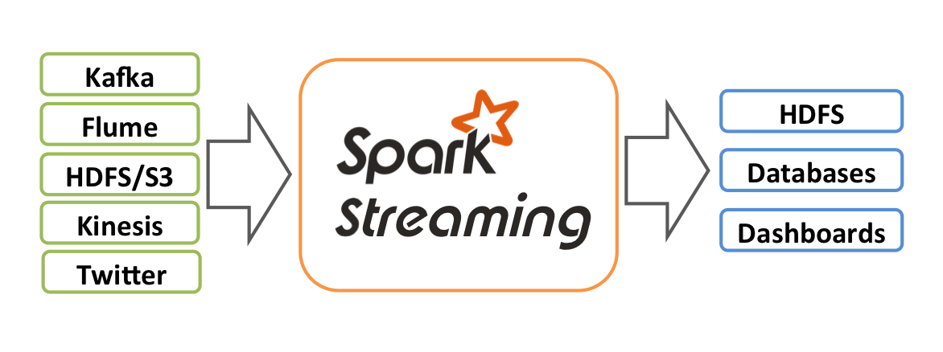

Internally, it works as follows. Spark Streaming receives live input data streams and divides the data into batches, which are then processed by the Spark engine to generate the final stream of results in batches.

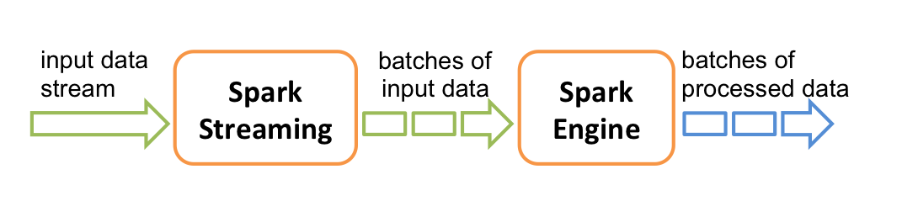

Spark Streaming provides a high-level abstraction called discretized stream or DStream, which represents a continuous stream of data. DStreams can be created either from input data streams from sources such as Kafka, and Kinesis, or by applying high-level operations on other DStreams. Internally, a DStream is represented as a sequence of RDDs.

This guide shows you how to start writing Spark Streaming programs with DStreams. You can write Spark Streaming programs in Scala, Java or Python (introduced in Spark 1.2), all of which are presented in this guide. You will find tabs throughout this guide that let you choose between code snippets of different languages.

Note: There are a few APIs that are either different or not available in Python. Throughout this guide, you will find the tag **Python API** highlighting these differences.

## A Quick Example - Python

Before we go into the details of how to write your own Spark Streaming program, let’s take a quick look at what a simple Spark Streaming program looks like. Let’s say we want to count the number of words in text data received from a data server listening on a TCP socket. All you need to do is as follows.

First, we import StreamingContext, which is the main entry point for all streaming functionality. We create a local StreamingContext with two execution threads, and batch interval of 1 second.

**from** **pyspark** **import** SparkContext

**from** **pyspark.streaming** **import** StreamingContext

*# Create a local StreamingContext with two working thread and batch interval of 1 second*

sc = SparkContext("local[2]", "NetworkWordCount")

ssc = StreamingContext(sc, 1)

Using this context, we can create a DStream that represents streaming data from a TCP source, specified as hostname (e.g. localhost) and port (e.g. 9999).

*# Create a DStream that will connect to hostname:port, like localhost:9999*

lines = ssc.socketTextStream("localhost", 9999)

This lines DStream represents the stream of data that will be received from the data server. Each record in this DStream is a line of text. Next, we want to split the lines by space into words.

*# Split each line into words*

words = lines.flatMap(**lambda** line: line.split(" "))

flatMap is a one-to-many DStream operation that creates a new DStream by generating multiple new records from each record in the source DStream. In this case, each line will be split into multiple words and the stream of words is represented as the words DStream. Next, we want to count these words.

*# Count each word in each batch*

pairs = words.map(**lambda** word: (word, 1))

wordCounts = pairs.reduceByKey(**lambda** x, y: x + y)

*# Print the first ten elements of each RDD generated in this DStream to the console*

wordCounts.pprint()

The words DStream is further mapped (one-to-one transformation) to a DStream of (word, 1) pairs, which is then reduced to get the frequency of words in each batch of data. Finally, wordCounts.pprint() will print a few of the counts generated every second.

Note that when these lines are executed, Spark Streaming only sets up the computation it will perform when it is started, and no real processing has started yet. To start the processing after all the transformations have been setup, we finally call

ssc.start() *# Start the computation*

ssc.awaitTermination() *# Wait for the computation to terminate*

The complete code can be found in the Spark Streaming example [NetworkWordCount](https://github.com/apache/spark/blob/v3.1.2/examples/src/main/python/streaming/network_wordcount.py).

If you have already [downloaded](https://spark.apache.org/docs/latest/index.html#downloading) and [built](https://spark.apache.org/docs/latest/index.html#building) Spark, you can run this example as follows. You will first need to run Netcat (a small utility found in most Unix-like systems) as a data server by using

$ nc **-lk** 9999

Then, in a different terminal, you can start the example by using

$ ./bin/spark-submit examples/src/main/python/streaming/network_wordcount.py localhost 9999

Then, any lines typed in the terminal running the netcat server will be counted and printed on screen every second. It will look something like the following.

|  |  |
| --- | --- |
| *# TERMINAL 1:*  *# Running Netcat*  $ nc **-lk** 9999  hello world  ... | *# TERMINAL 2: RUNNING NetworkWordCount*  $ ./bin/run-example streaming.NetworkWordCount localhost 9999  ...  **-------------------------------------------**  Time: 1357008430000 ms  **-------------------------------------------**  (hello,1)  (world,1)  ... |

### Process

After a context is defined, you have to do the following.

1. Define the input sources by creating input DStreams.
2. Define the streaming computations by applying transformation and output operations to DStreams.
3. Start receiving data and processing it using streamingContext.start().
4. Wait for the processing to be stopped (manually or due to any error) using streamingContext.awaitTermination().
5. The processing can be manually stopped using streamingContext.stop().

### Points to remember:

* Once a context has been started, no new streaming computations can be set up or added to it.
* Once a context has been stopped, it cannot be restarted.
* Only one StreamingContext can be active in a JVM at the same time.
* stop() on StreamingContext also stops the SparkContext. To stop only the StreamingContext, set the optional parameter of stop() called stopSparkContext to false.
* A SparkContext can be re-used to create multiple StreamingContexts, as long as the previous StreamingContext is stopped (without stopping the SparkContext) before the next StreamingContext is created.

### Full code: NetworkWordCount.py:

#NetworkWordcount.py

from pyspark import SparkContext

from pyspark.streaming import StreamingContext

# Create a local StreamingContext with two working thread and batch interval of 1 second

# local[2] means the master requires 2 cores.

sc = SparkContext("local[2]", "NetworkWordCount")

ssc = StreamingContext(sc, 10)

# Create a DStream that will connect to hostname:port, like localhost:9999

lines = ssc.socketTextStream("localhost", 9999)

# Split each line into words

words = lines.flatMap(lambda line: line.split(" "))

# Count each word in each batch

pairs = words.map(lambda word: (word, 1))

wordCounts = pairs.reduceByKey(lambda x, y: x + y)

# Print the first ten elements of each RDD generated in this DStream to the console

wordCounts.pprint()

ssc.start() # Start the computation

ssc.awaitTermination() # Wait for the computation to terminate

You will first need to run Netcat (*a small utility found in most Unix-like systems*) as a data server by using (*on a separate terminal*) as follows:

$ nc -lk 9999

Then, in a different terminal, you can start the example by using:

./bin/spark-submit ./NetworkWordCount.py localhost 9999

## A Quick Example – Scala

<https://spark.apache.org/docs/latest/streaming-programming-guide.html>

Before we go into the details of how to write your own Spark Streaming program, let’s take a quick look at what a simple Spark Streaming program looks like. Let’s say we want to count the number of words in text data received from a data server listening on a TCP socket. All you need to do is as follows.

First, we import StreamingContext, which is the main entry point for all streaming functionality. We create a local StreamingContext with two execution threads, and batch interval of 1 second.

**Example: NetworkWordCount.scala (*same as the Python example, but in Scala*):**

// networkwordcount.scala

import org.apache.spark._

import org.apache.spark.streaming._

import org.apache.spark.streaming.StreamingContext._ // not necessary since Spark 1.3

// Create a local StreamingContext with two working thread and batch interval of 1 second.

// The master requires 2 cores to prevent from a starvation scenario.

//val conf = new SparkConf().setMaster("local[2]").setAppName("NetworkWordCount")

//val ssc = new StreamingContext(conf, Seconds(1))

val ssc = new StreamingContext(sc, Seconds(1))

// Create a DStream that will connect to hostname:port, like localhost:9999

val lines = ssc.socketTextStream("localhost", 9999)

// Split each line into words

val words = lines.flatMap(_.split(" "))

// Count each word in each batch

val pairs = words.map(word => (word, 1))

val wordCounts = pairs.reduceByKey(_ + _)

// Print the first ten elements of each RDD generated in this DStream to the console

wordCounts.print()

ssc.start() // Start the computation

ssc.awaitTermination() // Wait for the computation to terminate

ssc.stop() // Stop the computation.

You will first need to run Netcat (a small utility found in most Unix-like systems) as a data server by using (*on a separate terminal*) as follows:

$ nc -lk 9999

Then, in a different terminal, you can start the example by using:

$ spark-shell --master local[2]

OR

$ spark-shell --packages org.apache.spark:spark-sql-kafka-0-10_2.12:3.1.2 --master local[2]

Then in the Scala shell:

scala> :load networkwordcount.scala

Then, in the terminal where you started the Netcat server, type some words and press <ENTER>. You should see the results in the Scala shell. Try a few lines of words. Exit out of the shell.

### Process

After a context is defined, you have to do the following.

1. Define the input sources by creating input DStreams.
2. Define the streaming computations by applying transformation and output operations to DStreams.
3. Start receiving data and processing it using streamingContext.start().
4. Wait for the processing to be stopped (manually or due to any error) using streamingContext.awaitTermination().
5. The processing can be manually stopped using streamingContext.stop().

### Points to remember

* Once a context has been started, no new streaming computations can be set up or added to it.
* Once a context has been stopped, it cannot be restarted.
* Only one StreamingContext can be active in a JVM at the same time.
* stop() on StreamingContext also stops the SparkContext. To stop only the StreamingContext, set the optional parameter of stop() called stopSparkContext to false.
* A SparkContext can be re-used to create multiple StreamingContexts, as long as the previous StreamingContext is stopped (without stopping the SparkContext) before the next StreamingContext is created.

**Same Network Word Count example executed using spark-submit**: **nwwordcount.scala**:

Make sure the Netcat server is running. If not, start it again in a separate terminal.

// nwordcount.scala

package org.apache.spark.examples.streaming

import org.apache.spark.SparkConf

import org.apache.spark.storage.StorageLevel

import org.apache.spark.streaming.{Seconds, StreamingContext}

/**

* Counts words in UTF8 encoded, ‘\n’ delimited text received from the network every second.

*

* Usage: NetworkWordCount <hostname> <port>

* <hostname> and <port> describe the TCP server that Spark Streaming would connect to receive data.

*

* To run this on your local machine, you need to first run a Netcat server

* `$ nc -lk 9999`

* and then run the example

* `$ bin/run-example org.apache.spark.examples.streaming.NetworkWordCount localhost 9999`

*/

object NetworkWordCount {

def main(args: Array[String]) {

if (args.length < 2) {

System.err.println("Usage: NetworkWordCount <hostname> <port>")

System.exit(1)

}

StreamingExamples.setStreamingLogLevels()

// Create the context with a 1 second batch size

val sparkConf = new SparkConf().setAppName("NetworkWordCount")

val ssc = new StreamingContext(sparkConf, Seconds(1))

// Create a socket stream on target ip:port and count the

// words in input stream of \n delimited text (eg. generated by ‘nc’)

// Note that no duplication in storage level only for running locally.

// Replication necessary in distributed scenario for fault tolerance.

val lines = ssc.socketTextStream(args(0), args(1).toInt, StorageLevel.MEMORY_AND_DISK_SER)

val words = lines.flatMap(_.split(" "))

val wordCounts = words.map(x => (x, 1)).reduceByKey(_ + _)

wordCounts.print()

ssc.start()

ssc.awaitTermination()

}

}

Run this program from the prompt as follows:

$ ~/spark/bin/run-example --packages org.apache.spark:spark-sql-kafka-0-10_2.12:3.1.2 --master local[2] streaming.NetworkWordCount localhost 9999

Then, in the terminal where you started the Netcat server, type some words and press <ENTER>. You should see the results in the Scala shell. Try a few lines of words.

**Another small example of basic Spark Streaming using Scala**:

Start the Spark Shell as follows:

$ spark-shell --packages org.apache.spark:spark-sql-kafka-0-10_2.12:3.1.2

And then run this code from the shell as follows:

scala>:load words.scala

**words.scala**:

// words.scala

import org.apache.spark.rdd.RDD

import org.apache.spark.sql.SparkSession

//object SparkTellDifference {

// set up Spark Context

val sparkSession = SparkSession.builder.appName("Simple Application").config("spark.master", "local[*]").getOrCreate()

val sparkContext = sparkSession.sparkContext

sparkContext.setLogLevel("ERROR")

// step 0: establish source data sets

val stringsToAnalyse: List[String] = List("Can you tell the difference between Scala & Spark?", "You will have to look really closely!")

val stringsToAnalyseRdd: RDD[String] = sparkContext.parallelize(stringsToAnalyse)

// step 1: split sentences into words

val wordsList: List[String] = stringsToAnalyse.flatMap (_.split(" "))

val wordsListRdd: RDD[String] = stringsToAnalyseRdd.flatMap (_.split(" "))

// step 2: convert words to lists of chars, create (key,value) pairs.

val lettersList: List[(Char,Int)] = wordsList.flatMap (_.toList).map ((_,1))

val lettersListRdd: RDD[(Char,Int)] = wordsListRdd.flatMap (_.toList).map ((_,1))

// step 3: count letters

val lettersCount: List[(Char, Int)] = lettersList.groupBy(_._1).mapValues(_.size).toList

val lettersCountRdd: RDD[(Char, Int)] = lettersListRdd.reduceByKey(_ + _)

// step 4: get Top 5 letters in our sentences.

val lettersCountTop5: List[(Char, Int)] = lettersCount.sortBy(- _._2).take(5)

val lettersCountTop5FromRdd: List[(Char, Int)] = lettersCountRdd.sortBy(_._2, ascending = false).take(5).toList

// the results

println(s"Top 5 letters by Scala native: ${lettersCountTop5}")

println(s"Top 5 letters by Spark: ${lettersCountTop5FromRdd}")

// we are done

//sparkSession.stop()

//}

More examples: <https://spark.apache.org/docs/latest/structured-streaming-programming-guide.html>

## Spark Streaming with Kafka (Python)

**Note**: KafkaUtils does not work since Spark Streaming was deprecated as of Spark 2.4. You should be using Structured Streaming instead via pyspark.sql modules

**Code: kafka_wordcount.py**

#kafka_wordcount.py

from __future__ import print_function

import sys

from pyspark import SparkContext

from pyspark.streaming import StreamingContext

from pyspark.streaming.kafka import KafkaUtils

if __name__ == "__main__":

if len(sys.argv) != 3:

print("Usage: kafka_wordcount.py <zk> <topic>", file=sys.stderr)

exit(-1)

sc = SparkContext(appName="PythonStreamingKafkaWordCount")

ssc = StreamingContext(sc, 10)

zkQuorum, topic = sys.argv[1:]

kvs = KafkaUtils.createStream(ssc, zkQuorum, "spark-streaming-consumer", {topic: 1})

lines = kvs.map(lambda x: x[1])

counts = lines.flatMap(lambda line: line.split(" ")) \

.map(lambda word: (word, 1)) \

.reduceByKey(lambda a, b: a+b)

counts.pprint()

ssc.start()

ssc.awaitTermination()

Then, in 3 different terminals ,execute these commands:

***# Terminal #1***

$KAFKA_HOME/bin/kafka-console-producer.sh --broker-list sandbox-hdp.hortonworks.com:6667 --topic test

***# Terminal #2***

$KAFKA_HOME/bin/kafka-console-consumer.sh --bootstrap-server sandbox-hdp.hortonworks.com:6667 --topic test --from-beginning

***# Terminal #3***

spark-submit --packages org.apache.spark:spark-streaming-kafka-0-8-assembly_2.11:2.4.4 kafka_wordcount.py localhost:2181 test

*The jar file spark-streaming-kafka-0-8-assembly_2.11-2.4.4.jar is also available in the /home/maria_dev folder.*

In terminal #1, enter some text lines and see them being printed on terminals #2 and#3.

# Structured Streaming:

**Note**: Not working on Hortonworkds sandbox. Show on Ubuntu VM.

**Refer to Structured Streaming section in “Scala Tutorial.doc”.**

<https://mtpatter.github.io/bilao/notebooks/html/01-spark-struct-stream-kafka.html>

<https://sandeepkattepogu.medium.com/python-spark-transformations-on-kafka-data-8a19b498b32c>

<https://towardsdatascience.com/enabling-streaming-data-with-spark-structured-streaming-and-kafka-93ce91e5b435>

<https://spark.apache.org/docs/2.2.0/sql-programming-guide.html>

<https://wikitech.wikimedia.org/wiki/Event_Platform/EventStreams>

<https://www.youtube.com/watch?v=zVgPNjSjua0>

<https://www.youtube.com/watch?v=zVgPNjSjua0>

<https://mtpatter.github.io/bilao/notebooks/html/01-spark-struct-stream-kafka.html>

<https://sandeepkattepogu.medium.com/python-spark-transformations-on-kafka-data-8a19b498b32c>

<https://towardsdatascience.com/enabling-streaming-data-with-spark-structured-streaming-and-kafka-93ce91e5b435>

<https://spark.apache.org/docs/2.2.0/sql-programming-guide.html>

<https://wikitech.wikimedia.org/wiki/Event_Platform/EventStreams>

<https://www.youtube.com/watch?v=zVgPNjSjua0>

<https://www.youtube.com/watch?v=zVgPNjSjua0>

<https://stackoverflow.com/questions/62350425/what-is-the-optimal-way-to-read-from-multiple-kafka-topics-and-write-to-differen>

Working with streaming data is a little different from working with batch data. With streaming data, we will never have complete data for analysis, as data is continuously coming in. Apache Spark provides a streaming API to analyze streaming data in pretty much the same way we work with batch data. Apache Spark Structured Streaming is built on top of the Spark-SQL API to leverage its optimization. Spark Streaming is a processing engine to process data in real-time from sources and output data to external storage systems.

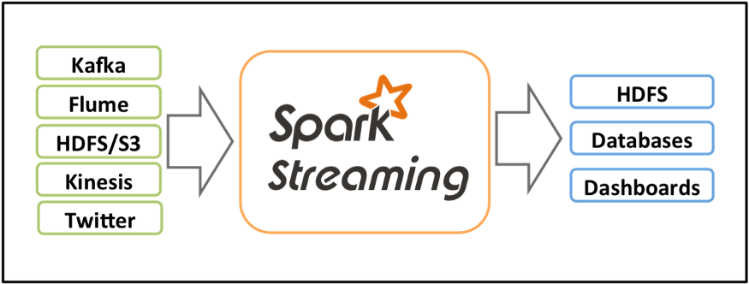

Spark Streaming has 3 major components: input sources, streaming engine, and sink. Input sources generate data like Kafka, Flume, HDFS/S3, etc. Spark Streaming engine processes incoming data from various input sources. Sinks store processed data from Spark Streaming engine like HDFS, relational databases, or NoSQL datastores.

Let’s conceptualise Spark Streaming data as an unbounded table where new data will always be appended at the end of the table.

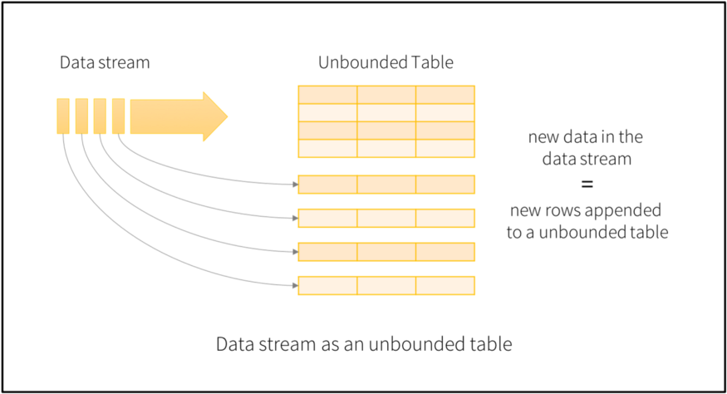

Spark will process data in micro-batches which can be defined by triggers. For example, let’s say we define a trigger as 1 second, this means Spark will create micro-batches every second and process them accordingly. We will discuss triggers in a separate blog.

## Output modes

After processing the streaming data, Spark needs to store it somewhere on persistent storage. Spark uses various output modes to store the streaming data.

* **Append Mode**: In this mode, Spark will output only newly processed rows since the last trigger.
* **Update Mode**: In this mode, Spark will output only updated rows since the last trigger. If we are not using aggregation on streaming data (meaning previous records can’t be updated) then it will behave similarly to append mode.
* **Complete Mode**: In this mode, Spark will output all the rows it has processed so far.

### How does it work?

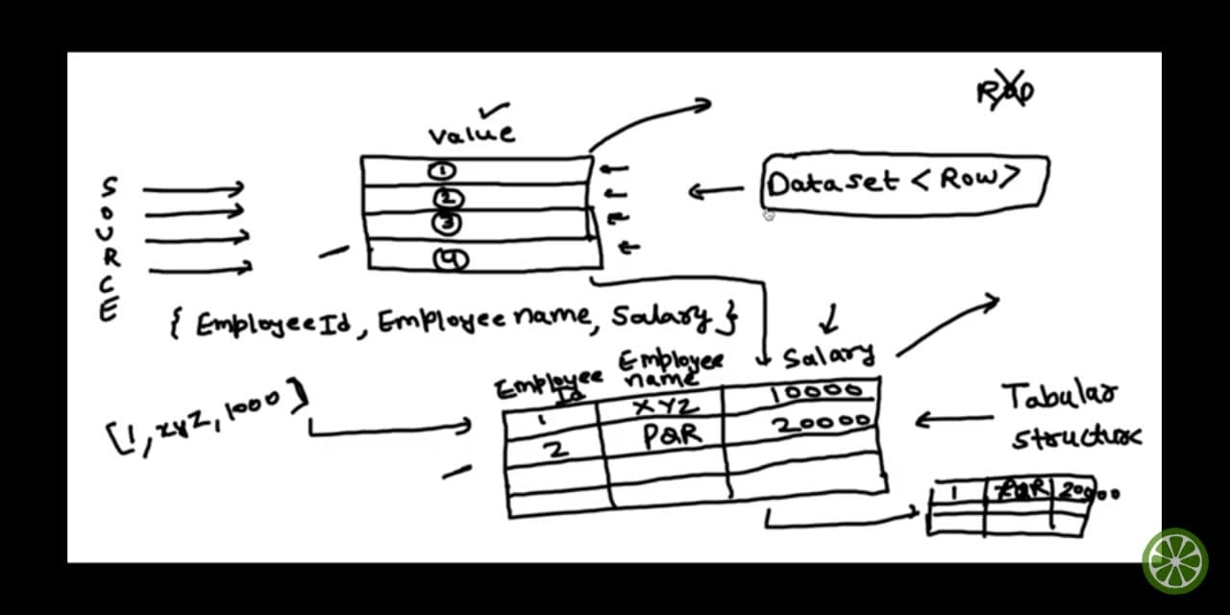

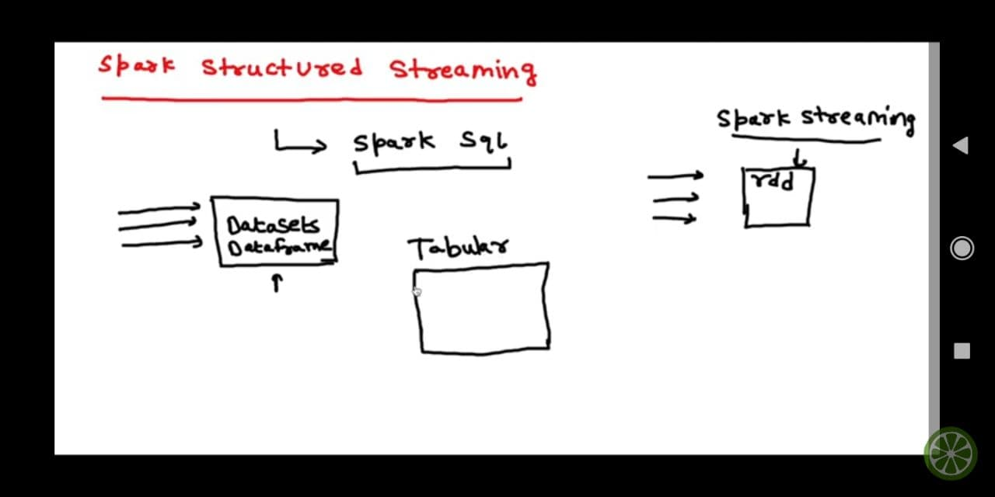

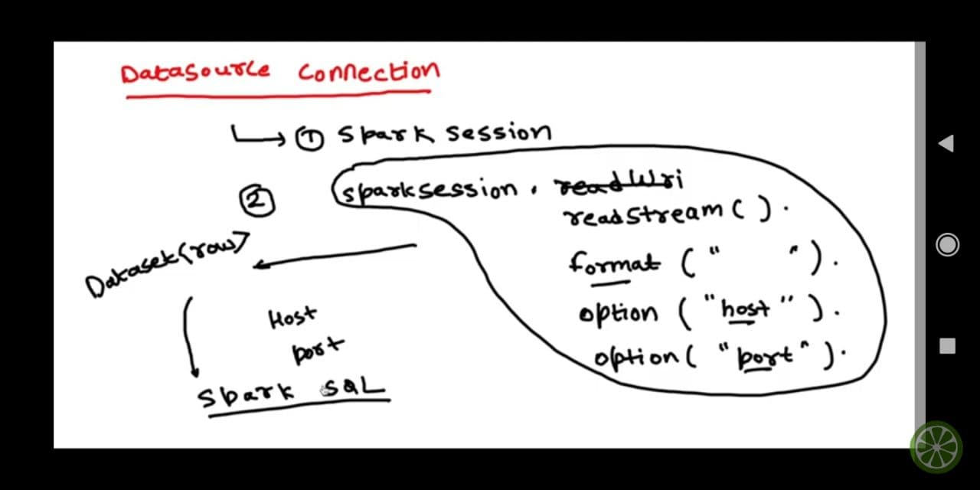

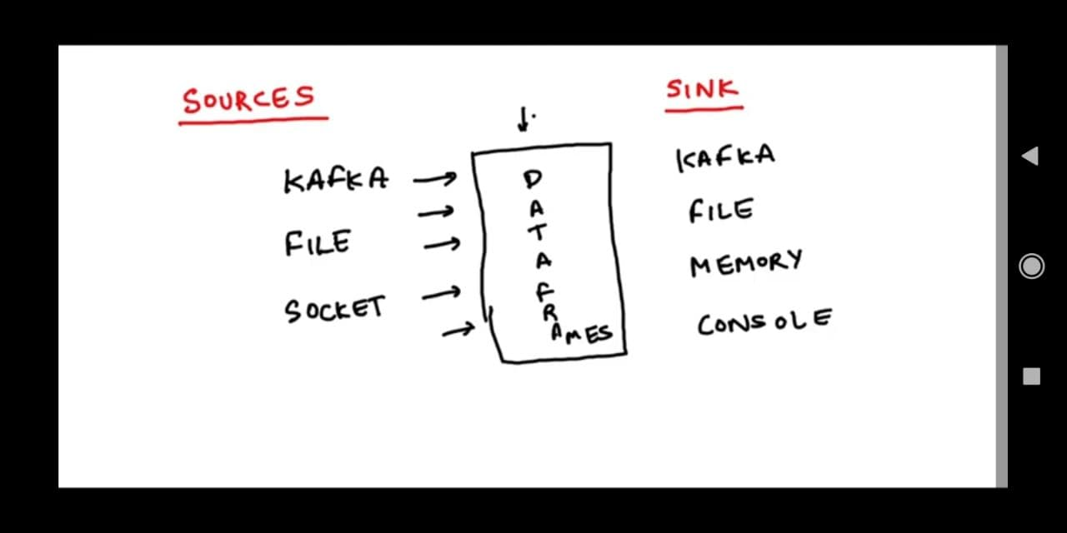

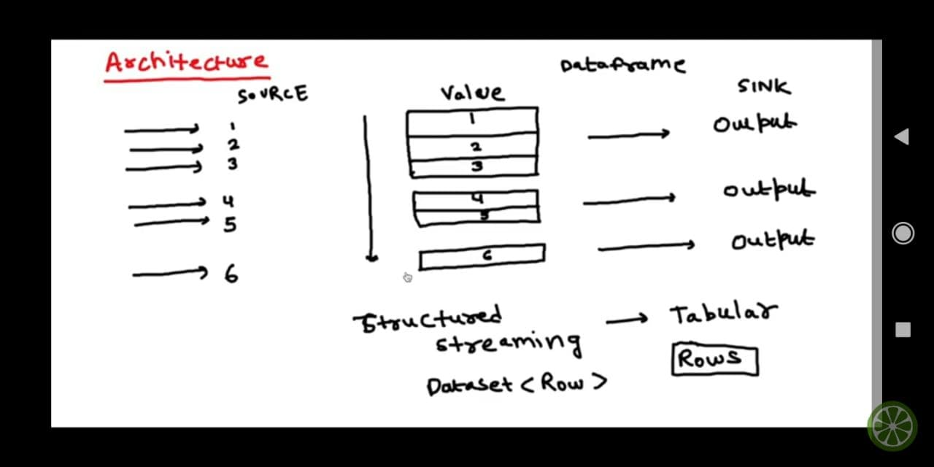

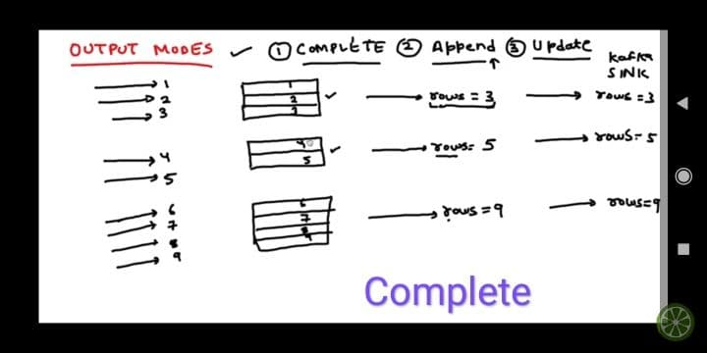

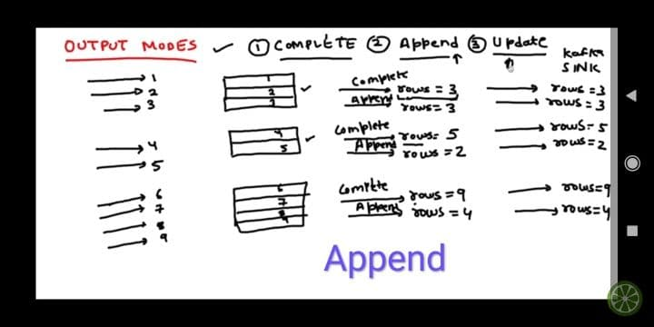

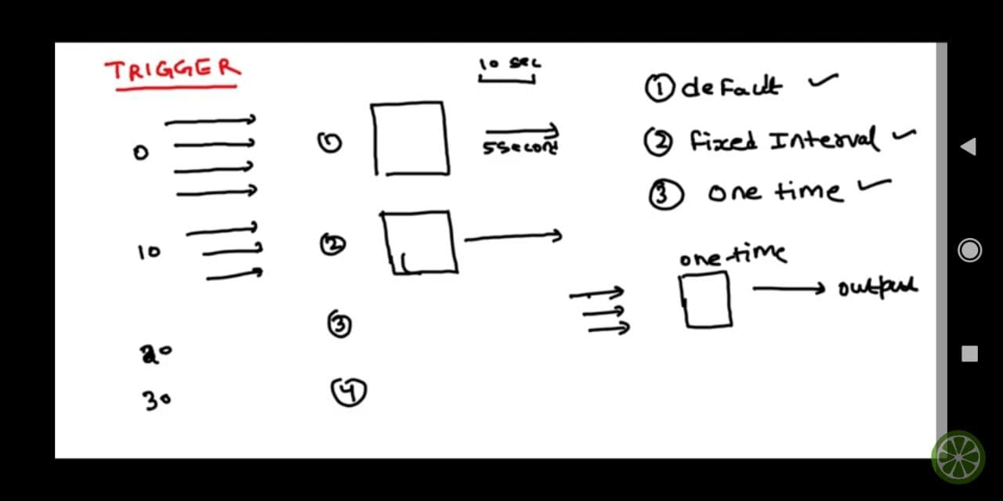

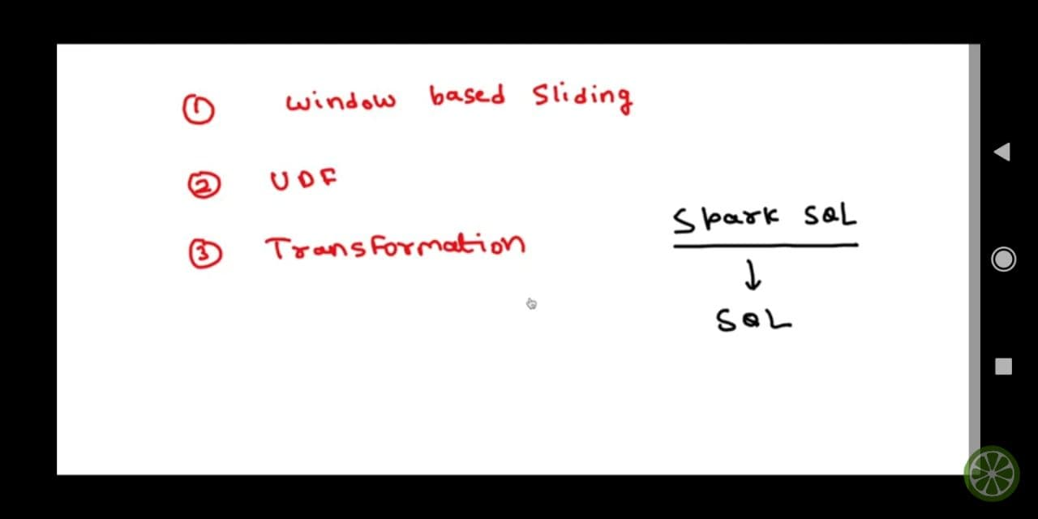

### Demo – Orders Data

**Terminal #1**

su - hdoop

ssh localhost

cd $HADOOP_HOME/sbin

start-dfs.sh

start-yarn.sh

python3 -m pip install kafka-python

OR

pip install kafka-python

cd $KAFKA_HOME

bin/zookeeper-server-start.sh config/zookeeper.properties

**Terminal #2**

su - hdoop

cd $KAFKA_HOME

bin/kafka-server-start.sh config/server.properties

**Terminal #3**

su - hdoop

cd $KAFKA_HOME

bin/kafka-topics.sh --create --zookeeper localhost:2181 --replication-factor 1 --partitions 1 --topic test-topic

**Terminal #4**

su - hdoop

cd $KAFKA_HOME

bin/kafka-console-consumer.sh --bootstrap-server localhost:9092 --topic test-topic --from-beginning

**Terminal #5**

su - hdoop

cd SparkSamples/OrderData

mkdir /tmp/spark-events

spark-submit --packages org.apache.spark:spark-streaming-kafka-0-8-assembly_2.11:2.4.4 kafka_streaming_json_demo.py

OR

spark-submit --packages org.apache.spark:spark-sql-kafka-0-10_2.12:3.1.2 kafka_streaming_json_demo.py

**Terminal #3**

cd SparkSamples/OrderData

python3 kafka_producer.py

### Demo – Transaction Data

**Terminal #1**

su - hdoop

ssh localhost

cd $HADOOP_HOME/sbin

start-dfs.sh

start-yarn.sh

cd $KAFKA_HOME

bin/zookeeper-server-start.sh config/zookeeper.properties

**Terminal #2**

su - hdoop

cd $KAFKA_HOME

bin/kafka-server-start.sh config/server.properties

**Terminal #3**

su - hdoop

cd $KAFKA_HOME

bin/kafka-topics.sh --create --zookeeper localhost:2181 --replication-factor 1 --partitions 1 --topic txn-topic

bin/kafka-topics.sh --create --zookeeper localhost:2181 --replication-factor 1 --partitions 1 --topic outputtopic

**Terminal #4**

su - hdoop

cd $KAFKA_HOME

bin/kafka-console-consumer.sh --bootstrap-server localhost:9092 --topic txn-topic --from-beginning

**Terminal #5**

su - hdoop

cd $KAFKA_HOME

bin/kafka-console-consumer.sh --bootstrap-server localhost:9092 --topic outputtopic --from-beginning

**Terminal #6**

su - hdoop

cd SparkSamples/TransactionData

mkdir /tmp/spark-events

spark-submit --packages org.apache.spark:spark-streaming-kafka-0-8-assembly_2.11:2.4.4 pyspark_structured_streaming_kafka_demo.py

OR

spark-submit --packages org.apache.spark:spark-sql-kafka-0-10_2.12:3.1.2 pyspark_structured_streaming_kafka_demo.py

**Terminal #3**

cd SparkSamples/TransactionData

python3 cloudtv_kafka_producer_demo.py

### Demo – Orders Data – AVRO

<https://spark.apache.org/docs/2.4.0/sql-data-sources-avro.html>

All steps remain the same, except running the producer and streaming (consumer) programs:

**New Terminal**

su - hdoop

cd SparkSamples/OrderData

mkdir /tmp/spark-events

spark-submit --packages org.apache.spark:spark-sql-kafka-0-10_2.12:3.1.2,org.apache.spark:spark-avro_2.12:3.1.2 kafka_streaming_avro_demo.py

**New Terminal**

cd SparkSamples/OrderData

python3 kafka_producer_avro.py

### Demo – Orders Data - CSV

All steps remain the same, except running the producer and streaming (consumer) programs:

**New Terminal**

su - hdoop

cd SparkSamples/OrderData

mkdir /tmp/spark-events

spark-submit --packages org.apache.spark:spark-sql-kafka-0-10_2.12:3.1.2,org.apache.spark:spark-avro_2.12:3.1.2 kafka_streaming_csv_demo.py

**New Terminal**

cd SparkSamples/OrderData

python3 kafka_producer_csv.py

## Spark Streaming with Kafka (Scala)

<https://sparkbyexamples.com/spark/spark-streaming-with-kafka/>

### Topic commands

#### Ubuntu Custom

$KAFKA_HOME/bin/kafka-topics.sh --create --zookeeper localhost:2181 --replication-factor 1 --partitions 1 --topic json_topic

$KAFKA_HOME/bin/kafka-topics.sh --create --zookeeper localhost:2181 --replication-factor 1 --partitions 1 --topic json_output_topic

$KAFKA_HOME/bin/kafka-console-producer.sh --broker-list localhost:9092 --topic json_topic

$KAFKA_HOME/bin/kafka-console-consumer.sh --bootstrap-server localhost:9092 --topic json_topic

$KAFKA_HOME/bin/kafka-console-consumer.sh --bootstrap-server localhost:9092 --topic json_output_topic

#### On Hortonworks HDP Sandbox

$KAFKA_HOME/bin/kafka-topics.sh --create --zookeeper sandbox-hdp.hortonworks.com:6667 --replication-factor 1 --partitions 1 --topic json_topic

$KAFKA_HOME/bin/kafka-topics.sh --create --zookeeper sandbox-hdp.hortonworks.com:6667 --replication-factor 1 --partitions 1 --topic json_output_topic

$KAFKA_HOME/bin/kafka-console-producer.sh --broker-list sandbox-hdp.hortonworks.com:6667 --topic json_topic

$KAFKA_HOME/bin/kafka-console-consumer.sh --bootstrap-server sandbox-hdp.hortonworks.com:6667 --topic json_topic

$KAFKA_HOME/bin/kafka-console-consumer.sh --bootstrap-server sandbox-hdp.hortonworks.com:6667 --topic json_output_topic

### Run Kafka Producer Shell

First, let’s produce some JSON data to Kafka topic "json_topic", Kafka distribution comes with Kafka Producer shell, run this producer and input the JSON data from [person.json.](https://github.com/sparkbyexamples/spark-examples/blob/master/spark-streaming/src/main/resources/person.json) Just copy one line at a time from person.json file and paste it on the console where Kafka Producer shell is running.

person.json:

|  |
| --- |
| {"id":1,"firstname":"James ","middlename":"","lastname":"Smith","dob_year":2018,"dob_month":1,"gender":"M","salary":3000} |
| {"id":2,"firstname":"Michael ","middlename":"Rose","lastname":"","dob_year":2010,"dob_month":3,"gender":"M","salary":4000} |
| {"id":3,"firstname":"Robert ","middlename":"","lastname":"Williams","dob_year":2010,"dob_month":3,"gender":"M","salary":4000} |
| {"id":4,"firstname":"Maria ","middlename":"Anne","lastname":"Jones","dob_year":2005,"dob_month":5,"gender":"F","salary":4000} |
| {"id":5,"firstname":"Jen","middlename":"Mary","lastname":"Brown","dob_year":2010,"dob_month":7,"gender":"","salary":-1} |

**Note**: By default when you write a message to a topic, Kafka automatically creates a topic however, you can also create a topic manually and specify your partition and replication factor.

bin/kafka-console-producer.sh \

--broker-list localhost:9092 --topic json_topic

### Streaming With Kafka

#### Kafka Maven dependency

In order to streaming data from Kafka topic, we need to use below Kafka client Maven dependencies. You use the version according to your Kafka and Scala versions. Sample below:

<dependency>

<groupId>org.apache.spark</groupId>

<artifactId>spark-sql-kafka-0-10_2.11</artifactId>

<version>2.4.0</version>

</dependency>

### Spark Streaming Scala example

To run the code in REPL mode, start the Spark Shell as follows:

On the Custom Ubuntu VM:

**Note**: Run the following command first on the custom Ubuntu VM:

mkdir /tmp/spark-events

$ spark-shell --packages org.apache.spark:spark-sql-kafka-0-10_2.12:3.1.2

On the Hortonworks HDP:

$ spark-shell --packages org.apache.spark:spark-sql-kafka-0-10_2.11:2.3.0

Spark Streaming uses readStream() on SparkSession to load a streaming Dataset from Kafka. Option startingOffsets earliest is used to read all data available in the Kafka at the start of the query, we may not use this option that often and the default value for startingOffsets is latest which reads only new data that’s not been processed.

### Source code stream.scala: (SparkSamples\Scala)

val df = spark.readStream.format("kafka").option("kafka.bootstrap.servers", "localhost:9092").option("subscribe", "json_topic").option("startingOffsets", "earliest").load()

df.printSchema()

Since there are multiple options to stream from, we need to explicitly state from where you are streaming with format("kafka") and should provide the Kafka servers and subscribe to the topic you are streaming from using the option.

df.printSchema() returns the schema of streaming data from Kafka. The returned DataFrame contains all the familiar fields of a Kafka record and its associated metadata.

Possible values for “startingOffsets” are “earliest”, “latest” or a json string as follows:

{"topicA":{"0":23,"1":-1},"topicB":{"0":-2}}

where -2 as an offset refers to earliest and -1 refers to latest.

### Spark Streaming Write to Console

Since the value is in binary, first we need to convert the binary value to String using selectExpr()

val personStringDF = df.selectExpr("CAST(value AS STRING)")

Now, extract the value which is in [JSON String to DataFrame](https://sparkbyexamples.com/spark/spark-parse-json-from-text-file-string/) and convert to DataFrame columns using [custom schema](https://sparkbyexamples.com/spark/spark-schema-explained-with-examples/).

import org.apache.spark.sql.types.{StructType, StructField, StringType, IntegerType};

val schema = new StructType()

.add("id",IntegerType)

.add("firstname",StringType)

.add("middlename",StringType)

.add("lastname",StringType)

.add("dob_year",IntegerType)

.add("dob_month",IntegerType)

.add("gender",StringType)

.add("salary",IntegerType)

val personDF = personStringDF.select(from_json(col("value"), schema).as("data"))

.select("data.*")

personDF.writeStream

.format("console")

.outputMode("append")

.start()

.awaitTermination()

The complete Streaming Kafka Example code can be downloaded from [GitHub](https://github.com/sparkbyexamples/spark-examples/blob/master/spark-streaming/src/main/scala/com/sparkbyexamples/spark/streaming/kafka/json/SparkStreamingConsumerKafkaJson.scala). After download, import project to your favorite IDE and change Kafka broker IP address to your server IP on SparkStreamingConsumerKafkaJson.scala program. When you run this program, you should see Batch: 0 with data. As you input new data(from step 1), results get updated with Batch: 1, Batch: 2 and so on.

**Run as:**

***On Hortonworks:***

$ spark-submit --packages org.apache.spark:spark-sql-kafka-0-10_2.11:2.3.0 ~/kafkaspark_2.11-0.1.0-SNAPSHOT.jar --class example.stream

**OR**

spark-shell --packages org.apache.spark:spark-sql-kafka-0-10_2.11:2.3.0

scala> :load stream.scala

**Sample data to test**:

{"id":1,"firstname":"ajay","middlename":"J","lastname":"singala","dob_year":1969,"dob_month":9,"gender":"male","salary":1234}

{"id":2,"firstname":"starlord","middlename":"Peter","lastname":"quill","dob_year":1969,"dob_month":9,"gender":"male","salary":1234}

{"id":3,"firstname":"tony","middlename":"potts","lastname":"stark","dob_year":1969,"dob_month":9,"gender":"male","salary":1234}

### Spark Streaming Write to Kafka Topic

Note that In order to write Spark Streaming data to Kafka, value column is required and all other fields are optional.

Columns key and value are binary in Kafka; hence, first, these should convert to String before processing. If a key column is not specified, then a null valued key column will be automatically added.

Let’s produce the data to Kafka topic "json_data_topic". Since we are processing JSON, let’s convert data to JSON using to_json() function and store it in a value column.

df.selectExpr("CAST(id AS STRING) AS key", "to_json(struct(*)) AS value")

.writeStream

.format("kafka")

.outputMode("append")

.option("kafka.bootstrap.servers", "localhost:9092")

.option("topic", "json_output_topic")

.start()

.awaitTermination()

Use writeStream.format("kafka") to write the streaming DataFrame to Kafka topic. Since we are just reading a file (without any aggregations) and writing as-is, we are using outputMode("append"). [OutputMode](https://sparkbyexamples.com/spark/spark-streaming-outputmode/) is used to what data will be written to a sink when there is new data available in a DataFrame/Dataset.

### Run Kafka Consumer Shell

Now run the Kafka consumer shell program that comes with Kafka distribution.

bin/kafka-console-consumer.sh \

--bootstrap-server localhost:9092 --topic json_topic

As you feed more data (from step 1), you should see JSON output on the consumer shell console.

### Full code stream.scala: (SparkSamples\Scala)

// stream.scala

import org.apache.spark.sql.SparkSession

//import org.apache.spark.sql.functions.{col, from_json}

import org.apache.spark.sql.functions._

import org.apache.spark.sql.types.{IntegerType, StringType, StructType}

//object SparkStreamingConsumerKafkaJson {

//  def main(args: Array[String]): Unit = {

   val spark: SparkSession = SparkSession.builder().master("local[3]").appName("ajaysingala").getOrCreate()

   import spark.implicits._

   spark.sparkContext.setLogLevel("ERROR")

   // Read from start.

   // // Custom Ubuntu VM.

   // val df = spark.readStream.format("kafka").option("kafka.bootstrap.servers", "localhost:9092").option("subscribe", "json_topic").option("startingOffsets", "earliest").load()

   // Hortonworks HDP VM.

   val df = spark.readStream.format("kafka").option("kafka.bootstrap.servers", "sandbox-hdp.hortonworks.com:6667").option("subscribe", "json_topic").option("startingOffsets", "earliest").load()

   //df.printSchema()

   val schema = new StructType().add("id",IntegerType).add("firstname",StringType).add("middlename",StringType).add("lastname",StringType).add("dob_year",IntegerType).add("dob_month",IntegerType).add("gender",StringType).add("salary",IntegerType)

   // Since the value is in binary, first we need to convert the binary value to String using selectExpr().

   // Also apply the schema.

   val personDF = df.selectExpr("CAST(value AS STRING)").select(from_json(col("value"), schema).as("data")).select("data.*")

   /**

    *uncomment below code if you want to write it to console for testing.

   */

   val query = personDF.writeStream.format("console").outputMode("append").option("truncate", "false").start()

      //.awaitTermination()

   /**

    * uncomment below code if you want to write it to kafka topic.

   */

   val dfOut = personDF.selectExpr("CAST(id AS STRING) AS key", "to_json(struct(*)) AS value").alias("value")

   dfOut.printSchema()

   // // Custom Ubuntu VM.

   // dfOut

   //    .writeStream.format("kafka")

   //    .outputMode("append")

   //    .option("kafka.bootstrap.servers", "localhost:9092")

   //    .option("checkpointLocation", "/tmp/kafka_checkpoints")

   //    .option("topic", "json_output_topic")

   //    .start()

   //    //.awaitTermination()

   // Hortonworks HDP VM.

   dfOut

      .writeStream.format("kafka")

      .outputMode("append")

      .option("kafka.bootstrap.servers", "sandbox-hdp.hortonworks.com:6667")

      .option("checkpointLocation", "/tmp/kafka_checkpoints")

      .option("topic", "json_output_topic")

      .start()

      //.awaitTermination()

   dfOut.createOrReplaceTempView("Person")

   val dfSQL =  spark.sql("SELECT * FROM PERSON")

   val dfJSON = dfSQL.toJSON

   dfJSON.writeStream.format("console").outputMode("append").option("truncate", "false").start()

//  }

//}

**Run as:**

***On Hortonworks:***

$ spark-submit --packages org.apache.spark:spark-sql-kafka-0-10_2.11:2.3.0 ~/kafkaspark_2.11-0.1.0-SNAPSHOT.jar --class example.stream

**OR**

spark-shell --packages org.apache.spark:spark-sql-kafka-0-10_2.11:2.3.0

scala> :load stream.scala

Then, in the Producer console, send some JSON values. The data should now appear in the Consumer console.

**To read:**

*// Subscribe to 1 topic*

**val** df **=** spark

.readStream

.format("kafka")

.option("kafka.bootstrap.servers", "localhost:9092")

.option("subscribe", "topic1")

.load()

df.selectExpr("CAST(key AS STRING)", "CAST(value AS STRING)")

.as[(String, String)]

**To write key-value data**:

*//Write key-value data from a DataFrame to a specific Kafka topic specified in an option*

**val** ds **=** df

.selectExpr("CAST(key AS STRING)", "CAST(value AS STRING)")

.writeStream

.format("kafka")

.option("kafka.bootstrap.servers", "host1:port1,host2:port2")

.option("topic", "topic1")

.start()

*// Write key-value data from a DataFrame to Kafka using a topic specified in the data*

**val** ds **=** df

.selectExpr("topic", "CAST(key AS STRING)", "CAST(value AS STRING)")

.writeStream

.format("kafka")

.option("kafka.bootstrap.servers", "host1:port1,host2:port2")

.start()

## Other Articles – withWaterMark, window, multiple o/p sinks etc.

* <https://www.projectpro.io/recipes/perform-perform-spark-streaming-using-foreachbatch-sink>
* <https://stackoverflow.com/questions/57267347/append-output-mode-not-supported-when-there-are-streaming-aggregations-on-stream>
* <https://medium.com/expedia-group-tech/apache-spark-structured-streaming-operations-5-of-6-40d907866fa7>
* <https://www.rittmanmead.com/blog/2019/03/analysing-kafka-data-in-scala-spark/>
* <https://medium.com/knoldus/basic-example-for-spark-structured-streaming-kafka-integration-a6d0b3ffc3bd#:~:text=Save-,Basic%20Example%20for%20Spark%20Structured%20Streaming%20%26%20Kafka%20Integration,access%20to%20offsets%20and%20metadata>.
* <https://spark.apache.org/docs/latest/structured-streaming-kafka-integration.html>
* <https://medium.com/expedia-group-tech/apache-spark-structured-streaming-output-sinks-3-of-6-ed3247545fbc>
* <https://stackoverflow.com/questions/46295205/how-to-read-streaming-dataset-once-and-output-to-multiple-sinks>
* <https://stackoverflow.com/questions/62350425/what-is-the-optimal-way-to-read-from-multiple-kafka-topics-and-write-to-differen>
* <https://stackoverflow.com/questions/65352533/how-to-write-streaming-dataframe-into-multiple-sinks-in-spark-structured-streami>
* <https://stackoverflow.com/questions/50791975/spark-structured-streaming-multiple-writestreams-to-same-sink>
* <https://stackoverflow.com/questions/46295205/how-to-read-streaming-dataset-once-and-output-to-multiple-sinks>
* <https://stackoverflow.com/questions/57367226/structured-streaming-writing-to-multiple-streams>

## Complete Producer-Consumer Example (Scala)

<https://www.signifytechnology.com/blog/2019/10/windowing-kafka-streams-using-spark-structured-streaming-by-david-virgil-naranjo>

### The Domain

// ShopDomain.scala

package example

object Domain {

  case class SalesRecord(transactionTimestamp: String, shopId: Int, productId: Int, amount: Int, totalCost: Double)

}

### The Producer Generator (Helper)

// ProducerGenerator.scala

// spark-submit --packages org.apache.spark:spark-sql-kafka-0-10_2.11:2.3.0,net.liftweb:lift-json_2.11:3.5.0 kafkaspark_2.11-0.1.0-SNAPSHOT.jar --class example.ProducerGenerator

package example

import java.util.Date

import example.Domain.SalesRecord

import scala.util.Random

import org.apache.kafka.clients.producer.{KafkaProducer, ProducerRecord}

object ProducerGenerator {

  val productCost: Map[Int, Double] =

    Map(1 -> 9.99, 2 -> 40, 3 -> 15, 4 -> 22, 5 -> 34)

  val shopsProb: Map[Int, Double] = Map(1 -> 0.5, 2 -> 0.5)

  val productsByShopProb: Map[Int, Map[Int, Double]] = Map(

    1 -> Map(1 -> 0.3, 2 -> 0.35, 3 -> 0.15, 4 -> 0.2),

    2 -> Map(1 -> 0.35, 2 -> 0.35, 3 -> 0.15, 4 -> 0.15)

  )

  val numberItemsProb: Map[Int, Double] = Map(1 -> 0.75, 2 -> 0.2, 3 -> 0.05)

  val randomDelay = new Random()

  import java.text.SimpleDateFormat

  val sdf = new SimpleDateFormat("yyyy-MM-dd HH:mm:ss.SSS")

  def main_pg(args: Array[String]): Unit = {

    println("Generating record...")

    val rec = generateRecords(1).toList

    printRec(rec)

    val rec10 = generateRecords(10).toList

    printRec(rec10)

  }

  def printRec(rec: Seq[SalesRecord]) {

    println("Printing the record...")

    println(rec)

    import net.liftweb.json._

    import net.liftweb.json.Serialization.write

    implicit val formats = DefaultFormats

    rec.map(r => {

      val jsonString = write(r)

      println(jsonString)

      val json = parse(jsonString)

      val shopId = json \ "shopId"

      println(shopId.extract[String])

    })

  }

  // Function to generate records.

  def generateRecords(

      numberRecords: Int,

      late: Boolean = false

  ): Seq[SalesRecord] = {

    val randomPartners = new Random()

    val output = (1 to numberRecords).map { i =>

      val shopId: Int = randomValue(shopsProb)

      val product = randomValue(productsByShopProb(shopId))

      val numberOfItems = randomValue(numberItemsProb)

      val now = System.currentTimeMillis()

      val delay = randomDelay.nextInt(50)

      val timestamp = now

      val time = sdf.format(new Date(timestamp))

      SalesRecord(

        time,

        shopId,

        product,

        numberOfItems,

        productCost(product) * numberOfItems

      )

    }

    output

  }

  def randomValue[A](dist: Map[A, Double]): A = {

    val p = scala.util.Random.nextDouble

    val it = dist.iterator

    var accum = 0.0

    while (it.hasNext) {

      val (item, itemProb) = it.next

      accum += itemProb

      if (accum >= p)

        return item // return so that we don't have to search through the whole distribution

    }

    sys.error(f"This should never happen") // needed so it will compile

  }

}

### The Shops Records Producer

// ShopProducer.scala

// $KAFKA_HOME/bin/kafka-topics.sh --create --zookeeper localhost:2181 --replication-factor 1 --partitions 1 --topic shops_records

// $KAFKA_HOME/bin/kafka-console-consumer.sh --bootstrap-server sandbox-hdp.hortonworks.com:6667 --topic shops_records

// spark-submit --packages org.apache.spark:spark-sql-kafka-0-10_2.11:2.3.0,net.liftweb:lift-json_2.11:3.5.0 kafkaspark_2.11-0.1.0-SNAPSHOT.jar --class example.ShopProducer

// OR

// cp kafkaspark_2.11-0.1.0-SNAPSHOT.jar shopproducer.jar

// spark-submit --packages org.apache.spark:spark-sql-kafka-0-10_2.11:2.3.0,net.liftweb:lift-json_2.11:3.5.0 shopproducer.jar --class example.ShopProducer

package example

import example.Domain.SalesRecord

import java.util.Properties

import org.apache.kafka.clients.producer.{KafkaProducer, ProducerRecord}

import net.liftweb.json._

import net.liftweb.json.Serialization.write

object ShopProducer {

  def main(args: Array[String]): Unit = {

    val props: Properties = new Properties()

    //props.put("bootstrap.servers","localhost:9092")

    props.put("bootstrap.servers", "sandbox-hdp.hortonworks.com:6667")

    props.put(

      "key.serializer",

      "org.apache.kafka.common.serialization.StringSerializer"

    )

    props.put(

      "value.serializer",

      "org.apache.kafka.common.serialization.StringSerializer"

    )

    val producer = new KafkaProducer[String, String](props)

    val topic = "shops_records"

    try {

      for (i <- 0 to 15) {

        println(s"Running cycle # $i...")

        val shopData = ProducerGenerator.generateRecords(1000).toList

        implicit val formats = DefaultFormats

        //val shopDataJson = write(shopData)

        //println(shopDataJson)

        // val shopId = (parse(shopDataJson) \ "shopId").extract[String]

        // val record = new ProducerRecord[String, String](topic,

        //     shopDataJson

        // )

        shopData.map(r => {

          val jsonString = write(r)

          println(jsonString)

          val json = parse(jsonString)

          val record = new ProducerRecord[String, String](topic, jsonString)

          val metadata = producer.send(record)

          printf(

            s"sent record(key=%s value=%s) " +

              "meta(partition=%d, offset=%d)\n",

            record.key(),

            record.value(),

            metadata.get().partition(),

            metadata.get().offset()

          )

        })

        val ms = 10000

        println(s"Completed cycle # $i...")

        println(s"Going to sleep for $ms milliseconds...")

        Thread.sleep(ms)

      }

    } catch {

      case e: Exception => e.printStackTrace()

    } finally {

      producer.close()

    }

  }

}

### The Shops Records Consumer

// SparkStreamWindow.scala

// $KAFKA_HOME/bin/kafka-topics.sh --create --zookeeper localhost:2181 --replication-factor 1 --partitions 1 --topic shops_records

// $KAFKA_HOME/bin/kafka-console-consumer.sh --bootstrap-server sandbox-hdp.hortonworks.com:6667 --topic shops_records

// spark-submit --packages org.apache.spark:spark-sql-kafka-0-10_2.11:2.3.0,net.liftweb:lift-json_2.11:3.5.0 kafkaspark_2.11-0.1.0-SNAPSHOT.jar --class example.ShopConsumer

// OR

// cp kafkaspark_2.11-0.1.0-SNAPSHOT.jar shopconsumer.jar

// spark-submit --packages org.apache.spark:spark-sql-kafka-0-10_2.11:2.3.0,net.liftweb:lift-json_2.11:3.5.0 shopconsumer.jar --class example.ShopConsumer

package example

import org.apache.spark.sql.SparkSession

import org.apache.spark.sql.types._

import org.apache.spark.sql.functions._

object ShopConsumer {

  def main_sc(args: Array[String]): Unit = {

    println("Creating SparkSession object...")

    val spark = SparkSession.builder

      .appName("StructuredConsumerWindowing")

      .getOrCreate()

    spark.sparkContext.setLogLevel("ERROR")

    println("Define our input stream...")

    // val kafkaEndpoint = "localhost:9092"                    // Default.

    val kafkaEndpoint = "sandbox-hdp.hortonworks.com:6667" // Hortonworks.

    val inputStream = spark.readStream

      .format("kafka")

      .option("kafka.bootstrap.servers", kafkaEndpoint)

      .option("auto.offset.reset", "latest")

      .option("value.deserializer", "StringDeserializer")

      .option("subscribe", "shops_records")

      .load

    println("The schema from the stream dataframe...")

    inputStream.printSchema()

    println(

      "Convert Kafka topic input stream value, that has a binary type, into a meaningful dataframe..."

    )

    val schema = StructType(

      List(

        StructField("transactionTimestamp", TimestampType, true),

        StructField("shopId", IntegerType, true),

        StructField("productId", IntegerType, true),

        StructField("amount", IntegerType, true),

        StructField("totalCost", DoubleType, true)

      )

    )

    val initial = inputStream.selectExpr("CAST(value AS STRING)").toDF("value")

    initial.printSchema()

    println("Convert this String, into its JSON representation...")

    val aggregation_one = initial.select(from_json(col("value"), schema))

    aggregation_one.printSchema()

    println("Select the embedded values...")

    val aggregation = initial

      .select(from_json(col("value"), schema).alias("tmp"))

      .select("tmp.*")

    aggregation.printSchema()

    println("Define the window size and watermark...")

    val windows = aggregation

      //.withWatermark("transactionTimestamp", "5 minutes")

      .withWatermark("transactionTimestamp", "1 minute")

      .groupBy(

        //window(col("transactionTimestamp"), "1 minute", "1 minute"),

        window(col("transactionTimestamp"), "5 seconds", "5 seconds"),

        col("shopId")

      )

    println("Create a dataframe with multiple aggregations...")

    import org.apache.spark.sql.functions._

    val aggregatedDF = windows.agg(sum("totalCost"), count("*"))

    println("Write the aggregated data into a sink...")

    val dfcount = aggregatedDF.writeStream

      .outputMode("complete")

      .option("truncate", false)

      .format("console")

      .start()

    dfcount.awaitTermination()

  }

}

### Run the Application

**Terminal #1**:

Create the topic:

$KAFKA_HOME/bin/kafka-topics.sh --create --zookeeper localhost:2181 --replication-factor 1 --partitions 1 --topic shops_records

Create a console consumer for the topic:

$KAFKA_HOME/bin/kafka-console-consumer.sh --bootstrap-server sandbox-hdp.hortonworks.com:6667 --topic shops_records

**Terminal #2**:

Run the producer app:

spark-submit --packages org.apache.spark:spark-sql-kafka-0-10_2.11:2.3.0,net.liftweb:lift-json_2.11:3.5.0 kafkaspark_2.11-0.1.0-SNAPSHOT.jar --class example.ShopProducer

**OR**

cp kafkaspark_2.11-0.1.0-SNAPSHOT.jar shopproducer.jar

spark-submit --packages org.apache.spark:spark-sql-kafka-0-10_2.11:2.3.0,net.liftweb:lift-json_2.11:3.5.0 shopproducer.jar --class example.ShopProducer

**Terminal #3**:

Run the consumer app:

spark-submit --packages org.apache.spark:spark-sql-kafka-0-10_2.11:2.3.0,net.liftweb:lift-json_2.11:3.5.0 kafkaspark_2.11-0.1.0-SNAPSHOT.jar --class example.ShopConsumer

**OR**

cp kafkaspark_2.11-0.1.0-SNAPSHOT.jar shopconsumer.jar

spark-submit --packages org.apache.spark:spark-sql-kafka-0-10_2.11:2.3.0,net.liftweb:lift-json_2.11:3.5.0 shopconsumer.jar --class example.ShopConsumer

## Try these

<https://dzone.com/articles/apache-kafka-241-spark-streaming-300-preview-scala>

<https://jaceklaskowski.gitbooks.io/spark-structured-streaming/content/spark-sql-streaming-demo-kafka-data-source.html>

<https://www.signifytechnology.com/blog/2019/10/windowing-kafka-streams-using-spark-structured-streaming-by-david-virgil-naranjo>

## Need for Spark Streaming

To process the data, most traditional stream processing systems are designed with a continuous operator model, which works as follows:

* Streaming data is received from data sources (e.g. live logs, system telemetry data, IoT device data, etc.) into some data ingestion system like Apache Kafka, Amazon Kinesis, etc.
* The data is then processed in parallel on a cluster.
* Results are given to downstream systems like HBase, Cassandra, Kafka, etc.

There is a set of worker nodes, each of which runs one or more continuous operators. Each continuous operator processes the streaming data one record at a time and forwards the records to other operators in the pipeline.

Data is received from ingestion systems via Source operators and given as output to downstream systems via sink operators.

Continuous operators are a simple and natural model. However, this traditional architecture has also met some challenges with today’s trend towards larger scale and more complex real-time analytics:-

1. Fast Failure and Straggler Recovery

In real time, the system must be able to fastly and automatically recover from failures and stragglers to provide results which is challenging in traditional systems due to the static allocation of continuous operators to worker nodes.

1. Load Balancing

In a continuous operator system, uneven allocation of the processing load between the workers can cause bottlenecks. The system needs to be able to dynamically adapt the resource allocation based on the workload.

1. Unification of Streaming, Batch and Interactive Workloads

In many use cases, it is also attractive to query the streaming data interactively, or to combine it with static datasets (e.g. pre-computed models). This is hard in continuous operator systems which does not designed to new operators for ad-hoc queries. This requires a single engine that can combine batch, streaming and interactive queries.

1. Advanced Analytics with Machine learning and SQL Queries

Complex workloads require continuously learning and updating data models, or even querying the streaming data with SQL queries. Having a common abstraction across these analytic tasks makes the developer’s job much easier.

## Spark Streaming Sources

Every input DStream (except file stream) associate with a Receiver object which receives the data from a source and stores it in Spark’s memory for processing.

There are two categories of built-in streaming sources:

* Basic sources – These are the sources directly available in the StreamingContext API. Examples: file systems, and socket connections.
* Advanced sources – Sources like Kafka, Flume, Kinesis, etc. are available through extra utility classes. These require linking against extra dependencies.

There are two types of receivers base on their reliability:

* Reliable Receiver – A reliable receiver is the one that correctly sends an acknowledgment to a source when the data receives and stores in Spark with replication.
* Unreliable Receiver – An unreliable receiver does not send an acknowledgment to a source. This we can use for sources when one does not want or need to go into the complexity of acknowledgment.

## Spark Streaming Operations

Spark streaming support two types of operations:

1. **Transformation Operations in Spark**

Similar to Spark RDDs, Spark transformations allow modification of the data from the input DStream. DStreams support many transformations that are available on normal Spark RDD’s. Some of the common ones are as follows:

map(), flatMap(), filter(), repartition(numPartitions), union(otherStream), count(), reduce(), countByValue(), reduceByKey(func, [numTasks]), join(otherStream, [numTasks]), cogroup(otherStream, [numTasks]), transform(), updateStateByKey(), Window()

1. **Output Operations in Apache Spark**

DStream’s data push out to external systems like a database or file systems using Output Operations. Since external systems consume the transformed data as allowed by the output operations, they trigger the actual execution of all the DStream transformations. Currently, the following output operations define as:

print(), saveAsTextFiles(prefix, [suffix])”prefix-TIME_IN_MS[.suffix]”, saveAsObjectFiles(prefix, [suffix]), saveAsHadoopFiles(prefix, [suffix]), foreachRDD(func)

Hence, DStreams like RDDs execute lazily by the output operations. Specifically, the received data is processed forcefully by RDD actions inside the DStream output operations. By default, output operations execute one-at-a-time. And they executes in the order they are define in the Spark applications.

# Spark DStream (Discretized Streams)

*Discretized Stream Operations i.e Stateless and Stateful Transformations, Output operation, Input DStream, and Receivers.*

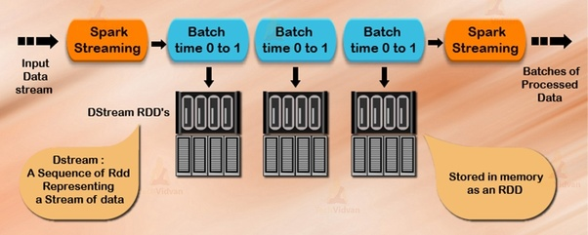

Spark DStream (Discretized Stream) is the basic abstraction of Spark Streaming. DStream is a continuous stream of data. It receives input from various sources like Kafka, Flume, Kinesis, or TCP sockets. It can also be a data stream generated by transforming the input stream. At its core, **DStream is a continuous stream of RDD (Spark abstraction)**. Every RDD in DStream contains data from the certain interval.

Any operation on a DStream applies to all the underlying RDDs. DStream covers all the details. It provides the developer a high-level API for convenience. As a result, Spark DStream facilitates working with streaming data.

Spark Streaming offers fault-tolerance properties for DStreams as that for RDDs. as long as a copy of the input data is available, it can recompute any state from it using the lineage of the RDDs. By default, Spark replicates data on two nodes. As a result, Spark Streaming can bear single worker failures.

## Apache Spark DStream Operations

Like RDD, Spark DStream also support two types of Operations: Transformations and output Operations-

### i. Transformation

There are two types of transformation in DStream:

* Stateless Transformations
* Stateful Transformations

#### a. Stateless Transformations

The processing of each batch has no dependency on the data of previous batches. Stateless transformations are simple RDD transformations. It applies on every batch meaning every RDD in a DStream. It includes common **RDD transformations** like map(), filter(), reduceByKey() etc.  
Although these functions seem like applying to the whole stream, *each DStream is a collection of many RDDs (batches)*. As a result, each stateless transformation applies to each RDD.

Stateless transformations are capable of combining data from many DStreams within each time step. For example, key/value DStreams have the same join-related transformations as RDDs— cogroup(), join(), leftOuterJoin() etc.

We can use these operations on DStreams to perform underlying RDD operations on each batch.

If stateless transformations are insufficient, DStreams comes with an advanced operator called transform(). transform() allow operating on the RDDs inside them. The transform() allows any arbitrary RDD-to-RDD function to act on the DStream. This function gets called on each batch of data in the stream to produce a new stream.

#### b. Stateful Transformations

It uses data or intermediate results from previous batches and computes the result of the current batch. Stateful transformations are operations on DStreams that track data across time. Thus it makes use of some data from previous batches to generate the results for a new batch.

The two main types are windowed operations, which act over a sliding window of time periods, and updateStateByKey(), which is used to track state across events for each key (e.g., to build up an object representing each user session).

Follow this link to[Read DStream Transformations in detail with the examples.](http://data-flair.training/blogs/apache-spark-streaming-transformation-operations/)

### ii. Output Operation

Once we get the data after transformation, on that data output operation are performed in Spark Streaming. After the debugging of our program, using output operation we can only save our output. Some of the output operations are print(), save() etc.. The save operation takes directory to save file into and an optional suffix. The print() takes in the first 10 elements from each batch of the DStream and prints the result.

## 4. Input DStreams and Receivers

Input DStream is a DStream representing the stream of input data from streaming source. Receiver (Scala doc, Java doc) object associated with every input DStream object. It receives the data from a source and stores it in Spark’s memory for processing.

Spark Streaming provides two categories of built-in streaming sources:

* ***Basic sources –*** These are Source which is directly available in the*StreamingContext API.* Examples: file systems, and socket connections.
* ***Advanced Sources –*** These sources are available by extra utility classes like *Kafka, Flume, Kinesis.* Thus, requires linking against extra dependencies.

For example:

* **Kafka:** the artifact required for Kafka is spark-streaming-kafka-0-8_2.11.
* **Flume:** the artifact requires for Flume is dspark-streaming-flume_2.11.
* **Kinesis:** the artifact required for Kinesis is spark-streaming-kinesis-asl_2.11.

It creates many inputs DStream to receive multiple streams of data in parallel. It creates multiple receivers that receive many data stream. Spark worker/executor is a long-running task. Thus, occupies one of the cores which associate to Spark Streaming application. So, it is necessary that, Spark Streaming application has enough cores to process received data.

## **Differences between DStreams and Spark Structured Streaming**

Spark Structured Streaming is the evolution of DStreams. Here are some fo the differences between them.

### **RDDs vs Dataframes/Datasets**

In one side RDDs are more flexible and allow to do much more low level operations, but on the other hand, Datasets/Dataframes offer the use of Spark SQL, and these are great for nearly all cases. Dataframes use the tree based Catalyst SQL query optimizer that improves significantly the Spark performance in terms of speed and memory. On the other hand, Datasets provide type safety as all of our queries would be done with JVM objects. We can consider a Dataframe as a Dataset[Row].

### **Real Streaming**

DStreams store the data into microbatches that simulate real time processing, while Spark Structured Streaming appends the real time events to the processing flow. DStreams’s microbatches are always executed even if there is no new data flowing to the stream, whilst in Structured Streaming there is a dedicated thread that checks for new data in the stream. If no data is available then the stream query is not executed. This is a significant difference between Spark Streaming (DStreams) and Spark Structured Streaming.

### **Windowing Event time**

Both DStreams and Structured Streaming provide grouping by windows, but with DStreams it is not possible to include the event time from one of the columns of the incoming data. In Structured Streaming it is possible to create windows by specifying: window period, slide length and event time column.

### **Sinks**

Using DStreams the output of the streaming is an RDD that can be manipulated. There is no requirement to use a sink as output.

Using Structured Streaming requires the use of an output sink. The output can be Hive, Parquet, Console… Since Spark 2.4 it is posisble to output the streaming computation result into a Dataframe using the**foreachBatch**sink.

# Troubleshooting

<https://jaceklaskowski.gitbooks.io/apache-kafka/content/kafka-topic-deletion.html>

<https://stackoverflow.com/questions/33537950/how-to-delete-a-topic-in-apache-kafka>

./bin/kafka-server-start.sh config/server.properties \

--override delete.topic.enable=true \

~~--override broker.id=200 \~~

~~--override log.dirs=/tmp/kafka-logs-200 \~~

~~--override port=9292~~

./bin/kafka-topics.sh --zookeeper localhost:2181 --delete --topic <topic_name>

Delete topic folders from /tmp/kafka-logs

**Zookeeper Shell:**

./bin/zookeeper-shell.sh localhost:2181

ls /admin/delete_topic

ls /brokers/topics

quit

## [Terminate the Kafka Environment](https://kafka.apache.org/quickstart#quickstart_kafkaterminate)

Now that you reached the end of the quickstart, feel free to tear down the Kafka environment—or continue playing around.

* Stop the producer and consumer clients with Ctrl-C, if you haven't done so already.
* Stop the Kafka broker with Ctrl-C.
* Lastly, stop the ZooKeeper server with Ctrl-C.

If you also want to delete any data of your local Kafka environment including any events you have created along the way, run the command:

$ rm -rf /tmp/kafka-logs /tmp/zookeeper

# References

https://www.digitalocean.com/community/tutorials/how-to-install-apache-kafka-on-ubuntu-20-04

https://tecadmin.net/how-to-install-apache-kafka-on-ubuntu-20-04/

https://kafka.apache.org/downloads

https://towardsdatascience.com/getting-started-with-apache-kafka-in-python-604b3250aa05

http://blog.adnansiddiqi.me/getting-started-with-apache-kafka-in-python/

https://timber.io/blog/hello-world-in-kafka-using-python/

https://linuxhint.com/apache-kafka-and-python/

https://linuxhint.com/read_data_kafka_python/

https://www.tutorialkart.com/apache-kafka-tutorial/

https://www.tutorialspoint.com/apache_kafka/index.htm

https://www.confluent.io/learn/kafka-tutorial/

https://kafka-tutorials.confluent.io/

https://www.javatpoint.com/apache-kafka

https://medium.com/@patelharshali136/apache-kafka-tutorial-kafka-for-beginners-a58140cef84f

https://www.confluent.io/blog/kafka-streams-tables-part-1-event-streaming/

https://data-flair.training/blogs/apache-spark-streaming-tutorial/

https://spark.apache.org/docs/latest/streaming-programming-guide.html

https://github.com/apache/spark/tree/master/examples/src/main/python/streaming

This one is very good:

https://www.cloudera.com/tutorials/kafka-in-trucking-iot/1.html

https://docs.confluent.io/platform/current/tutorials/examples/clients/docs/python.html?utm_medium=sem&utm_source=google&utm_campaign=ch.sem_br.nonbrand_tp.prs_tgt.kafka_mt.mbm_rgn.namer_lng.eng_dv.all_con.kafka-python&utm_term=%2Bkafka%20%2Bpython&creative=&device=c&placement=&gclid=Cj0KCQjwlMaGBhD3ARIsAPvWd6gUmwGCtWbZMjisqpT0sBSHsXCBeQ5yB4bi-wZFqm6XdsJUAjIS9foaAtd1EALw_wcB

https://mtpatter.github.io/bilao/notebooks/html/01-spark-struct-stream-kafka.html

https://databricks.com/blog/2017/04/04/real-time-end-to-end-integration-with-apache-kafka-in-apache-sparks-structured-streaming.html